**CDF Online**

Customer User Guide

Author – CDF Product Services

Published – 5th September 2024

**Table of Contents**

CDF Online User Guide 2

Overview 2

Expected Learning Outcomes 2

Glossary of Terms 3

Introduction to CDF Online 4

Overview 4

Security Features 5

Processing Cut-off Times 5

Establishing Access to CDF Online 6

Overview 6

Things to Consider before Applying for CDF Online 6

Applying for CDF Online 6

New User/ Changes to Online Access 7

Using the CDF Online System 8

Overview 8

First Time Sign On 8

Your Home Page 10

Viewing Accounts 11

Searching Transactions 11

Downloading Transactions 12

Generating a Statement 13

Viewing Periodical Payments (Direct Debits) 14

Updating Your Payee Address Books 15

Single EFT Payment 17

Single BPAY Payment 22

Single Internal Transfer – Between Your Accounts 26

Single Internal Transfer – To Another CDF Customer 30

Multiple EFT Payments 34

Multiple BPAY Payments 39

Uploading Files for Payment 44

Errors in a Batch Upload 49

Making Changes to a Batch 52

Deleting a Batch 54

**CDF Online User Guide**

# Overview

This user guide has been designed for all CDF clients who wish to use CDF Online to access their accounts online at any time. A basic level of understanding of reconciliation processes, making payments and usage of an accounting system is considered a pre-requisite for this training.

This user guide provides an overview of the functionality available to allow clients to reconcile their accounts and make payments. This user guide should be followed in conjunction with the CDF’s FAQs and your internal processes.

Contact details:

CDF Online Support is available Monday to Friday between the hours of 8:30am and 4:00pm.

Phone: 08 6104 3600

Email: [cdf@perthcatholic.org.au](mailto:cdf@perthcatholic.org.au)

Website: [cdf@perthcatholic.org.au](http://www.cdfperth.org.au)

# Expected Learning Outcomes

After completing this user guide you should:

* Have an in-depth understanding of CDF Online;
* Be able to confidently navigate the different areas of CDF Online;
* Know how to process internal and external payments; and
* Be able to easily export account statements or data for reconciliation.

# Glossary of Terms

Below is a listing of terminology that may be used throughout this user guide in relation to CDF Online, functionality and transactional processing.

CDF – Catholic Development Fund

Us – The CDF

Rejection – Term for when an EFT payment or direct debit is returned to the CDF as unpaid.

APCA – Australian Payments Clearing Association. APCA is the self-regulatory body for the Australian Payments industry. It is their responsibility to develop regulations, procedures, policies and standards governing payments processing within Australia. They oversee five clearing systems including the direct debit network. Part of the oversight of the direct debit network focuses on who can process direct debit payments.

BECS – Bulk Electronic Clearing System. NAB – National Australia Bank.

EFT – Electronic Funds Transfer of money to an account within Australia.

BPAY – BPAY is an electronic bill payment system in Australia which enables payments to be made through financial institutions online, mobile or telephone facility to organisations which are registered as BPAY billers.

CRN – Customer Reference Number. DDR – Direct Debit Request/s.

A# Number – CDF system generated reference number for the direct debit request.

**Introduction to CDF Online**

# Overview

CDF Online is an online platform that allows you to access your accounts and perform transactions 24 hours a day, 7 days a week from any location with internet access.

CDF Online gives customers the ability to:

* View current account balances;
* Transfer funds between CDF accounts;
* Transfer funds to accounts held at other financial institutions;
* View, print and download transaction listings;
* View future Periodic Payments or Direct Debits;
* The ability to upload creditor files for batch payments if your accounting package is able to generate ABA files;
* BPAY Payer functionality allowing you to make BPAY paymen[ts;[i]](https://adf.brisbanecatholic.org.au/products-services/adf-online/#_edn1)
* School specific functionality including the ability to create, change and delete school fee Direct Debits or upload Direct Debit files from school accounting package for self-managed direct debits[[ii]](https://adf.brisbanecatholic.org.au/products-services/adf-online/#_edn2);

1. BPAY Payer Online Access Agreement required to be completed before functionality is provided
2. Agreement to Process Direct Debits required to be completed before functionality is provided

# Security Features

We have a number of security features enabled on CDF Online. These include:

* + The ability to have CDF Online users set up with different access levels depending on the activity they are required to perform. Authorised users can be set up as:
    - Enquiry only.

View accounts and generate transaction listings but not perform any transactions).

* + - Data only.

Upload files, prepare payments, view accounts and generate transaction listings.

* + - Fully transactional.

Authorise transactions and/or files as well as all other actions that the enquiry and data only users can complete.

* + All data and transactional users are set up with their own unique login name and password and may be required to enter their date of birth each time they log in. We strongly recommend that users never record or share their log in details with anyone else, and that they regularly change their CDF Online password.
  + All transactions and batches processed through CDF Online require dual authorisation, meaning that 2 full transactional users are required to authorise all transactions and batches before they will be processed.
  + All accounts have a default external transfer limit (the amount that can be sent to another financial institution) of $0. If you would like to increase this, please complete the *Application for Variation of Standard Daily Limits form* which can be found on our website under the ‘Forms’ page.

# Processing Cut-off Times

We process your payments throughout each working day. In order for your external payment to be processed same day, please ensure they are fully authorised by the final cut-off time 2.00pm WST.

An internal transfer between your own accounts or to another CDF customer processes instantly.

**Establishing Access to CDF Online**

# Overview

In order to streamline processes, establishing access to CDF Online will soon be a part of the Account Authority process and all forms will be available on our website.

# Things to Consider before Applying for CDF Online

Consider who will be given full access to the accounts on CDF Online and their availability as you will require at least 2 full transactional users to be able to authorise transactions and batches before they will be processed.

The CDF Online site can be accessed on any smart device or computer with connection to the internet, so you do not need to be together in the office in order to process payments.

# Applying for CDF Online

Contact the CDF at [cdf@perthcatholic.org.au](mailto:cdf@perthcatholic.org.au) to obtain required forms.

The forms required are:

1. CDF Account Authority – this form is required to be completed upon membership with the CDF as well as each time new signatories or CDF Online users are to be added
2. CDF Online Access Form – this form is also used to amend or remove existing users

The following forms may also be required to be completed:

1. Identification – a new signatory on the Account Authority must also complete the CDF Identification process if they have not previously done so.
2. Daily External Limit Variation Form – this form is only required when you wish to establish or change your daily limit for making payments via EFT using CDF Online.
3. BPAY Payer Access Agreement – this agreement is only required to be completed once in order to register to make payments via BPAY using CDF Online.

All completed forms can be returned to the CDF via email to [cdf@perthcatholic.org.au](mailto:cdf@perthcatholic.org.au)

# 

# New User/ Changes to Online Access

We can delete a signatory or CDF Online user from a current Account Authority but if a new person is to be added then the process above for applying for CDF Online will need to be followed. Note details of all new and continuing signatories are to be included on your Account Authority form.

**Using the CDF Online System**

# Overview

In this section we will cover how to use CDF Online, including signing in for the first time, navigating the different areas, viewing balances, transactions and statements, transferring funds and uploading payment batches.

# First Time Sign On

We recommend you always access CDF Online via our website, [www.cdfperth.org.au.](http://www.cdfperth.org.au./) CDF Online will work in any internet browser however we do suggest using Microsoft Edge, Google Chrome or Firefox.

1. Click on the CDF Online Login button on our website
2. Enter your Login Details and select Login

**Login Name**: Enter the Login Name supplied by the CDF.

**Password:** Enter the password provided by the CDF.

1. This will prompt you to the below screen. You should receive a text with the one-time password. Enter this code and click ok. [Note this functionality will be commencing shortly]

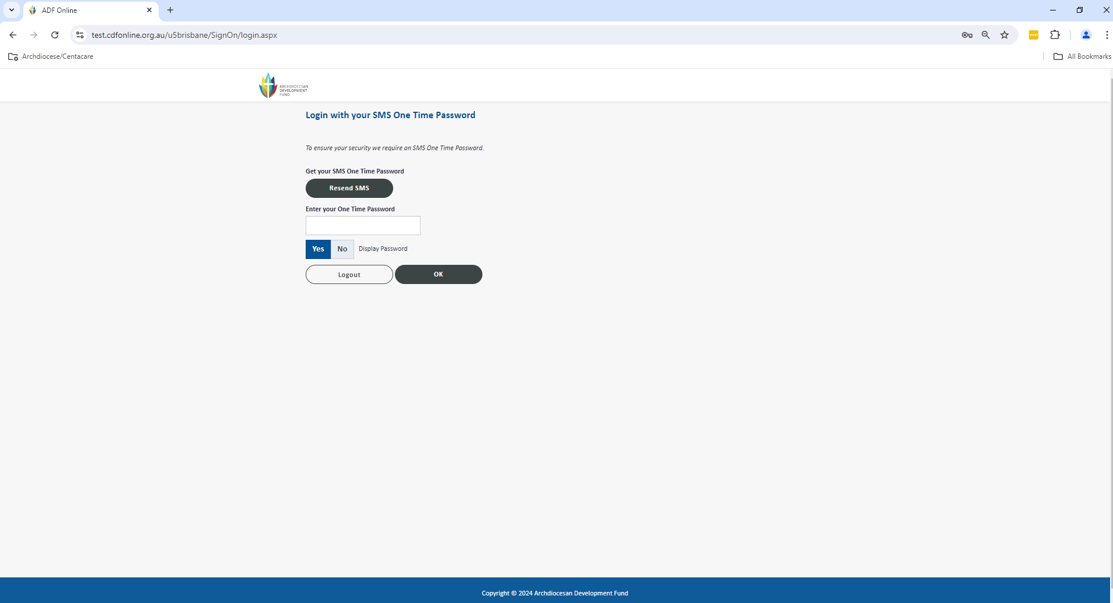

1. You will now see the below screen to create your new password for log in. You need to enter the existing password into the first box, and then the password you would like to create in the second and third boxes. Your password must be between 8 and 12 characters and include a mix of letters and numbers. Once you have entered your preferred password, select Change Password and this will be saved and you will be taken to the CDF Online homepage.

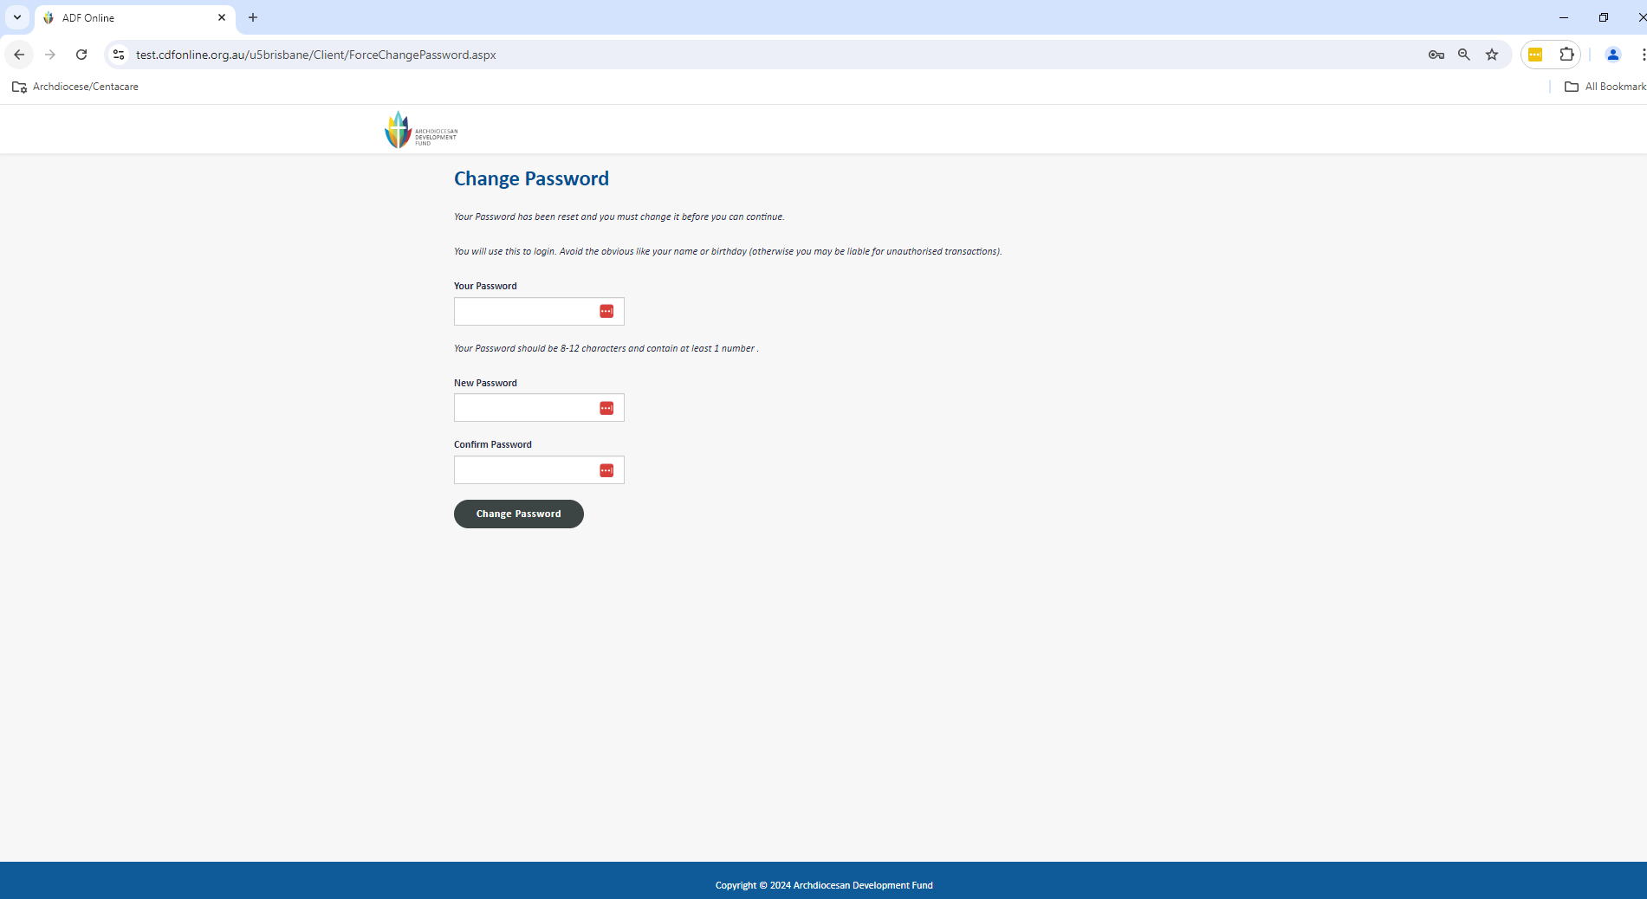

# Your Home Page

Once you sign in, your home page will show you a list of your accounts and the balances for each account.

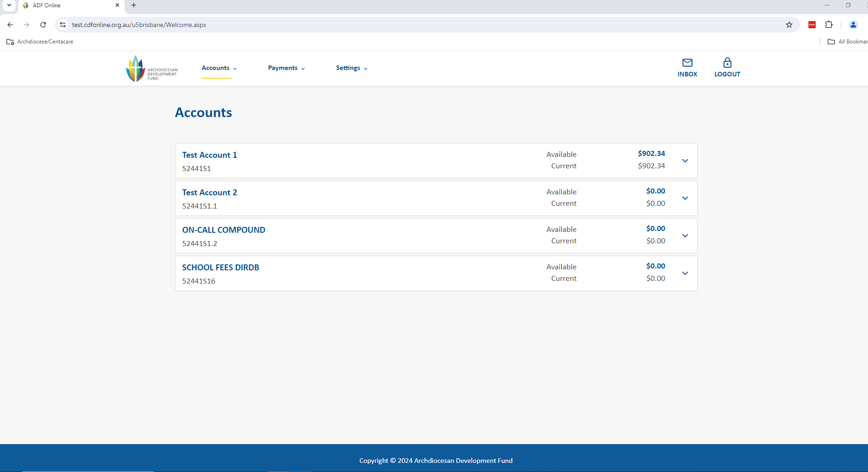

The menu at the top of the screen allows you to navigate to:

*Accounts* – this is where to get transaction details, generate statements as well as find interest details and retrieve BSB information

*Payments* – this is where to go to process transactions as well as manage periodic payments

*Settings* – this is where you can change your password and organize how your accounts appear on your home page

# Viewing Accounts

When on your home page, clicking on any account under Accounts will allow you to view the recent transactions. To view more transactions select View All Transaction and Account Details

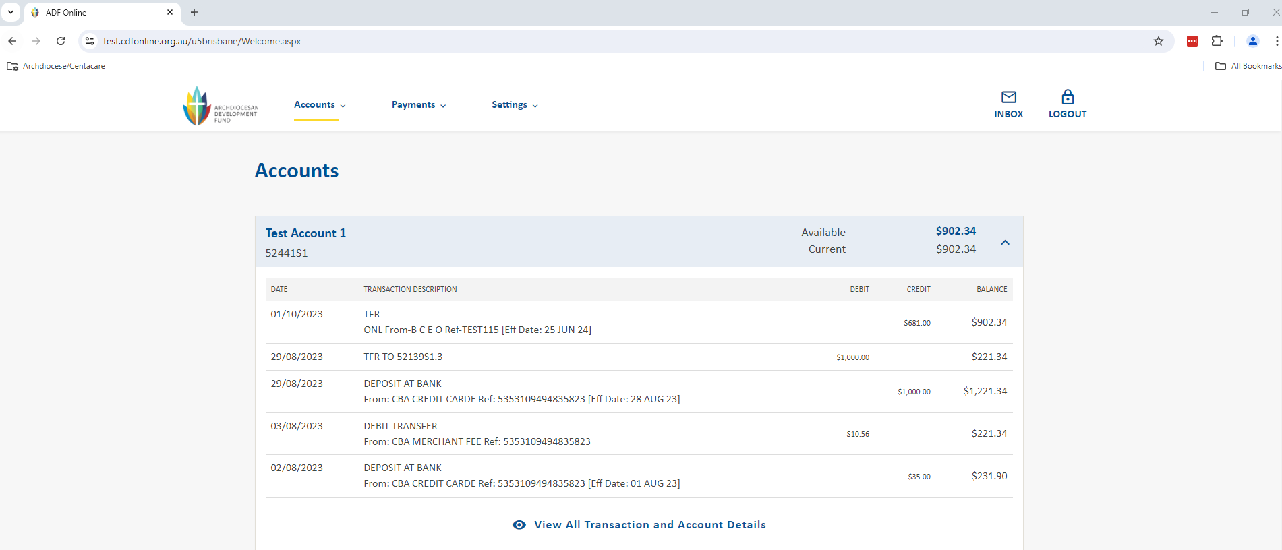

# Searching Transactions

When viewing any account you can click the Quick Search or Advanced Search to locate payments or transactions. Quick Search will allow you to search using a description, transaction type or for a specific amount.

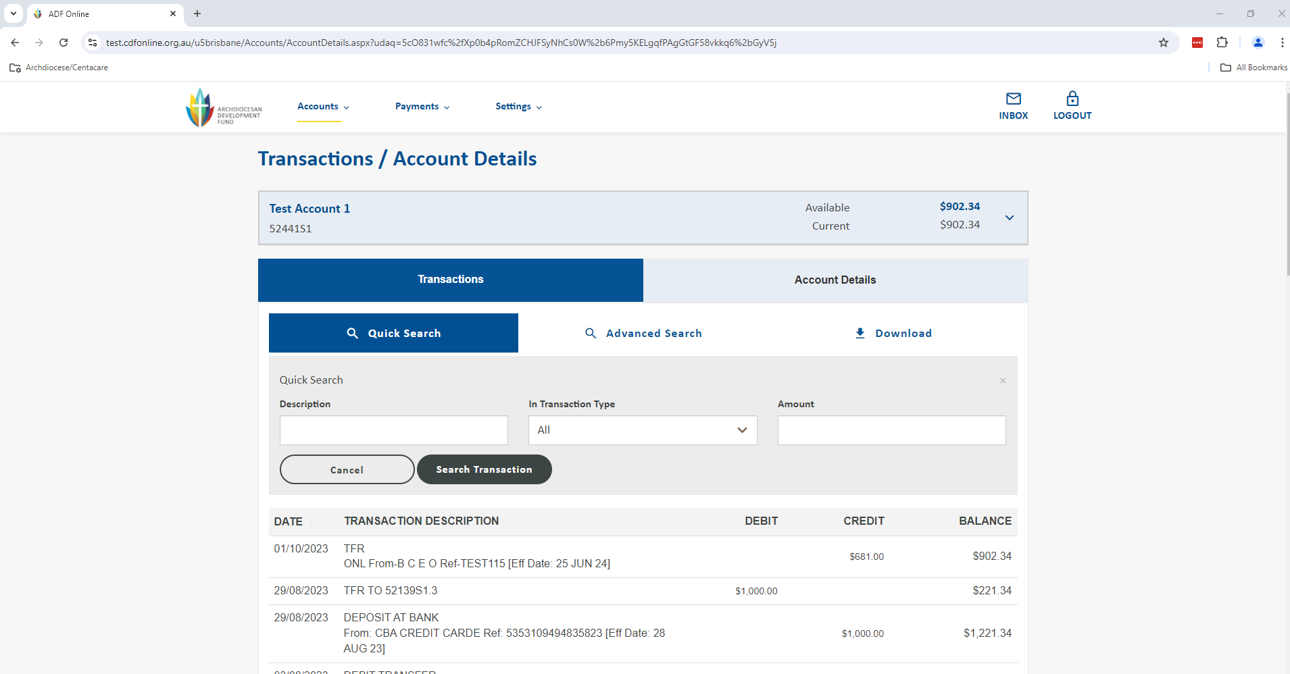

Advanced Search will give you further search options. This is particularly useful for locating deposits or finding an original payment that may have rejected back into your account.

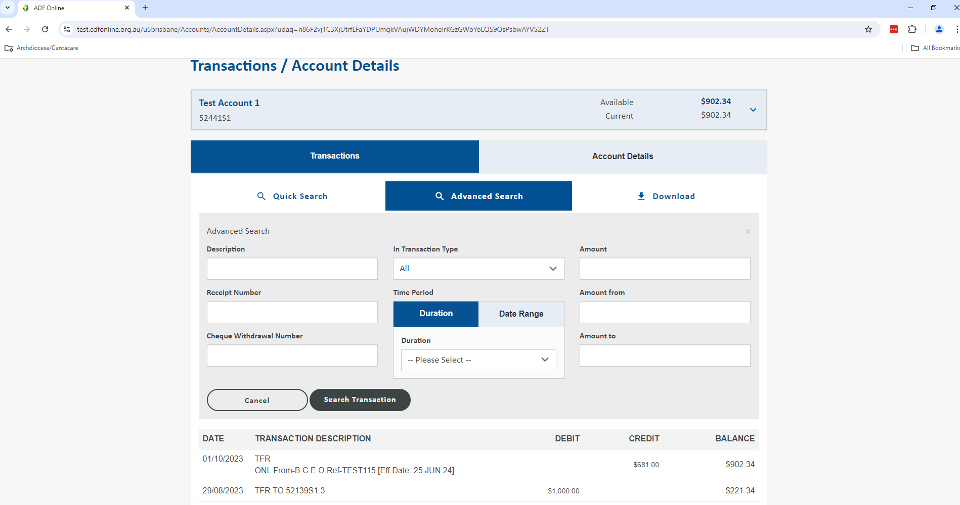

# Downloading Transactions

When viewing any account, you have the opportunity to download transactions in a variety of file types for the purpose of uploading into your accounting package. Select the Download link to be taken to the screen below where you can pick the Document Type and input the date range required. Click the Download button to generate your file. Note that you can only download up until the previous working day. To view transactions for the current day so far you can go to the account’s Transaction History.

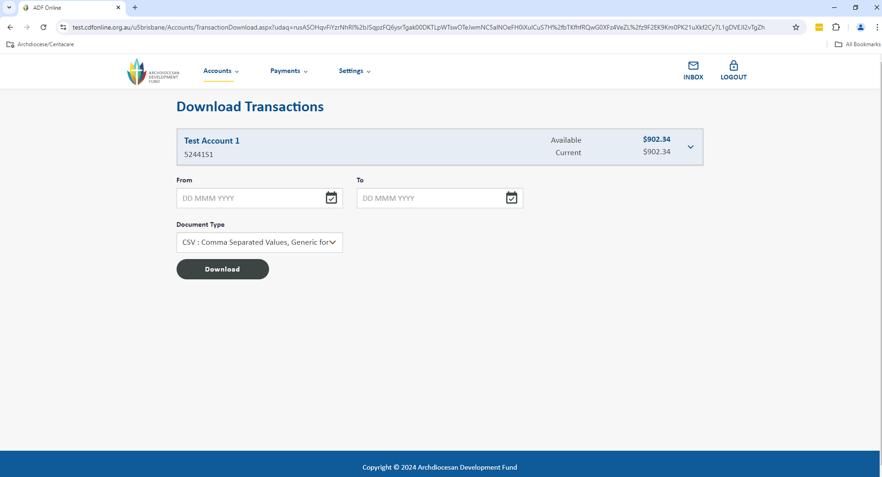

# Generating a Statement

As you are now a registered CDF Online user, you are able to generate and download statements online at any time. Go to the Accounts menu up the top of the screen and select Statement to be taken to the Statement screen below. On this screen you can click inside the Start Date and End Date boxes to bring up a calendar. You can pick any number of accounts or tick the check box For All Accounts. Click the Display button to generate your statement for download.

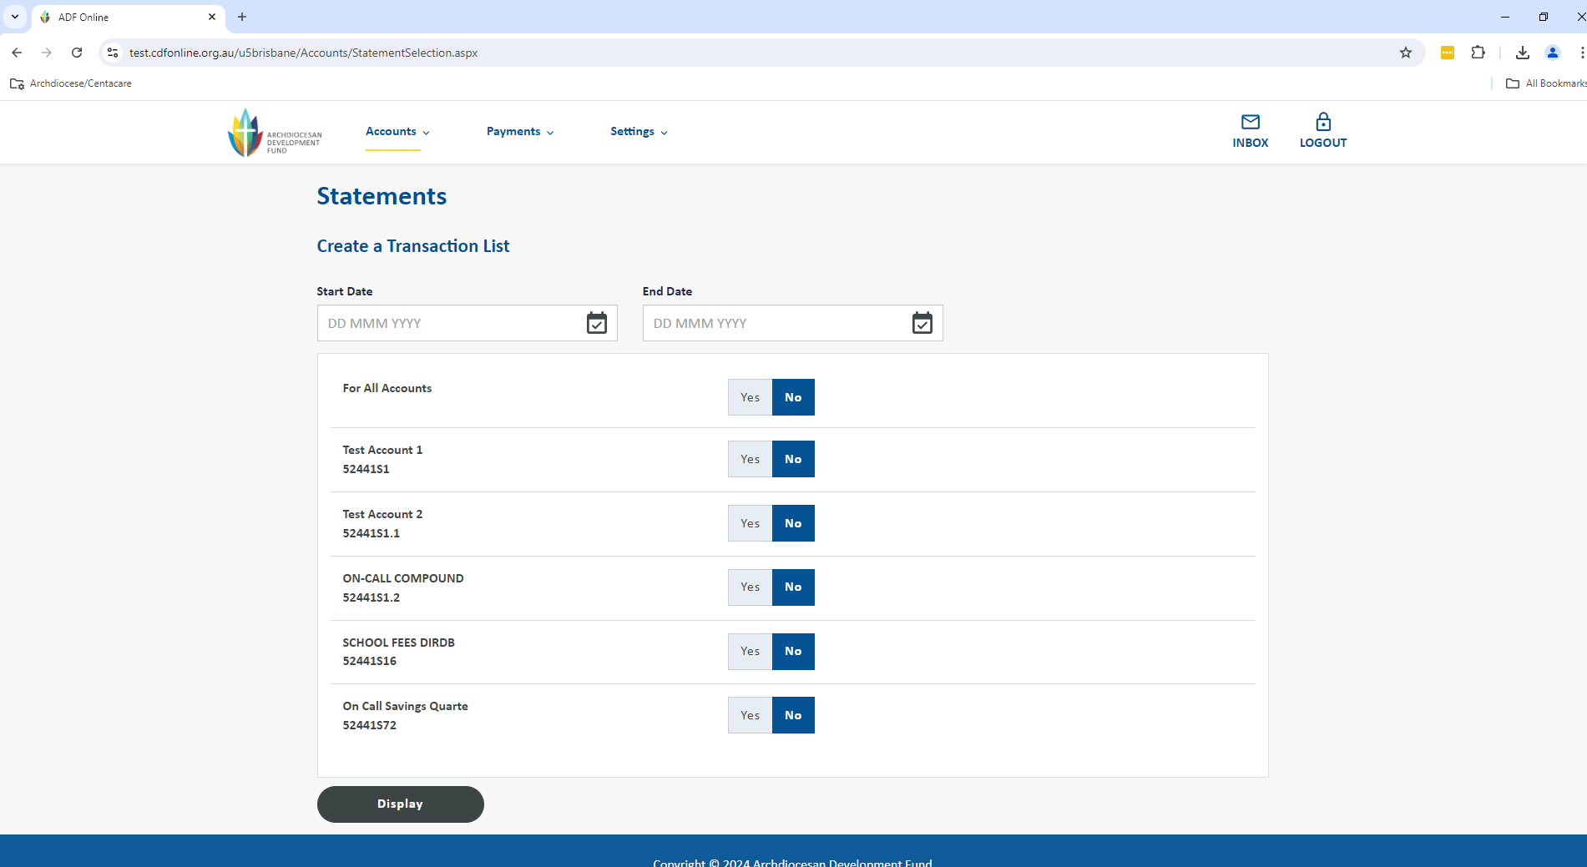

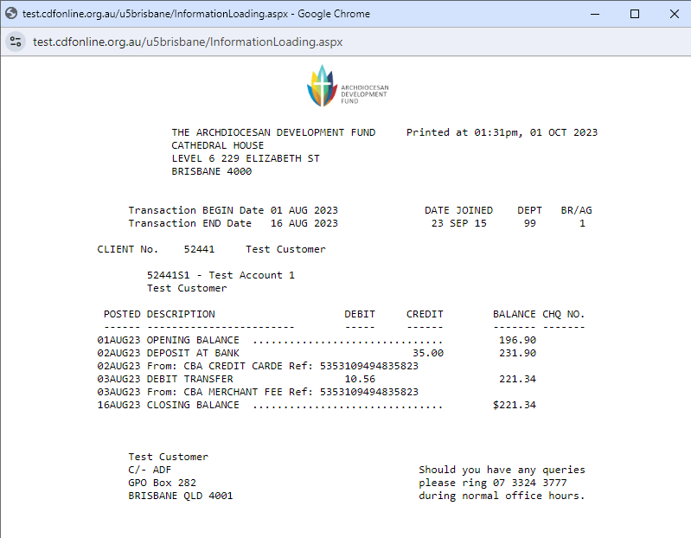

To save this file electronically select the Print button then change the printer to PDF.

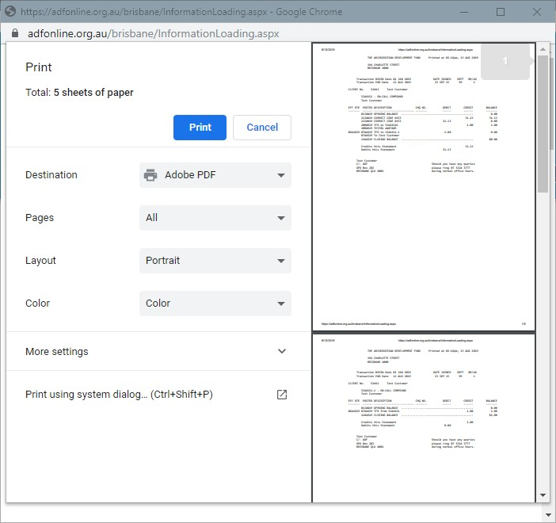

# Viewing Periodical Payments

When on your home page, you can view the upcoming payments in date order for the next 30 days. This is useful to double-check any about to be processed. Click on the Payments heading and then Periodical Payment to take you into the full Periodical Payments listing. You can find any scheduled payment by manually scrolling down the page or you can use CTRL+F to search.

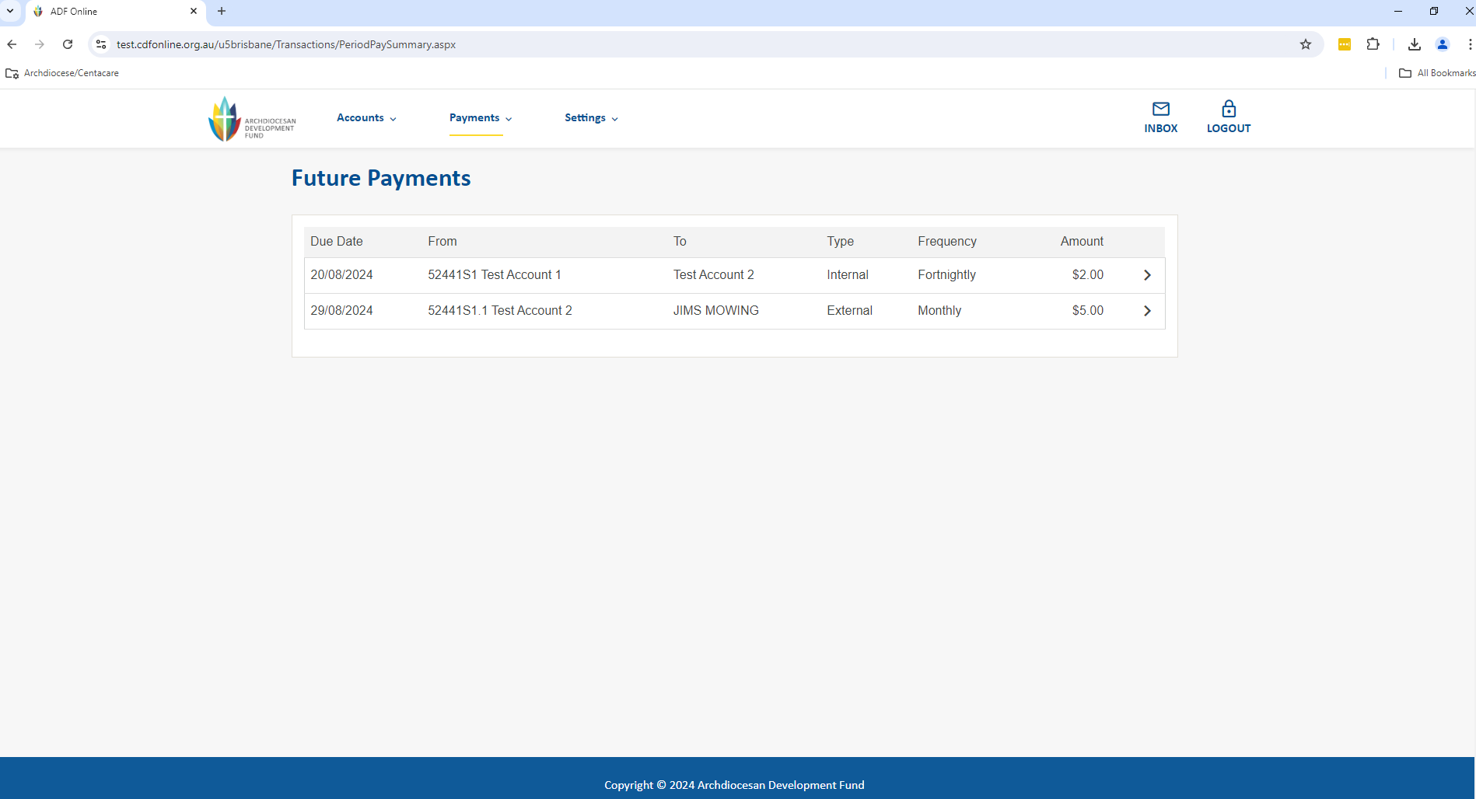

# Updating Your Payee Address Books

We recommend keeping your saved payee account details up to date by ‘cleaning up’ your address books listing. You can do this at any time.

Go to the Payments menu up the top of the screen and select Address Book. Your Address book is in 2 sections:

Payee – The Payee address book will show you all the account records you have saved for payments to other accounts. This will be referenced as External Payees. If you are a school utilising User Managed Direct Debits through CDF Online for your school fee management, you will also see all your fee payers’ details here, these will be referenced as Debit External Payees

Bpay – The Bpay address book will show all the Bpay Billers you have saved.

1. On this screen select Change to be taken to further options.

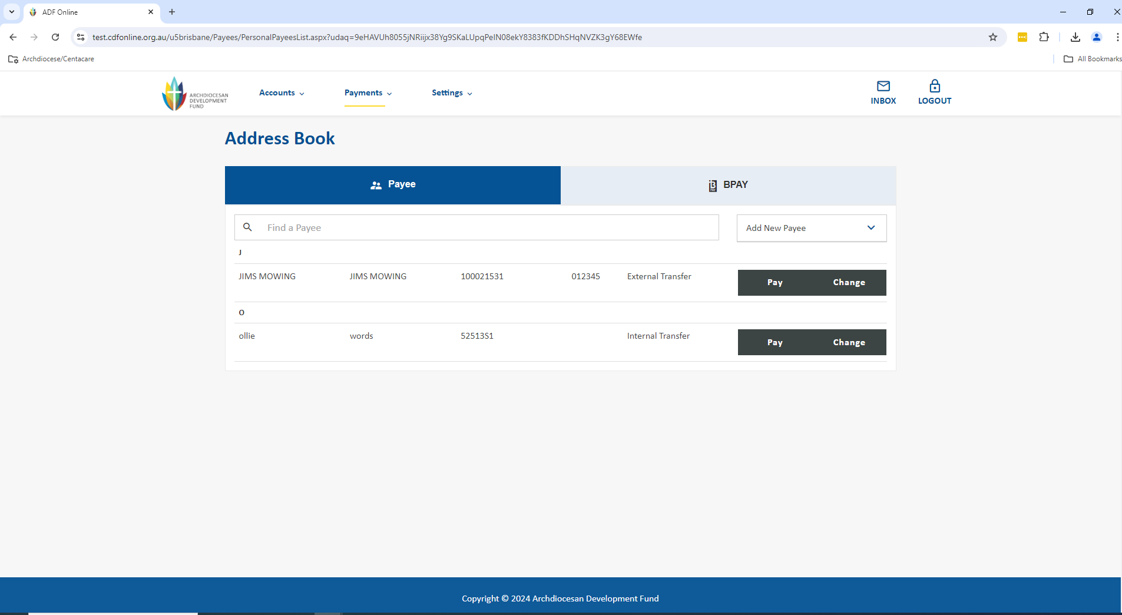

1. After selecting Change you can now either update the Payee details or click Delete to remove them from your address book. You also have the option to Update & Pay if you would like to proceed to payment.

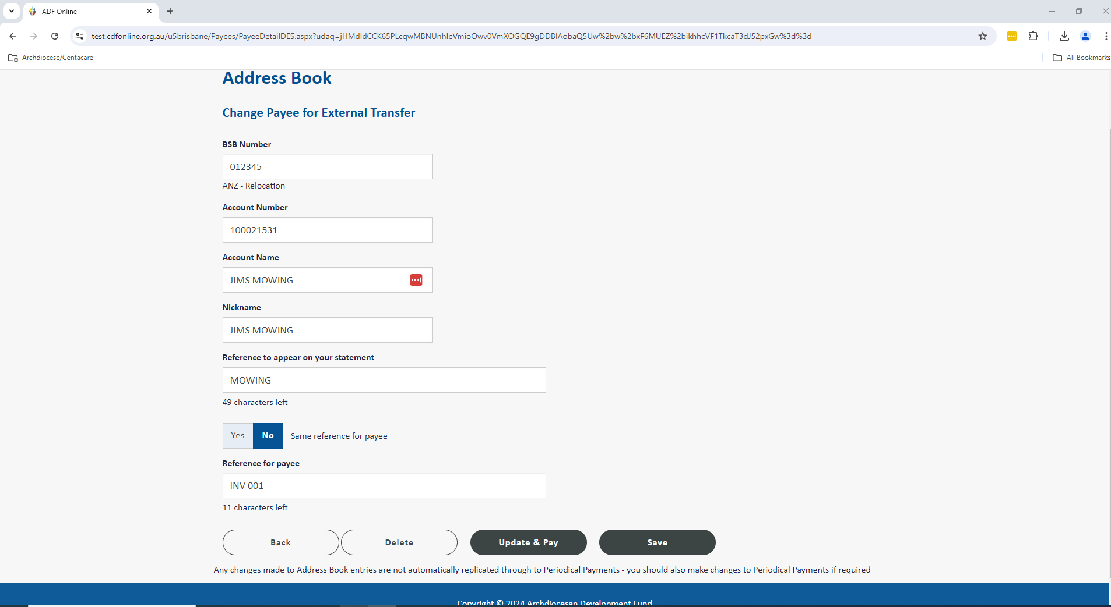

1. Please note that any changes made to Address Book entries are not replicated through to Periodic Payments, you must make those changes in the Periodical Payments section if required.

# Single EFT Payment

We generally recommend processing your EFT payments as a batch unless you have either one payment to process or a payment you wish to set up to process on a particular due date or as recurring. To read about processing as a batch go to the Multiple EFT Payments section in this guide, or to complete a single payment follow the steps below.

You can complete this process if you are a Data User or an Online Authoriser, the only difference is if you are a Data User you will need to have 2 authorisers to log in to authorise the transaction. If you are an Online Authoriser (full account signatory) creating the payment counts as the first authorisation and you will only require one other Authoriser to log in and authorise the transaction.

Go to the Payments menu up the top of the screen and select Transfer Money to be taken to the screen below.

1. Select your account you wish to debit. You then go through and complete the rest of the payment information. Once all the below information is completed, you will need to select the option for Next.
   1. Click in the Transfer From box to select your account (any account with available funds, and an external daily limit nominated)
   2. Under To Account Details you can either click in the box to choose a payee from your address book or select Pay New Account to input their external account details
   3. Enter the Amount you wish to pay
   4. Under When you can either elect to Transfer Now, pay later under Once on or even set it up as Recurring (this will be created as a periodical payment)
   5. Enter an appropriate Reference to appear on your statement
   6. Enter an appropriate reference for the person you are paying under Reference for payee e.g. Invoice # Please note that this field is mandatory.

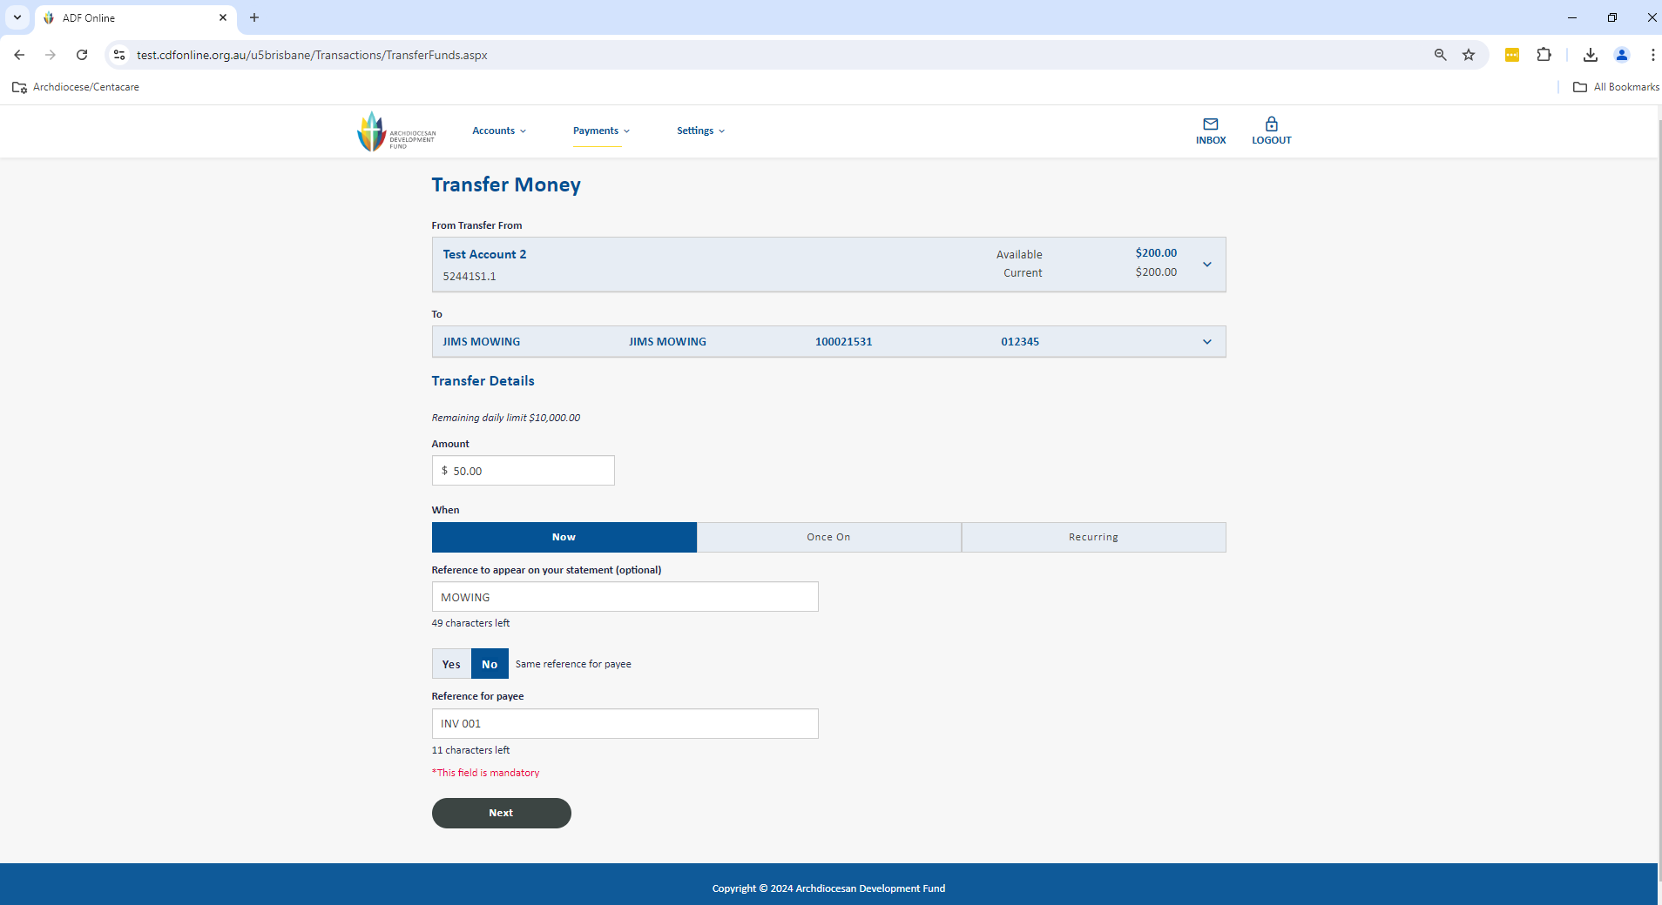

1. You will now be shown the summary screen of the payment for you to validate that all the information is correct.

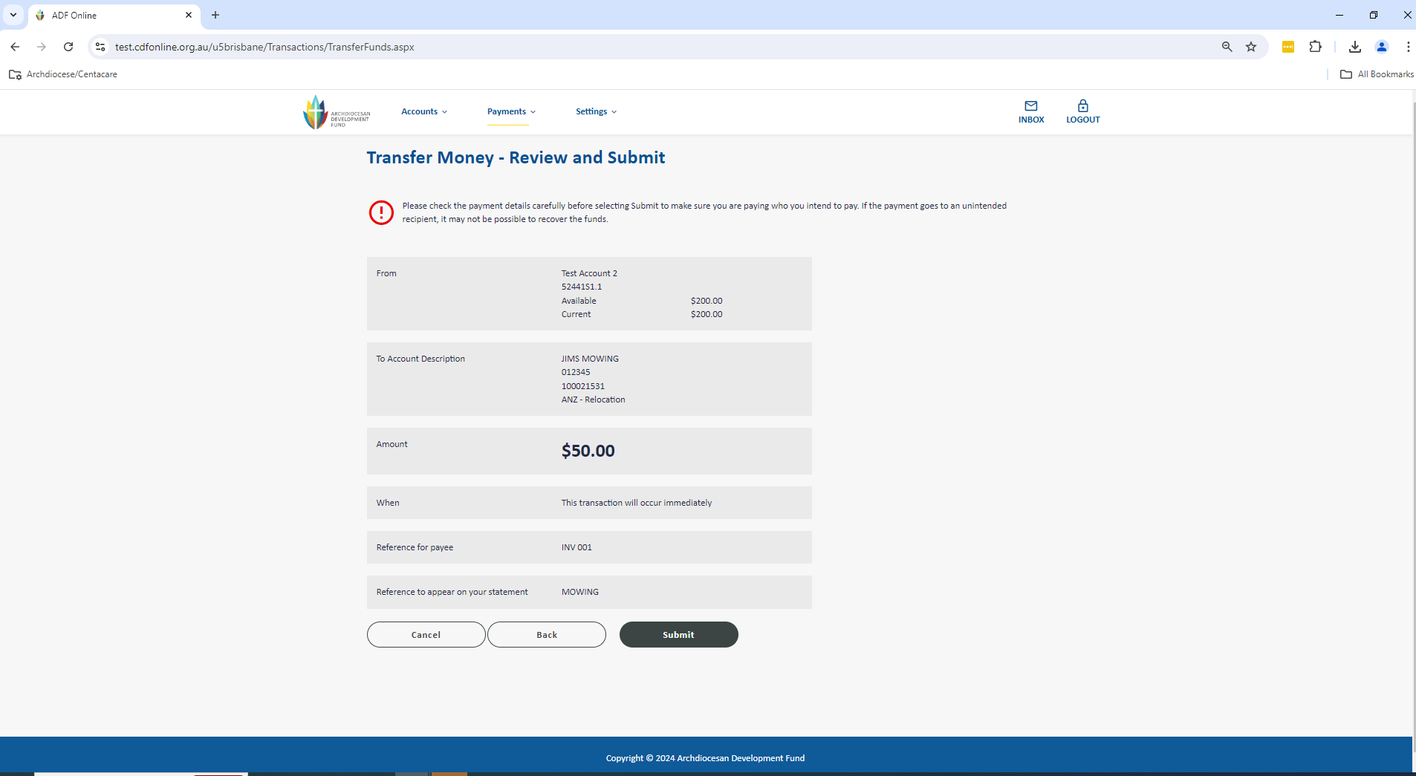

1. If the information is correct, you can select Submit which will store the payment as an authorisation request for a user with appropriate access level to be able to approve.
2. You can view any of your authorisation requests from by clicking on Authorisation Requests: By Me on the home screen (click View All) or by selecting Payments menu on the top of the screen and selecting Authorisation Requests.

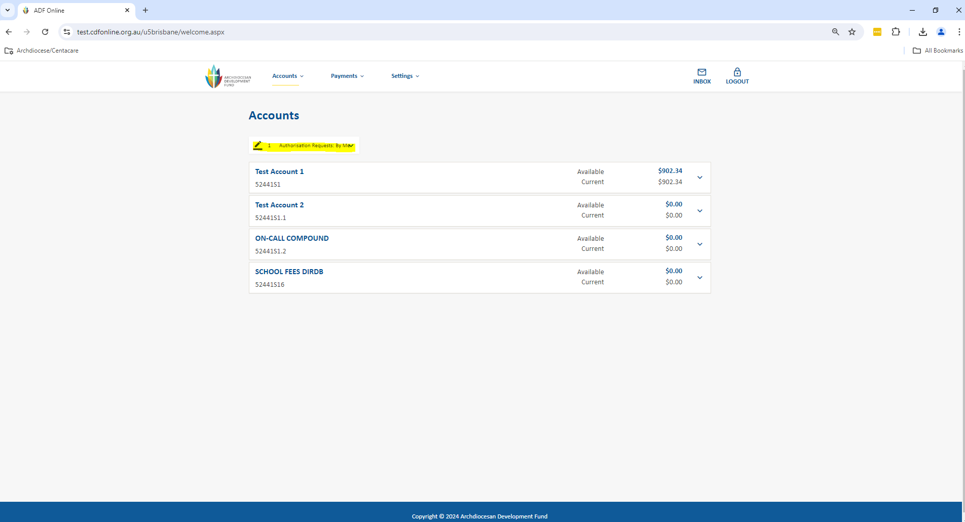

1. If you wish to notify your authorisers via email you can click into the transaction from the Authorisation Requests By Me:

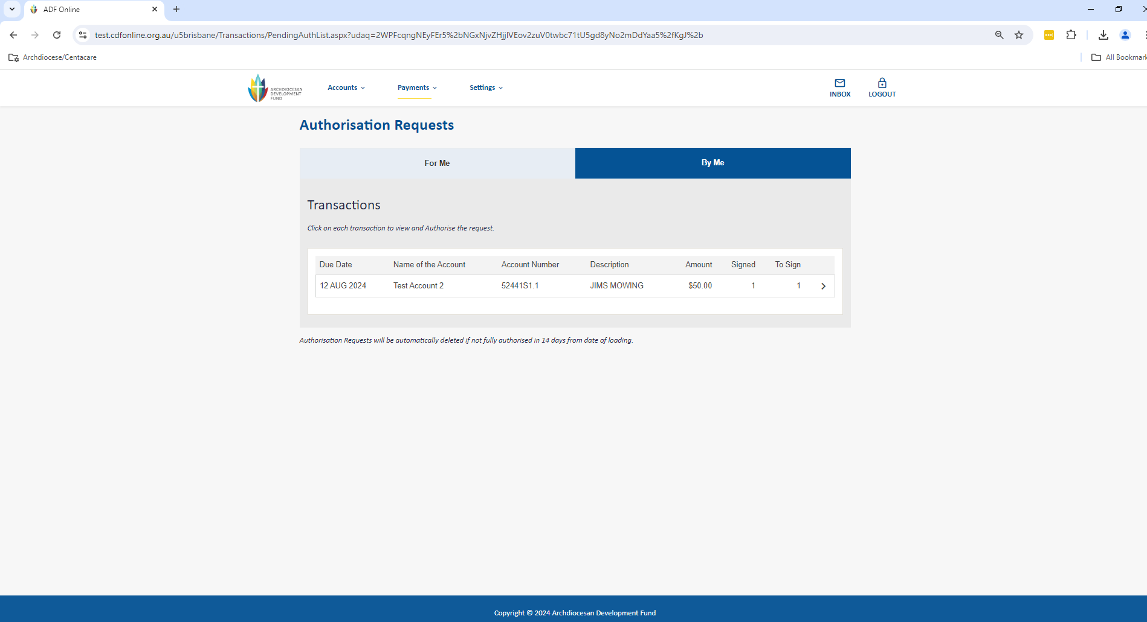

1. Add Yes to Notify Via Email and add a note as required and update the request.

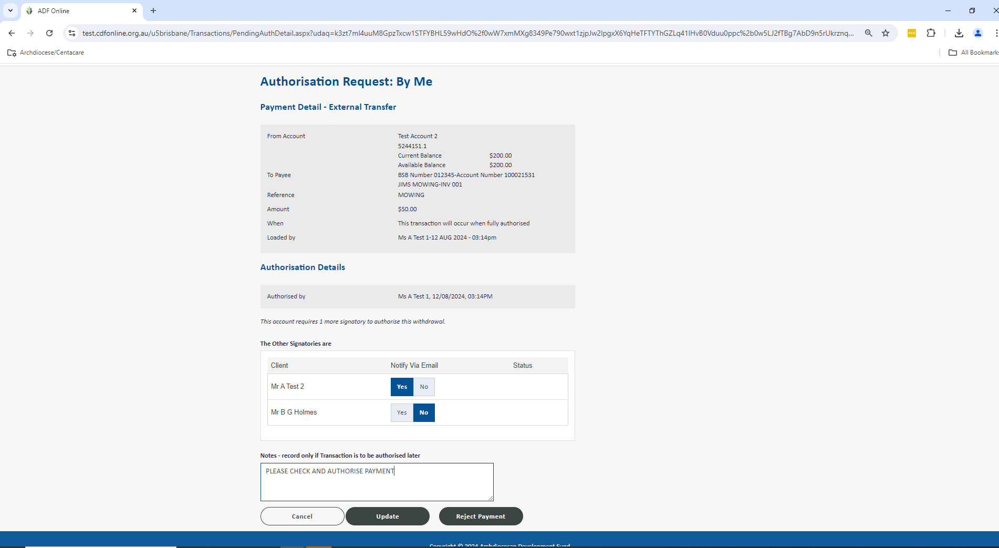

1. Authorisers can now login to CDF Online to view and approve the payment. On the home screen click on Authorisation Requests: For Me and then select View All.

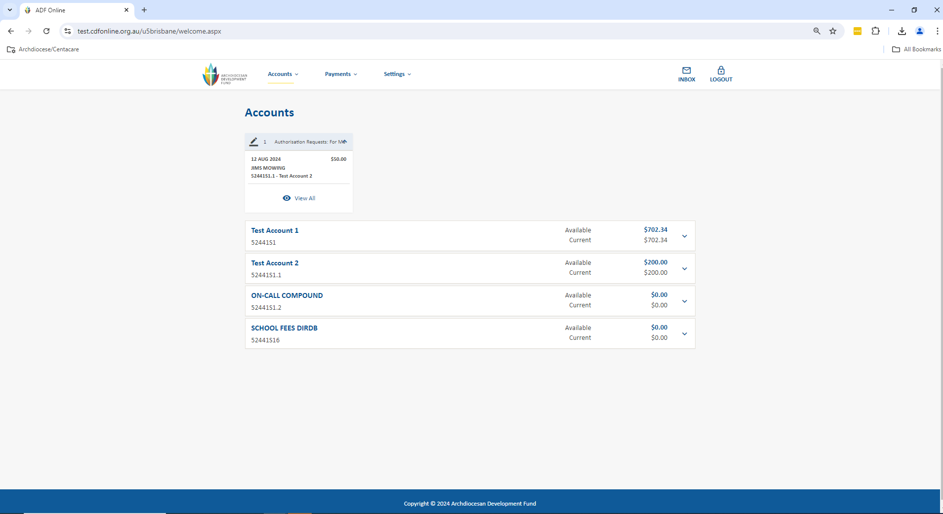

1. This will take you to view all transactions that require authorisation. You can view each one by one to check the details. To approve the payment select Accept Payment. Once fully authorised, the single payment will disappear from under Authorisation Requests and immediately debit from your account. Remember you have up until 2.00PM daily for the payment to be processed same-day, and for your recipient to receive the funds within approximately 1 business day.

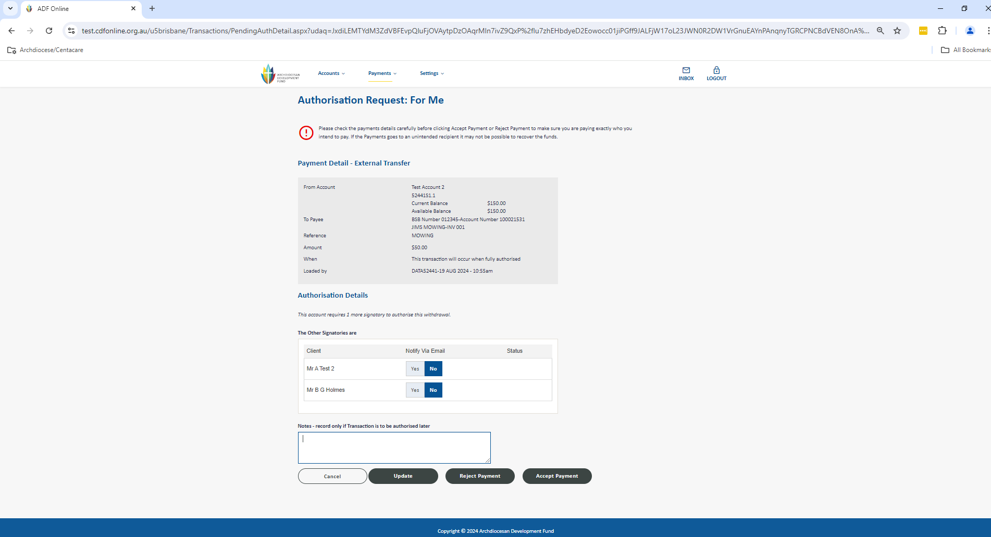

1. You can also approve the payment from the main screen in Authorisation Requests by selecting Yes and Authorise Selected Payments.

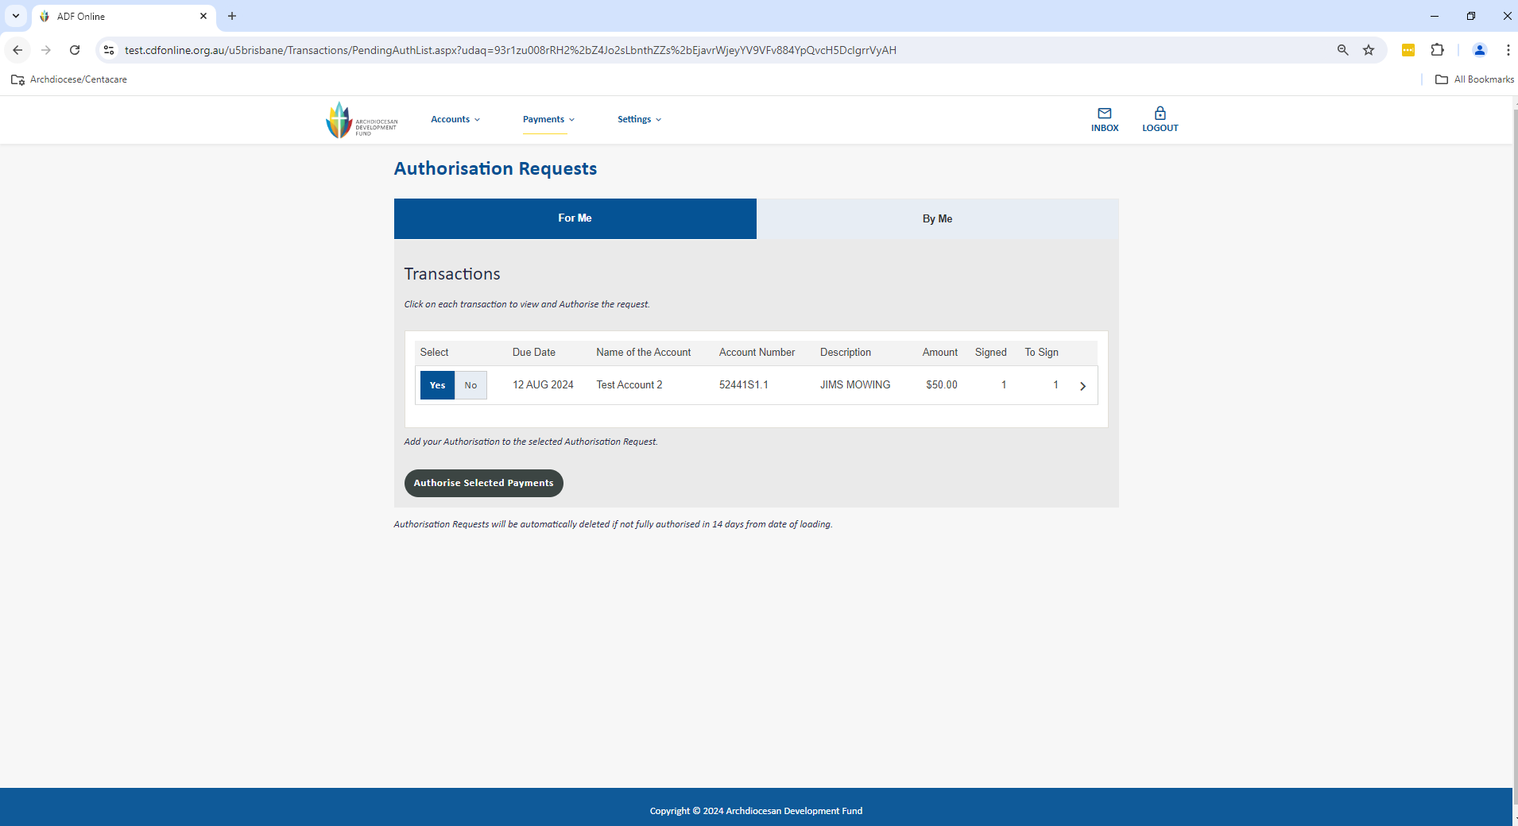

# Single BPAY Payment

We generally recommend processing your BPAY payments as single transactions however if you have an accounting package that can generate Bpay batches, you can use the batch upload functionality detailed in the Multiple BPAY Payments section in this guide. To complete a single payment follow the steps below.

Go to the Payments menu up the top of the screen and select BPAY to be taken to the screen below.

1. Firstly you need to select your account you wish to debit. You can then go through and complete the rest of the payment information. Once all the below information is completed, you will need to select the option for Next.
   1. Click in the Pay From box to select your account (any account with available funds)
   2. Click on the To drop down and either select an existing Biller or select New Biller
   3. Enter the CRN from the invoice in the Reference field
   4. Enter a nickname to save these details in your BPAY Address Book (optional and only applicable if new biller)
   5. Enter the amount of the payment
   6. Under When you can either elect to Transfer Now, pay later under Once on or even set it up as Recurring (this will be created as a periodical payment)

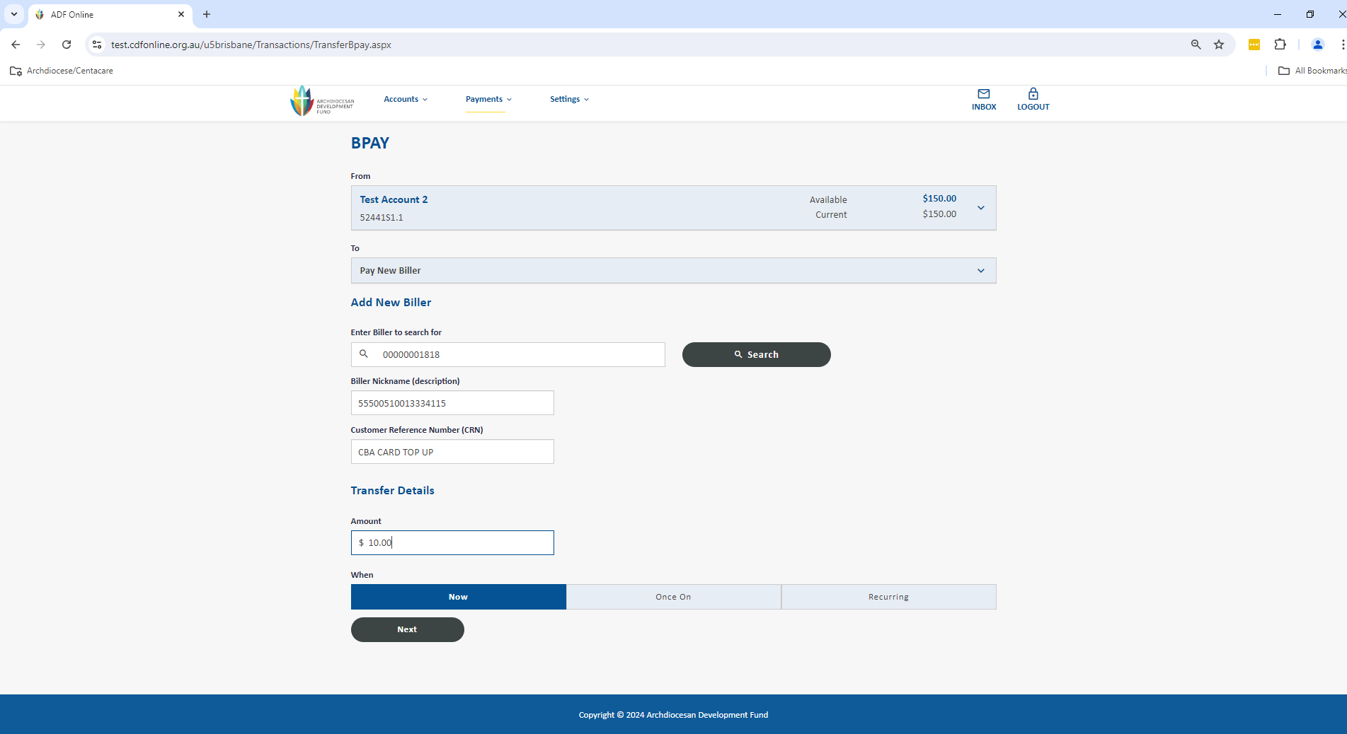

1. You will now be shown the summary screen of the payment for you to validate that all the information is correct. If it is, you have the opportunity to notify any users via email from the system before clicking SUBMIT. This will now store the payment as an Authorisation Request for a user with the appropriate access level to be able to approve.

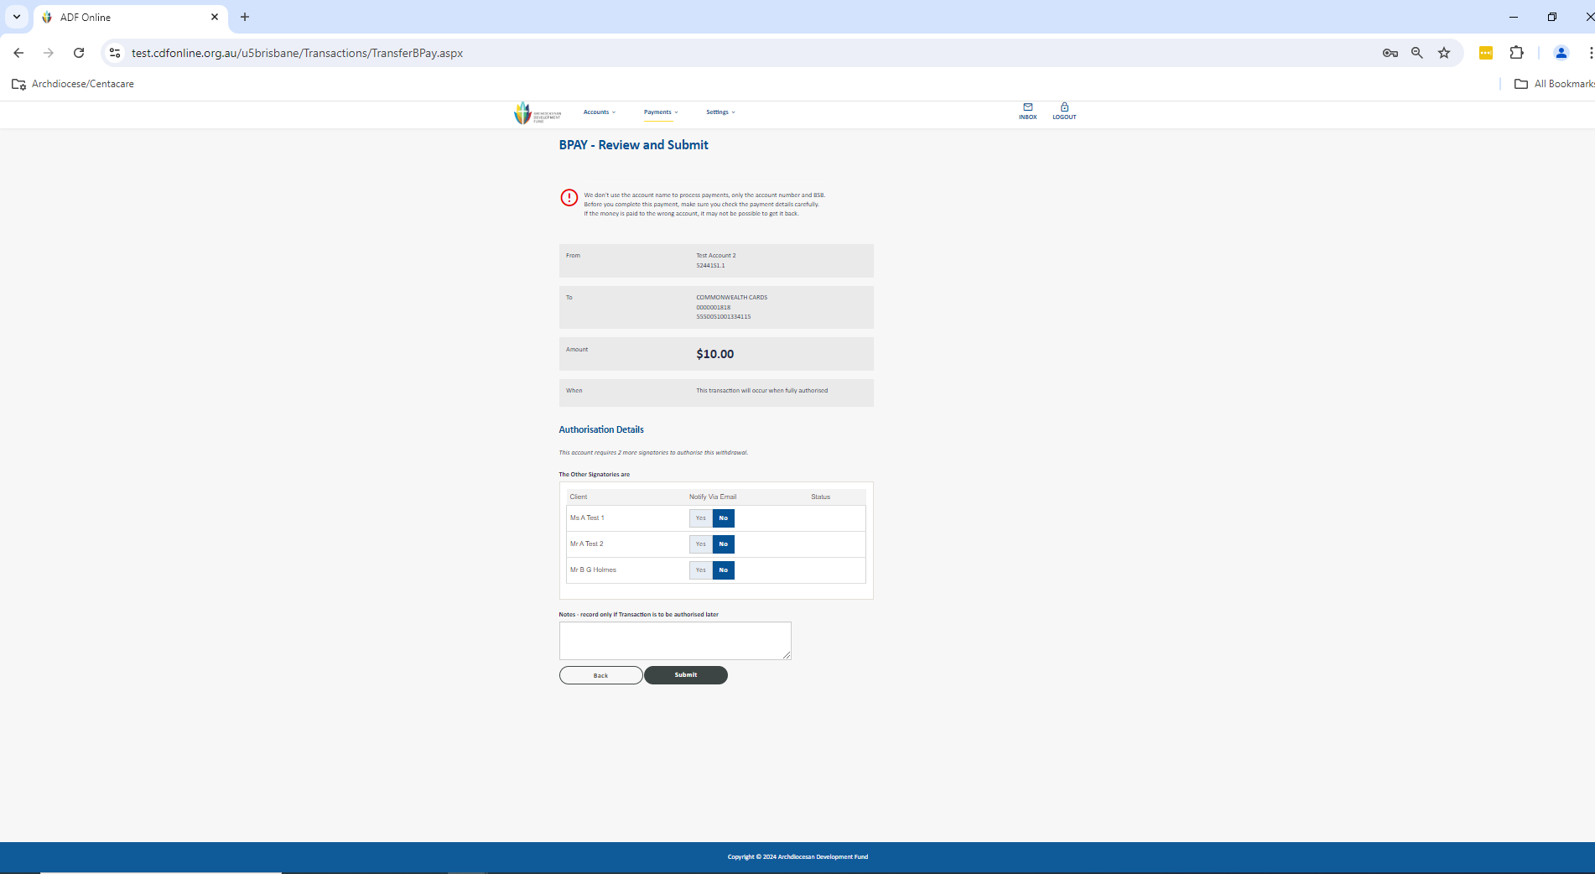

1. After selecting SUBMIT the payment has now been set up and you will see the confirmation screen. Once you click Finish it will take you back to your home page and you can check that this is sitting under Authorisation Requests for your authorisers.

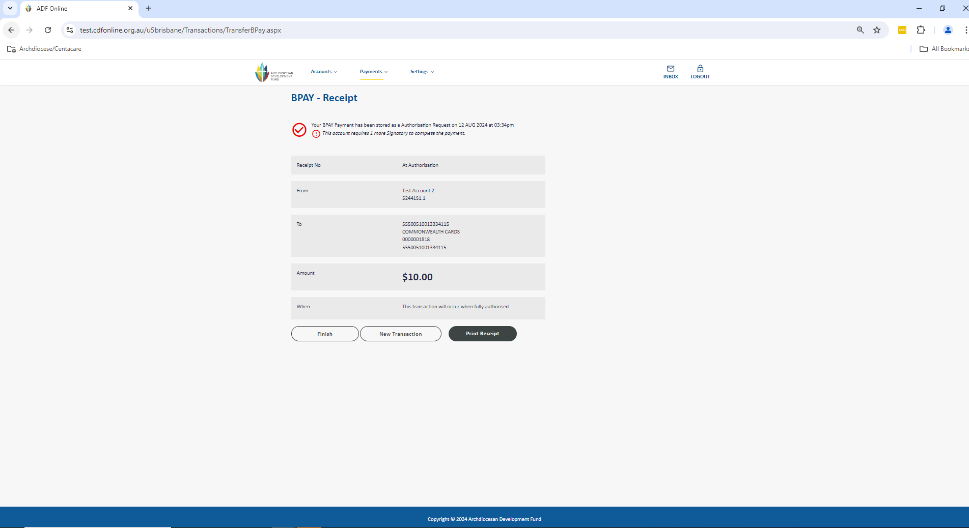

1. Authorisers can now login to CDF Online to view and approve the payment. On the home screen click the drop down menu on Authorisation Requests: For Me and select View All. Alternatively you can click straight into the pending authorisation.

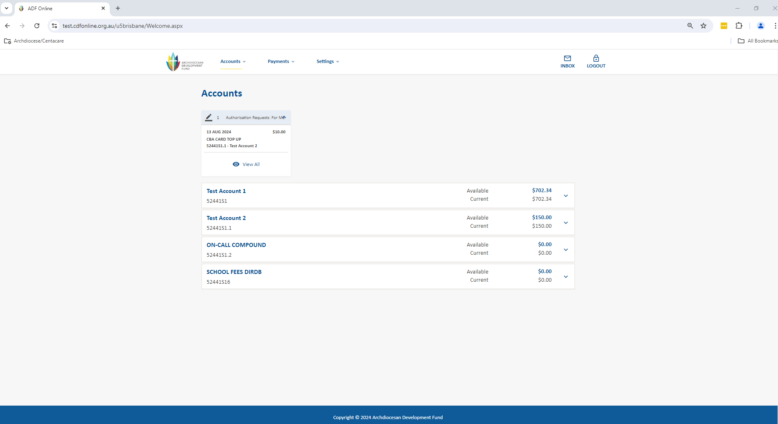

1. After clicking View All, you can see all pending authorisations. You can click into each transaction and select Accept Payment after checking the details. Once fully authorised, the single BPAY payment will disappear from under Authorisation Requests and immediately debit from your account. Remember you have up until 2.00pm daily for the payment to be processed same-day, and for your recipient to receive the funds within approximately 1 business day.

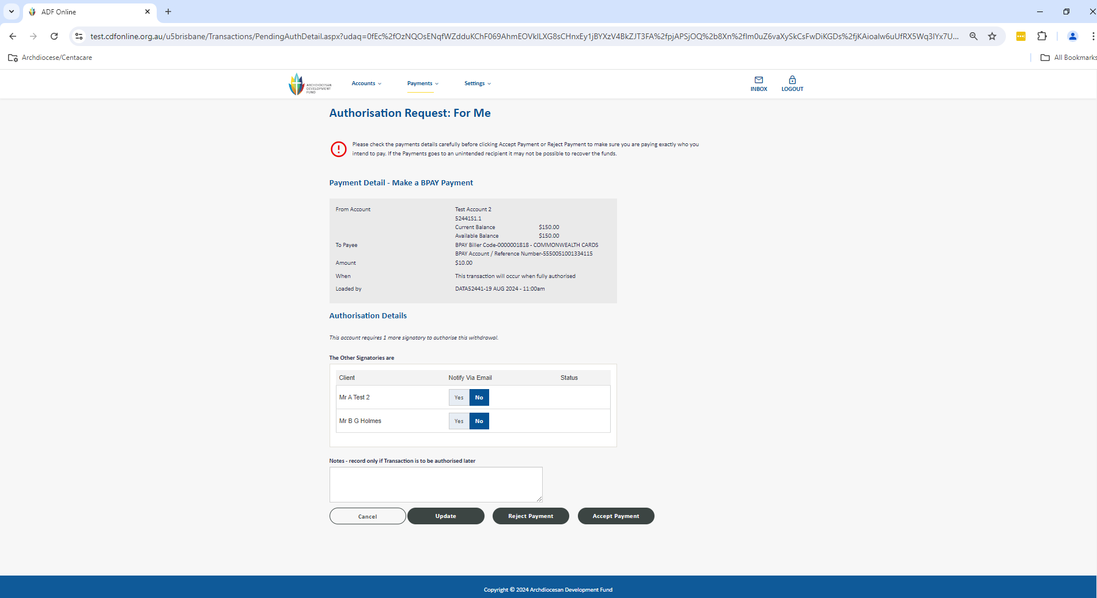

1. You can also approve the payment from the main screen in Authorisation Requests by selecting Yes and Authorise Selected Payments.

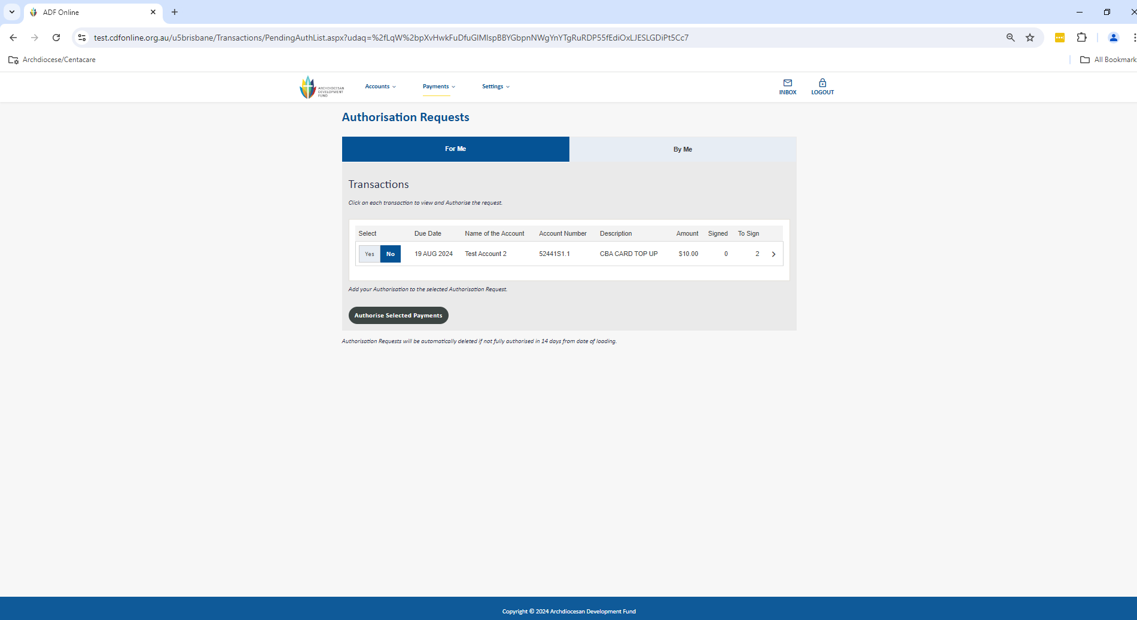

# Single Internal Transfer – Between Your Own Accounts

Go to the Payments menu up the top of the screen and select Transfer Money to be taken to the screen below.

1. Firstly you need to select your account you wish to debit. You can then go through and complete the rest of the payment information. Once all the below information is completed, you will need to select the option for Next.
   1. Click in the Transfer From box to select your account (any account with available funds)
   2. Under To Account Details click in the Select Account box to choose an internal account
   3. Enter the amount of the payment
   4. Under When you can either elect to Transfer Now, pay later under Once On or even set it up as Recurring (this will be created as a periodical payment)
   5. Enter an appropriate Reference to appear on your statement for this account
   6. Enter an appropriate reference for the account you are paying under Reference to Payee

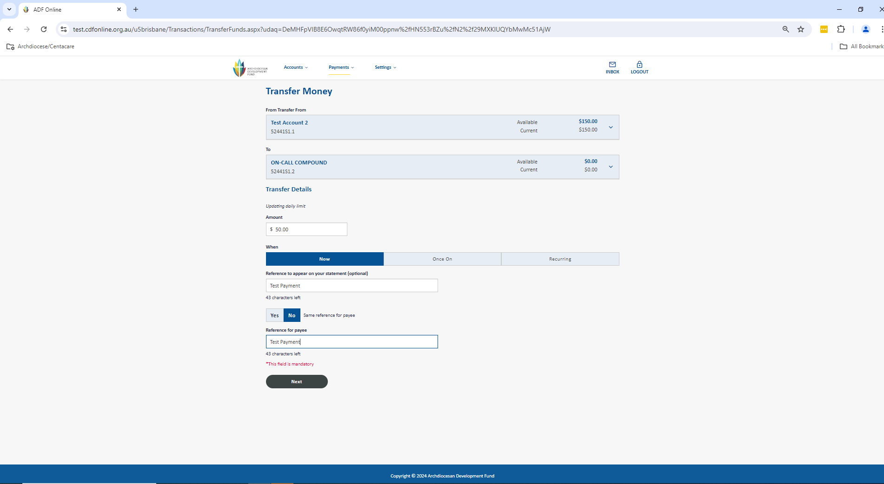

1. Click next and review payment. Click Submit to send the payment through.

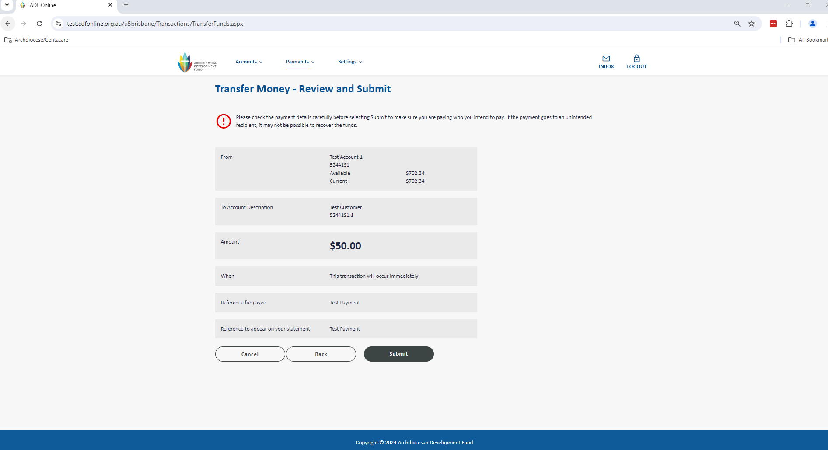

1. You can click Finish, New Transaction or Print Receipt.

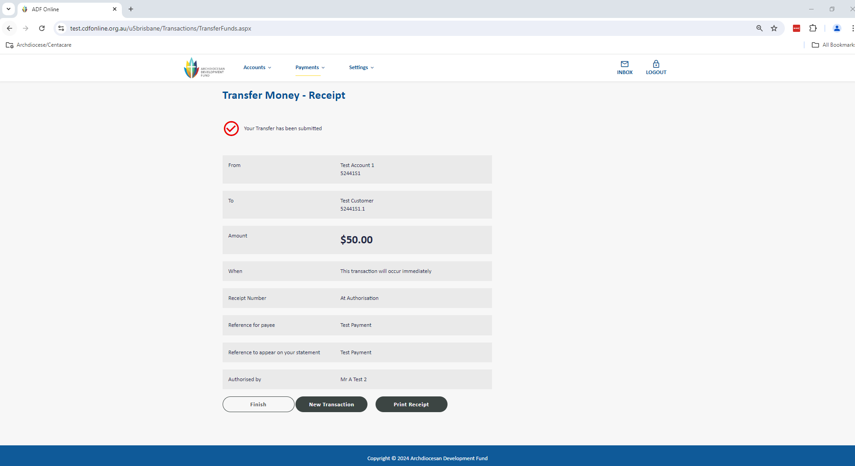

1. Authorisers can now login to CDF Online to view and approve the payment. On the home screen click on the drop down under Authorisation Requests: For Me and select View All.

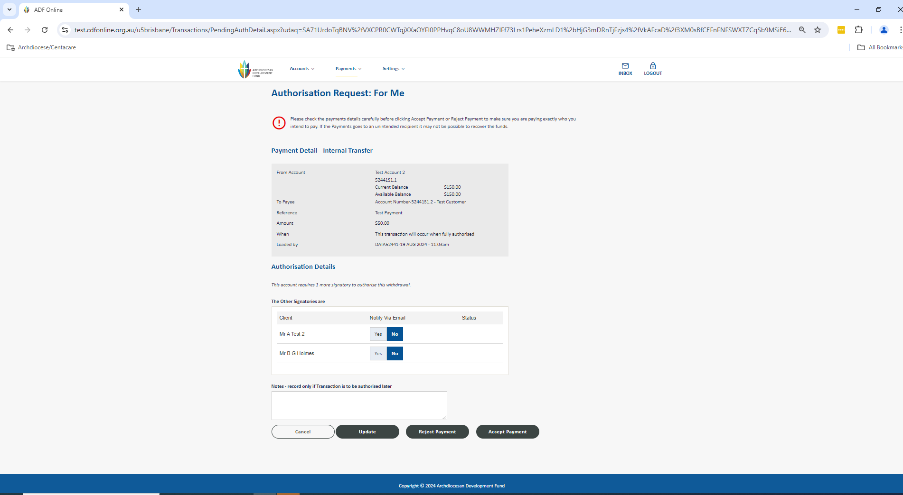

1. This will take you to view pending authorisations.. You can also click into the payment and select Accept Payment after checking the details. Once fully authorised, the Single Internal Transfer will disappear from under Authorisation Requests and apply the transfer between internal accounts.

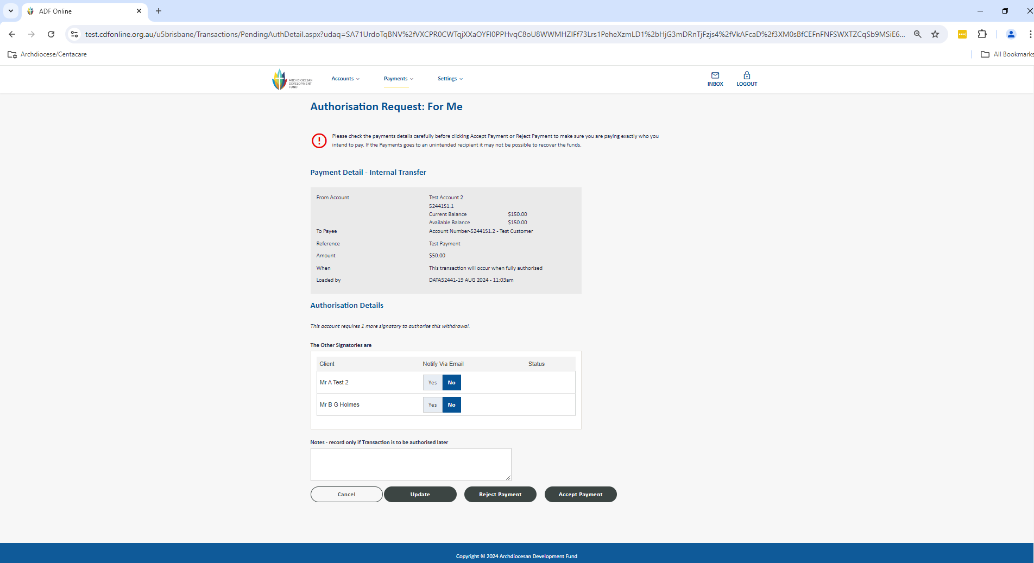

1. You can also approve the payment from the main screen in Authorisation Requests by selecting Yes and Authorise Selected Payments

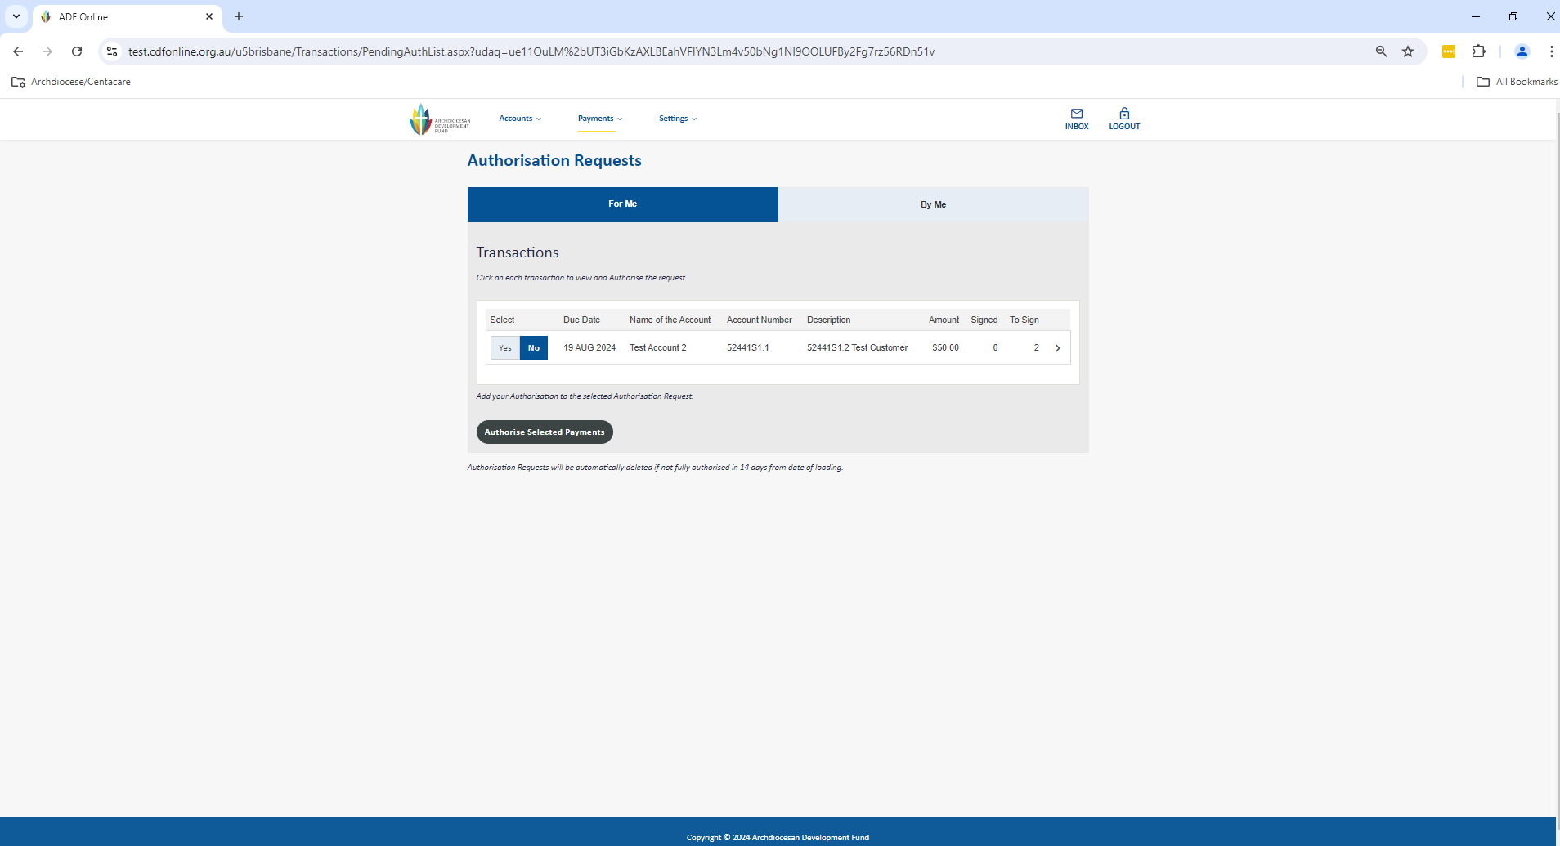

# Single Internal Transfer – To Another CDF Customer

Similar to transferring between your own accounts, there is also a way to make a payment to any other account held at the CDF that only requires their CDF account number i.e. 52441S1.1 and processes instantly once approved. Note internal transfers do not count towards your daily limit.

Go to the Payments menu up the top of the screen and select Transfer Money to be taken to the screen below.

1. Firstly you need to select your account you wish to debit. You can then go through and complete the rest of the payment information. Once all the below information is completed, you will need to select the option for Next.
   1. Click in the Transfer From box to select your account (any account with available funds)
   2. Under the To box select New Payee
   3. Select Yes on Transfer to CDF Account, this will automatically populate the BSB
   4. Enter the CDF account number and account name
   5. Add a Nickname to save for future use (optional)
   6. Enter the amount to transfer
   7. Under When you can either elect to Transfer Now, pay later under Once On or even set it up as Recurring (this will be created as a periodical payment)
   8. Enter an appropriate Reference to appear on your statement for this account
   9. Enter an appropriate reference for the account you are paying under Reference to Payee

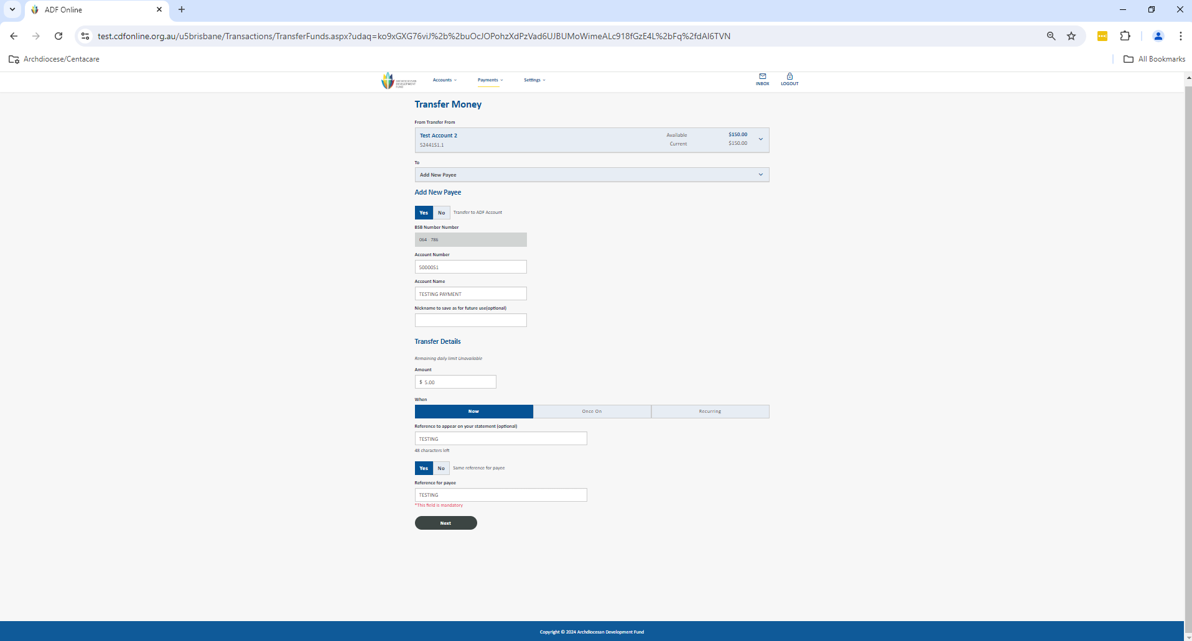

1. You will now be shown the summary screen of the payment for you to validate that all the information is correct. If it is, click Submit. This will now store the payment as an Authorisation Request for a user with the appropriate access level to be able to approve.

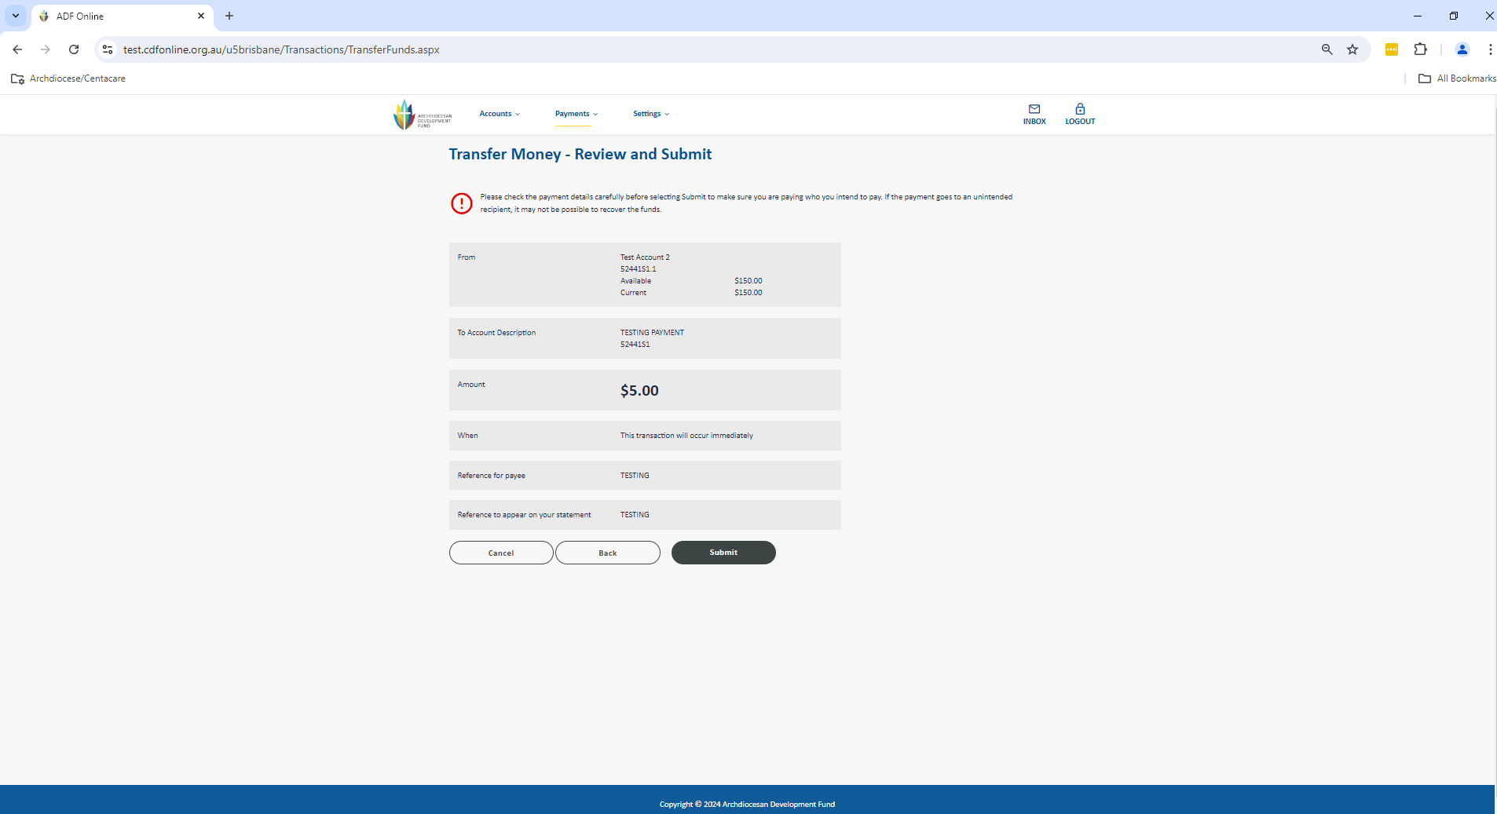

1. You can click Finish, New Transaction or Print Receipt.

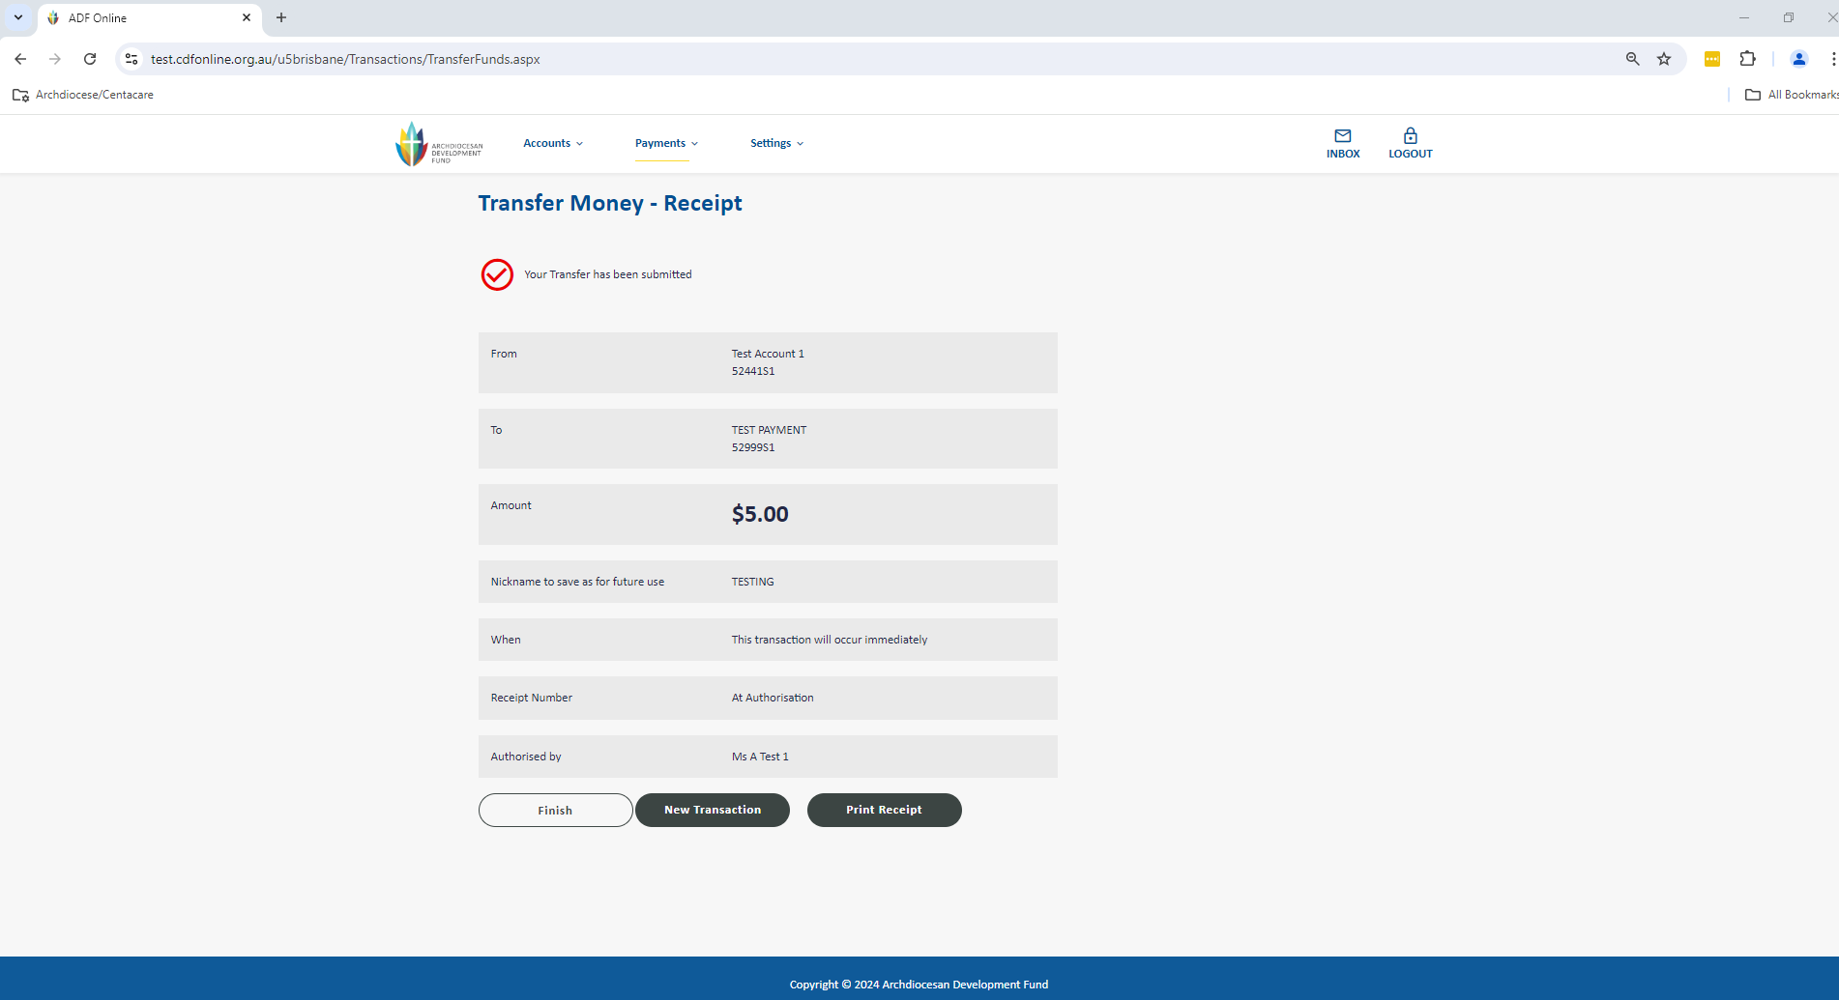

1. Authorisers can now login to CDF Online to view and approve the payment. On the home screen click on the drop down under Authorisation Requests: For Me and select View All.

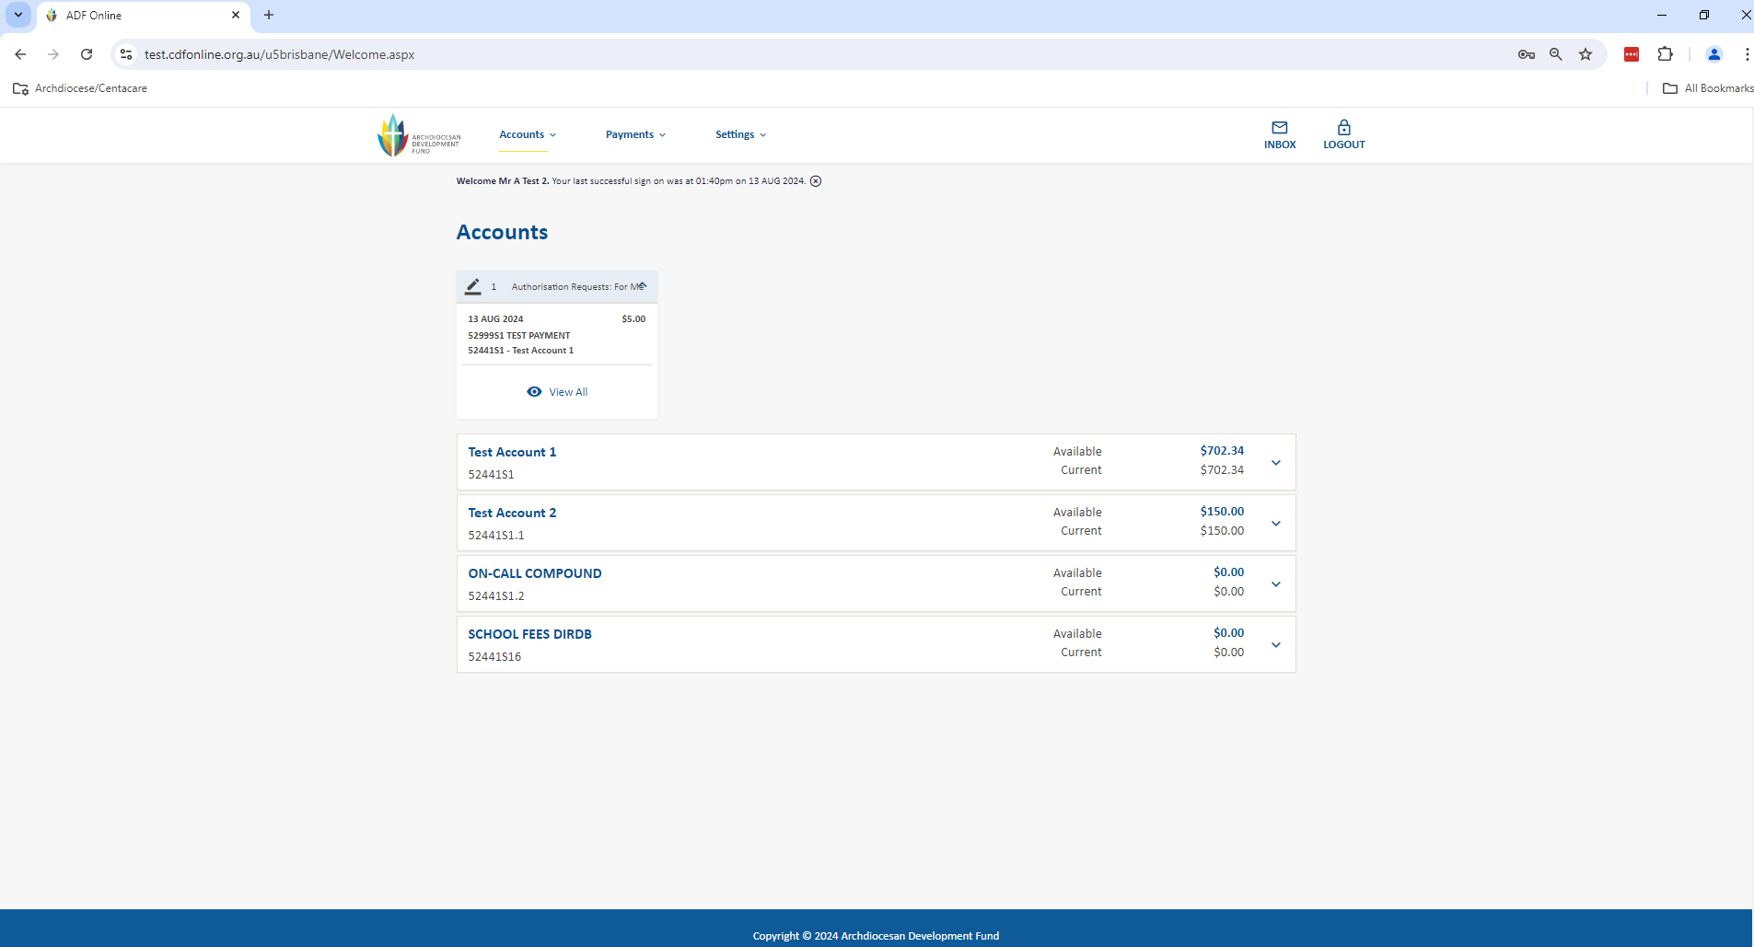

1. This will take you to view pending authorisations. You can also click into the payment and select Accept Payment after checking the details. Once fully authorised, the Single Internal Transfer to another CDF account will disappear from under Authorisation Requests and immediately debit from your account

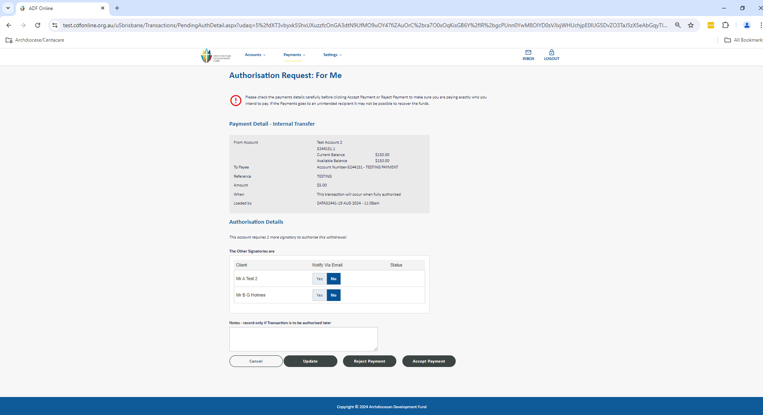

1. You can also approve the payment from the main screen in Authorisation Requests by selecting Yes and Authorise Selected Payments

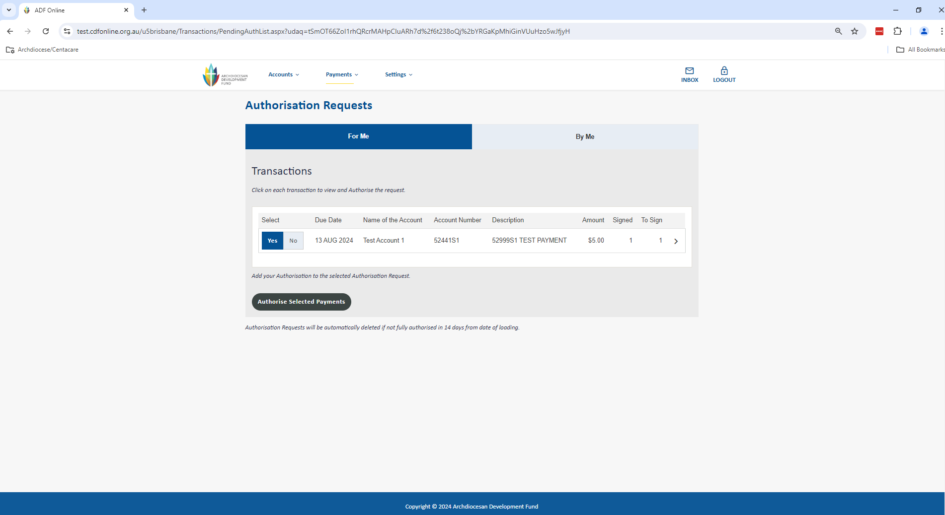

# Multiple EFT Payments

The Multiple Transfers section allows you to build a batch of payments. The benefits of this method are that you can efficiently process one or more payments together, this also means your authorisers are able to check and approve from one screen. Most importantly, you have more control; you can change the batch of payments at any time up until it is processed.

Go to the Payments menu up the top of the screen and select Multiple Transfers to be taken to the screen below.

1. Firstly you need to select your type of transfer. Under Add or Upload a Batch select External Transfer. You can then complete the Batch details. Once all the Batch information is completed, you will need to click Save to go to the next step to commence adding payees.
   1. Enter an appropriate description for your batch of payments e.g. EFTs and the date
   2. Click in the From Account box to select your account (any account with sufficient funds available and an external daily limit nominated). Note: if you have a sweep active on the account this will allow you to proceed with the payment without sufficient funds and will cover the overdrawn balance at the end of the day.
   3. Tick the Post as Total box to have the payment posted as a total on your statement or leave un-ticked if you prefer to itemise the individual payments on your statement
   4. Enter the reference for your batch (usually same as the description) – this is what you will see on your statement if you post as a total only

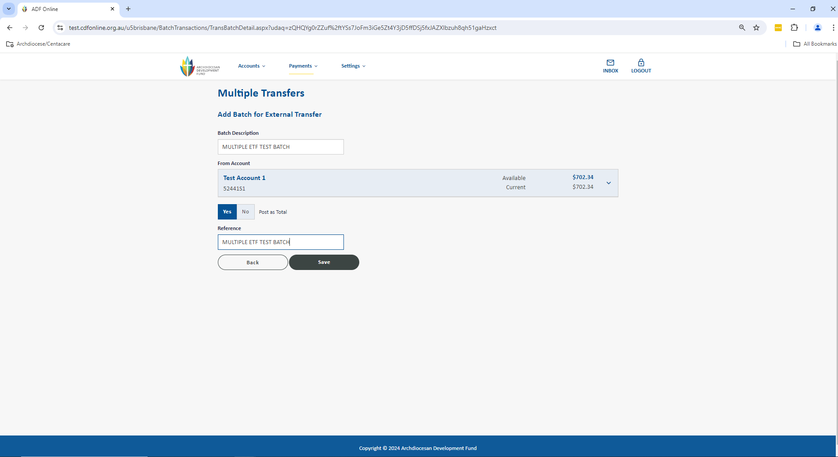

1. You will now see the screen below where you are able to add/change/delete your payees. Once all your payee information is completed, you will need to select Save to go to the next step to process your batch.
   1. Under Add a New or existing Payee you can either click in the box to choose a payee from your address book or select Add Payee To Batch to input their external account details
   2. Review or enter your payee account details
   3. Enter the amount of the payment
   4. Select Save to return to the batch
   5. Repeat the above steps until all payees are added

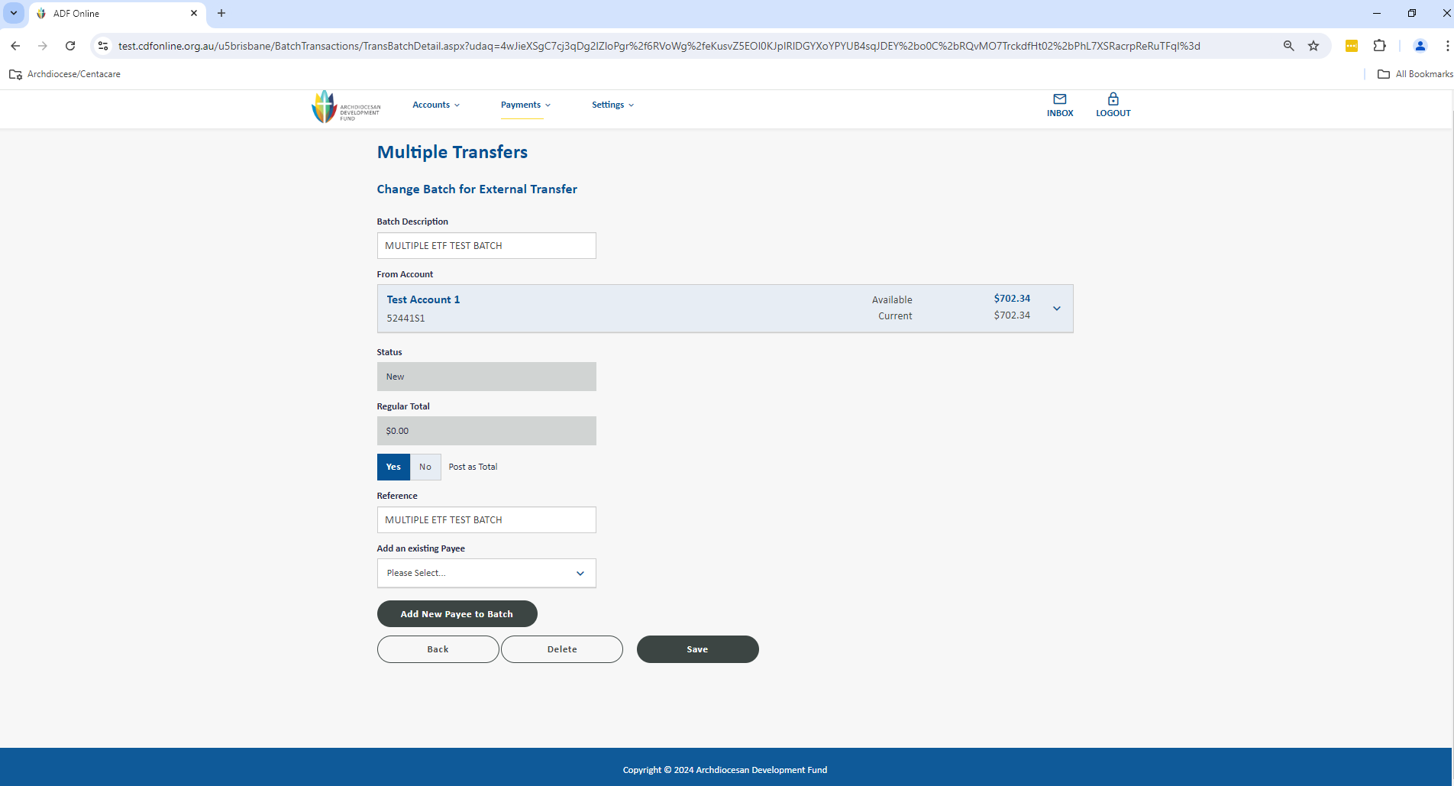 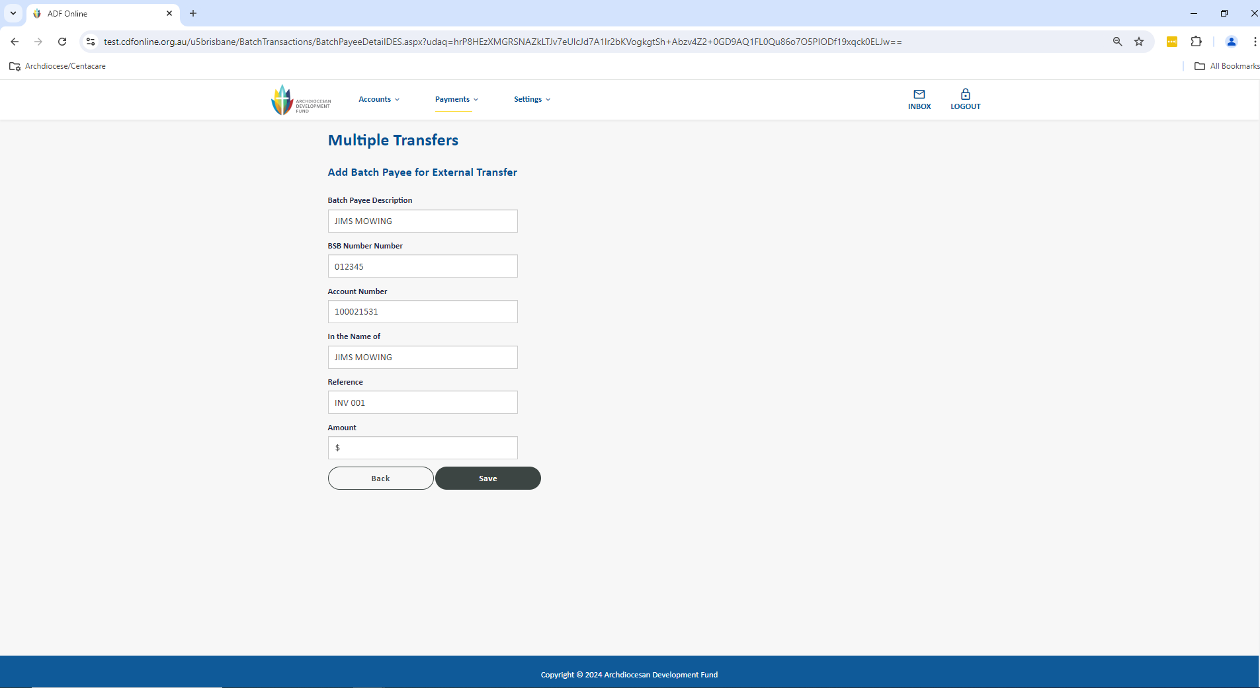

1. You are now taken back to your Multiple Transfers section that shows an overall view of all of your current or previous batches and most importantly their Status and History. From this screen you are able to change/delete/copy any of your batches as well as schedule the batch for payment. Click on Schedule to be taken to review the summary of payment details and date for the batch to process. Select Submit to proceed.

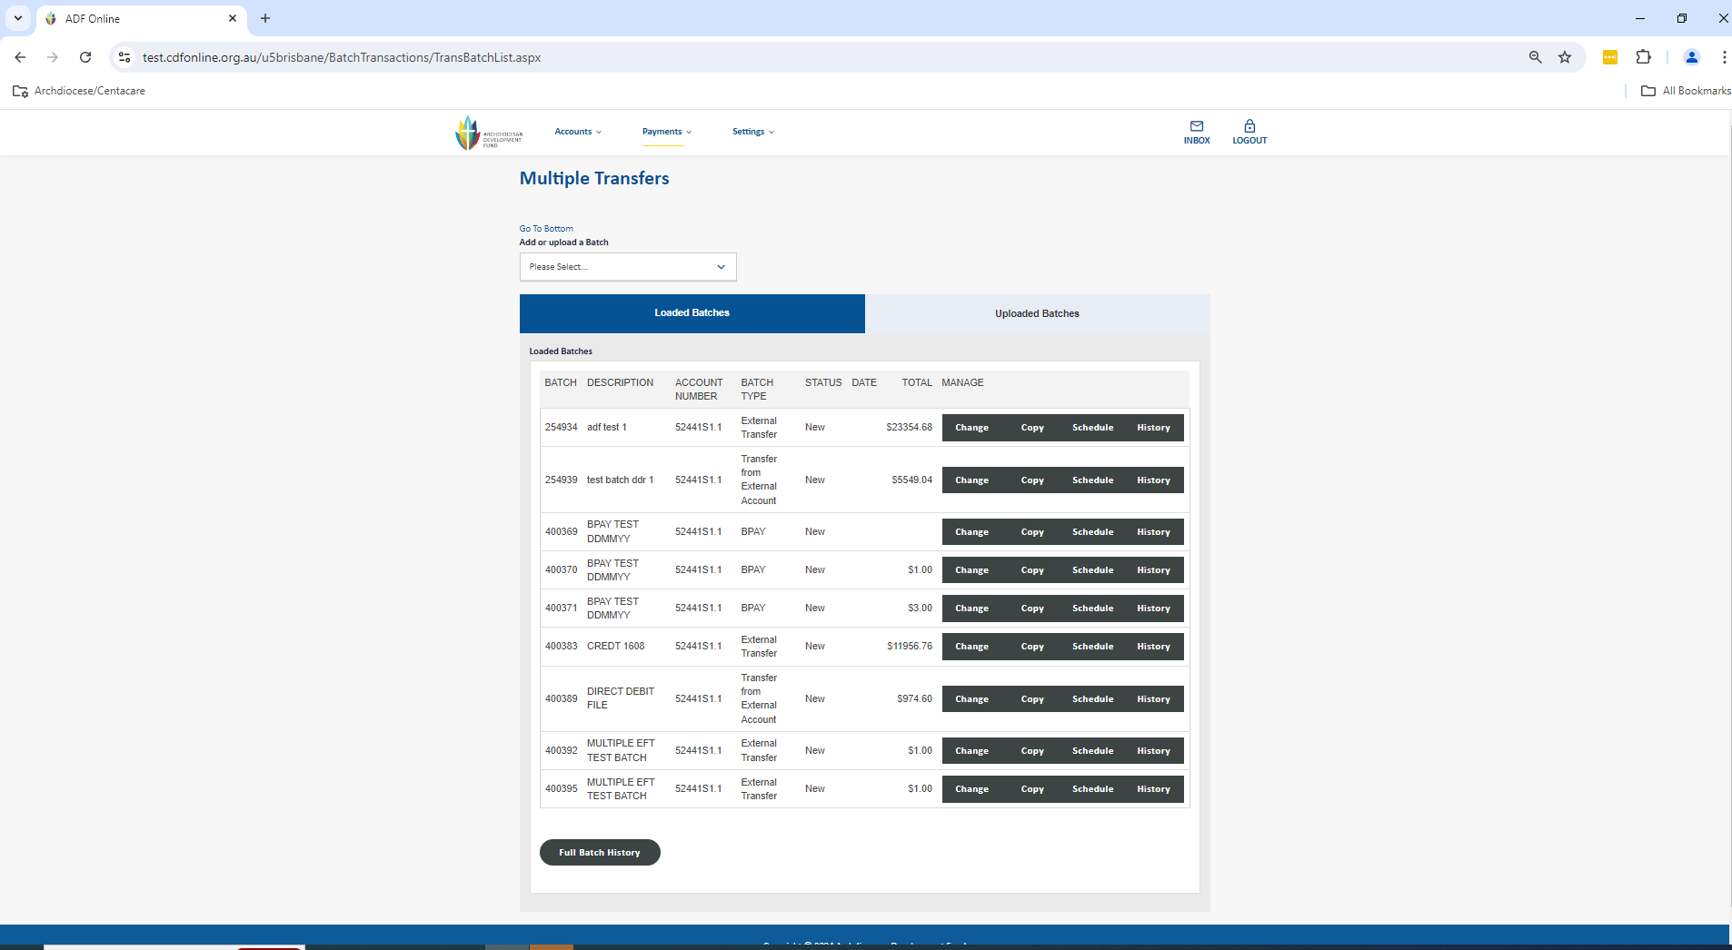

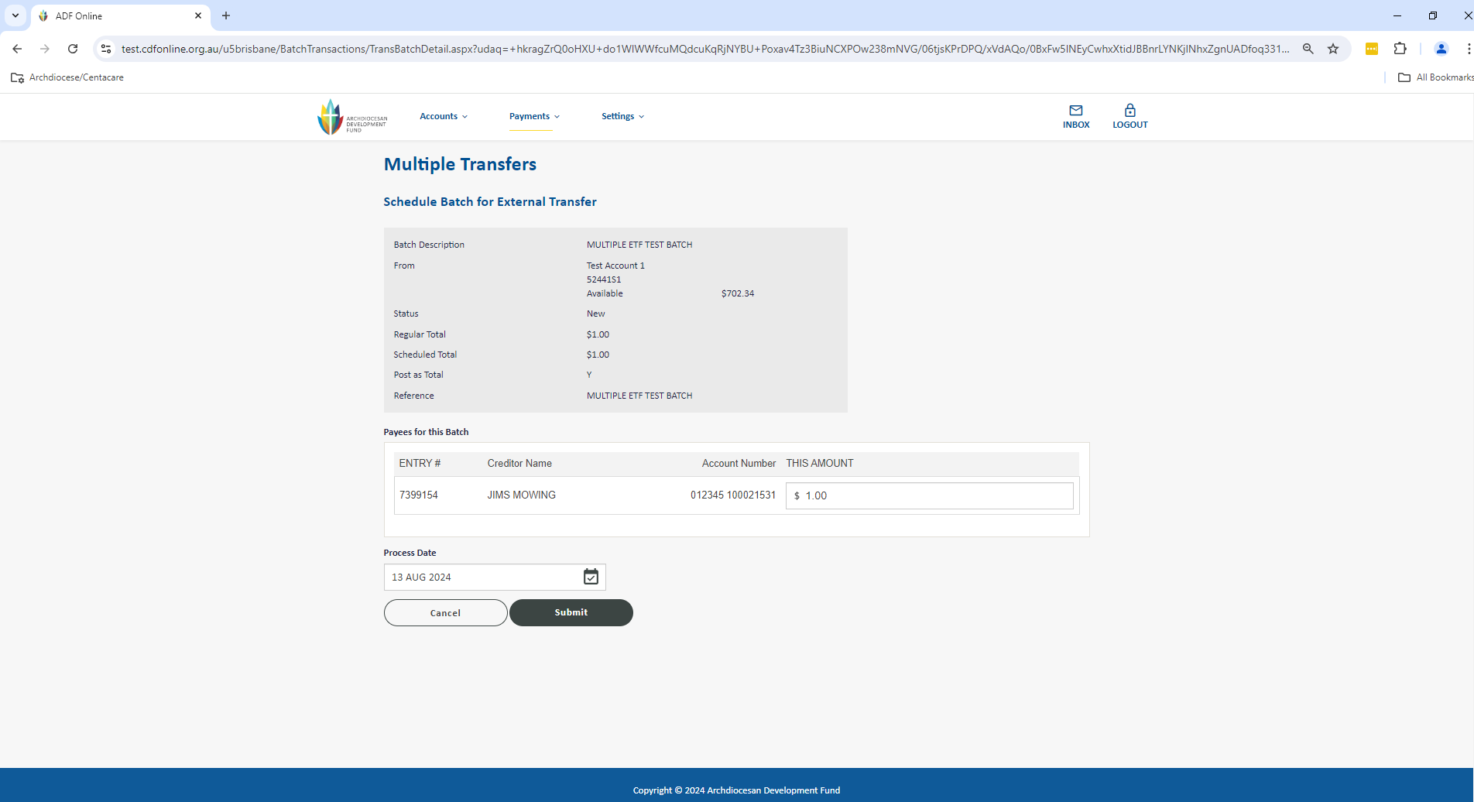

1. The screen will change slightly for you to validate that all the information is correct. If it is, you have the opportunity to notify any users via email from the system before clicking Submit. This will now store the payment as an Authorisation Request for a user with the appropriate access level to be able to approve.

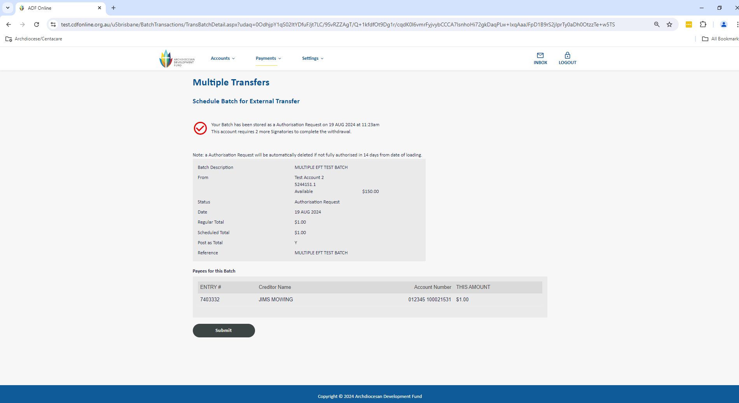

1. After selecting Submit the batch has now been set up for authorisation. On your Multiple Transfers page you can check the status is Authorisation Request which shows it is ready for your authorisers.

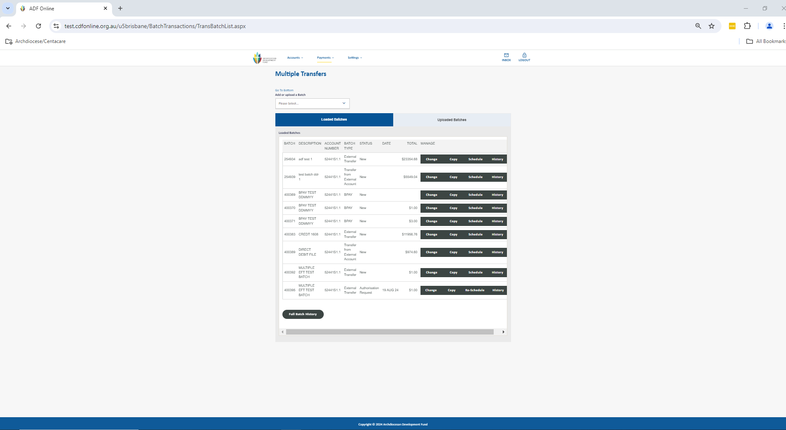

1. Authorisers can now login to CDF Online to view and approve the payments. On the home screen under click on the drop down on Authorisation Requests: For Me and click on View All.

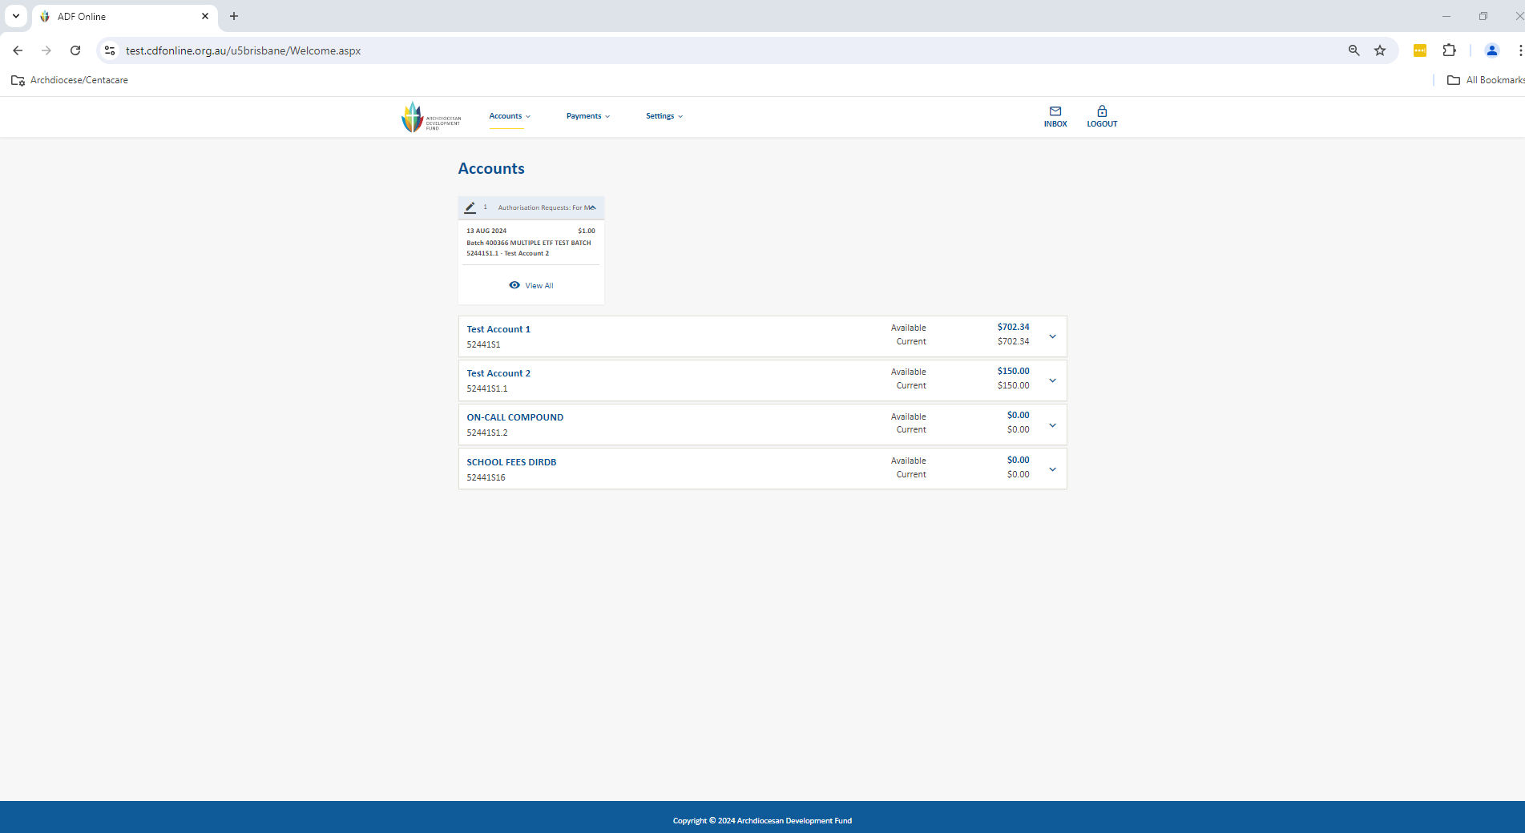

1. This will take you to view pending authorisations. You can also click into the payment and select Accept Payment after checking the details. Once fully authorised, the Multiple EFT Transfers will disappear from under Authorisation Requests and immediately debit from your account. Remember you have up until 2.00pm daily for the payment to be processed same-day, and for your recipient to receive the funds within approximately 1 business day.

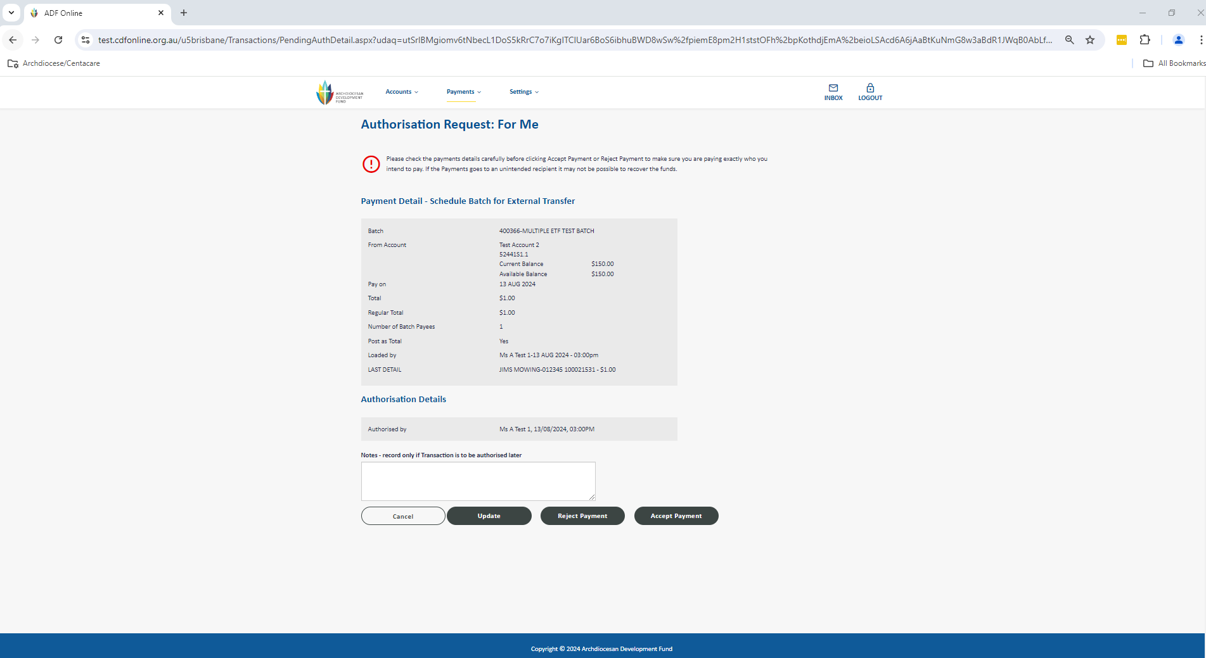

# Multiple BPAY Payments

The Multiple Transfers section allows you to build a batch of payments. The benefits of this method are that you can efficiently process one or more payments together, this also means your authorisers are able to check and approve from one screen. Most importantly, you have more control; you can change the batch of payments at any time up until it is processed.

Go to the Payments menu up the top of the screen and select Multiple Transfers to be taken to the screen below.

1. Firstly you need to select your type of Multiple Transfer- under the Add or Upload a Batch select BPAY.
   1. Enter an appropriate description for your batch of payments e.g. BPAYs and the date
   2. Click in the From Account box to select your account (any account with sufficient funds available). Note: if you have a sweep active on the account this will allow you to proceed with the payment without sufficient funds and will cover the overdrawn balance at the end of the day.
   3. Tick the Post as Total box to have the payment posted as a total on your statement or leave un-ticked if you prefer to itemise the individual payments on your statement
   4. Enter the reference for your batch (usually same as the description) – this is what you will see on

your statement if you post as a total only

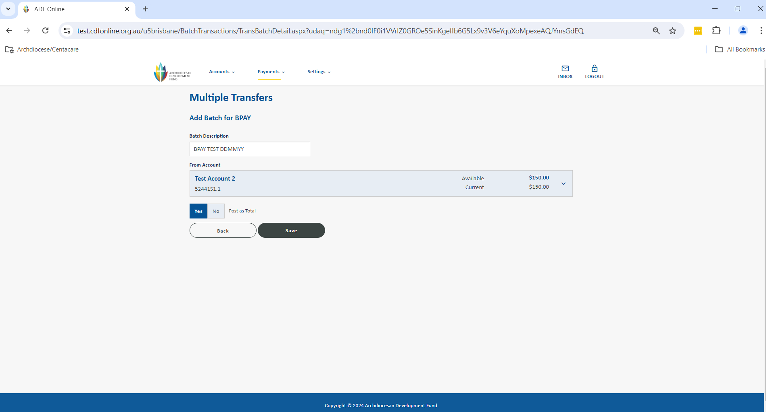

1. You will now see the screen below where you are able to add/change/delete your payees. Once all your payee information is completed, you will need to select Save to go to the next step to process your batch.
   1. You can Add a New or existing Payee by either clicking on the drop down menu under Add an existing Payee or selecting Add New Payee to Batch
   2. Review or enter your payee account details. The Search for a Biller box is helpful when adding a new payee’s biller code and name.
   3. Enter the amount of the payment
   4. Select Save to return to the batch
   5. Repeat the above steps until all payees are added

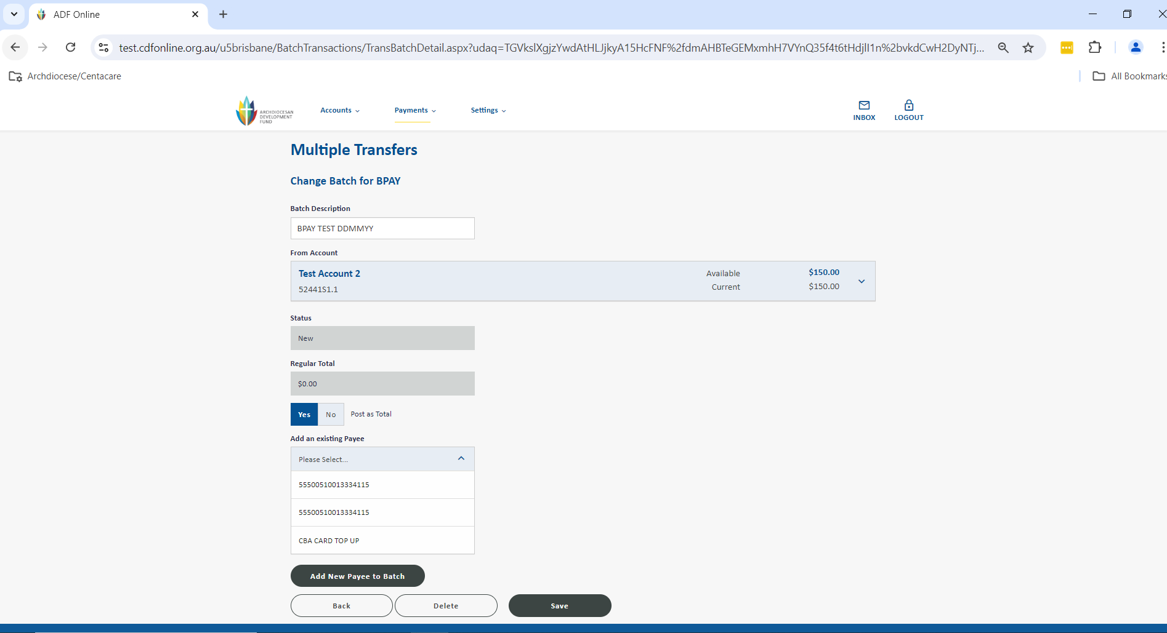 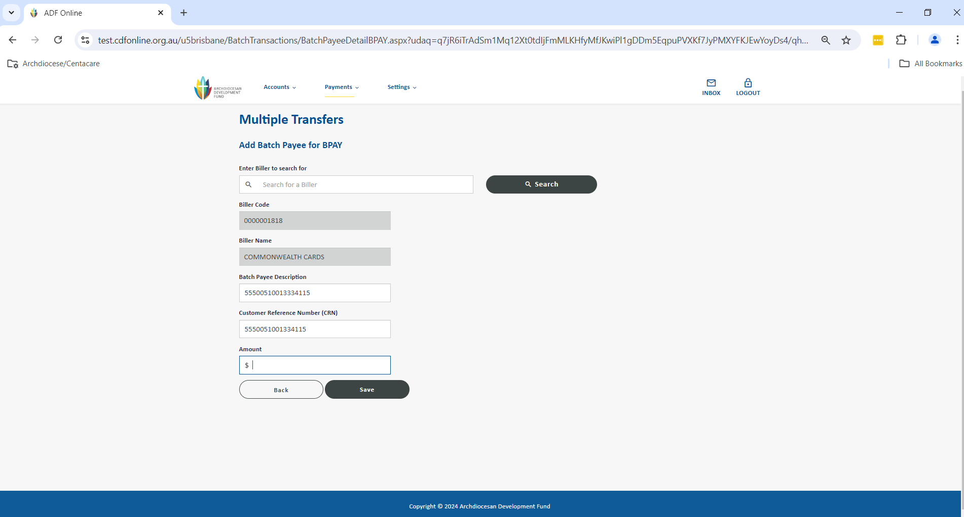

1. You are now taken back to your Multiple Transfers section that shows an overall view of all of your current or previous batches and most importantly their Status and History. From this screen you are able to change/delete/copy any of your batches as well as schedule the batch for payment. Click on Schedule to be taken to review the summary of payment details and date for the batch to process. Select Submit to proceed.

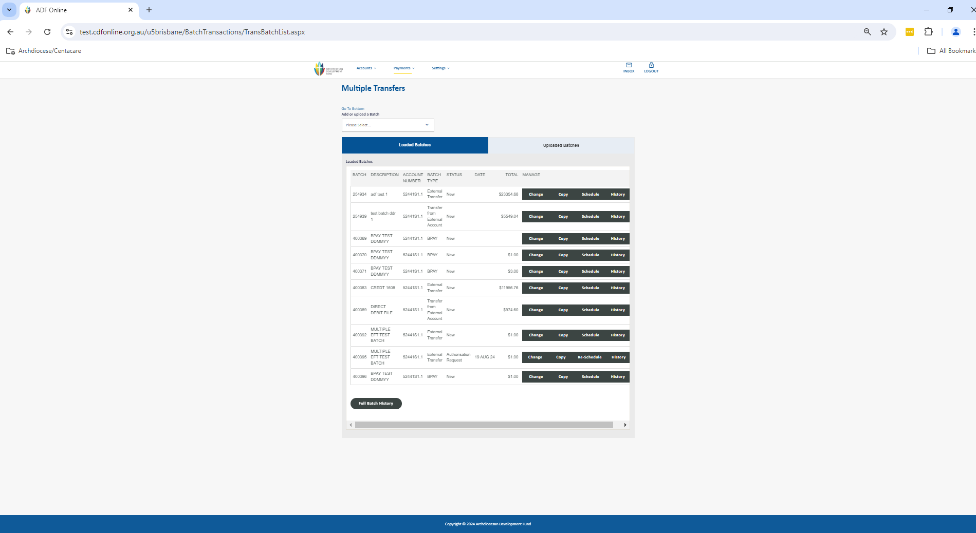

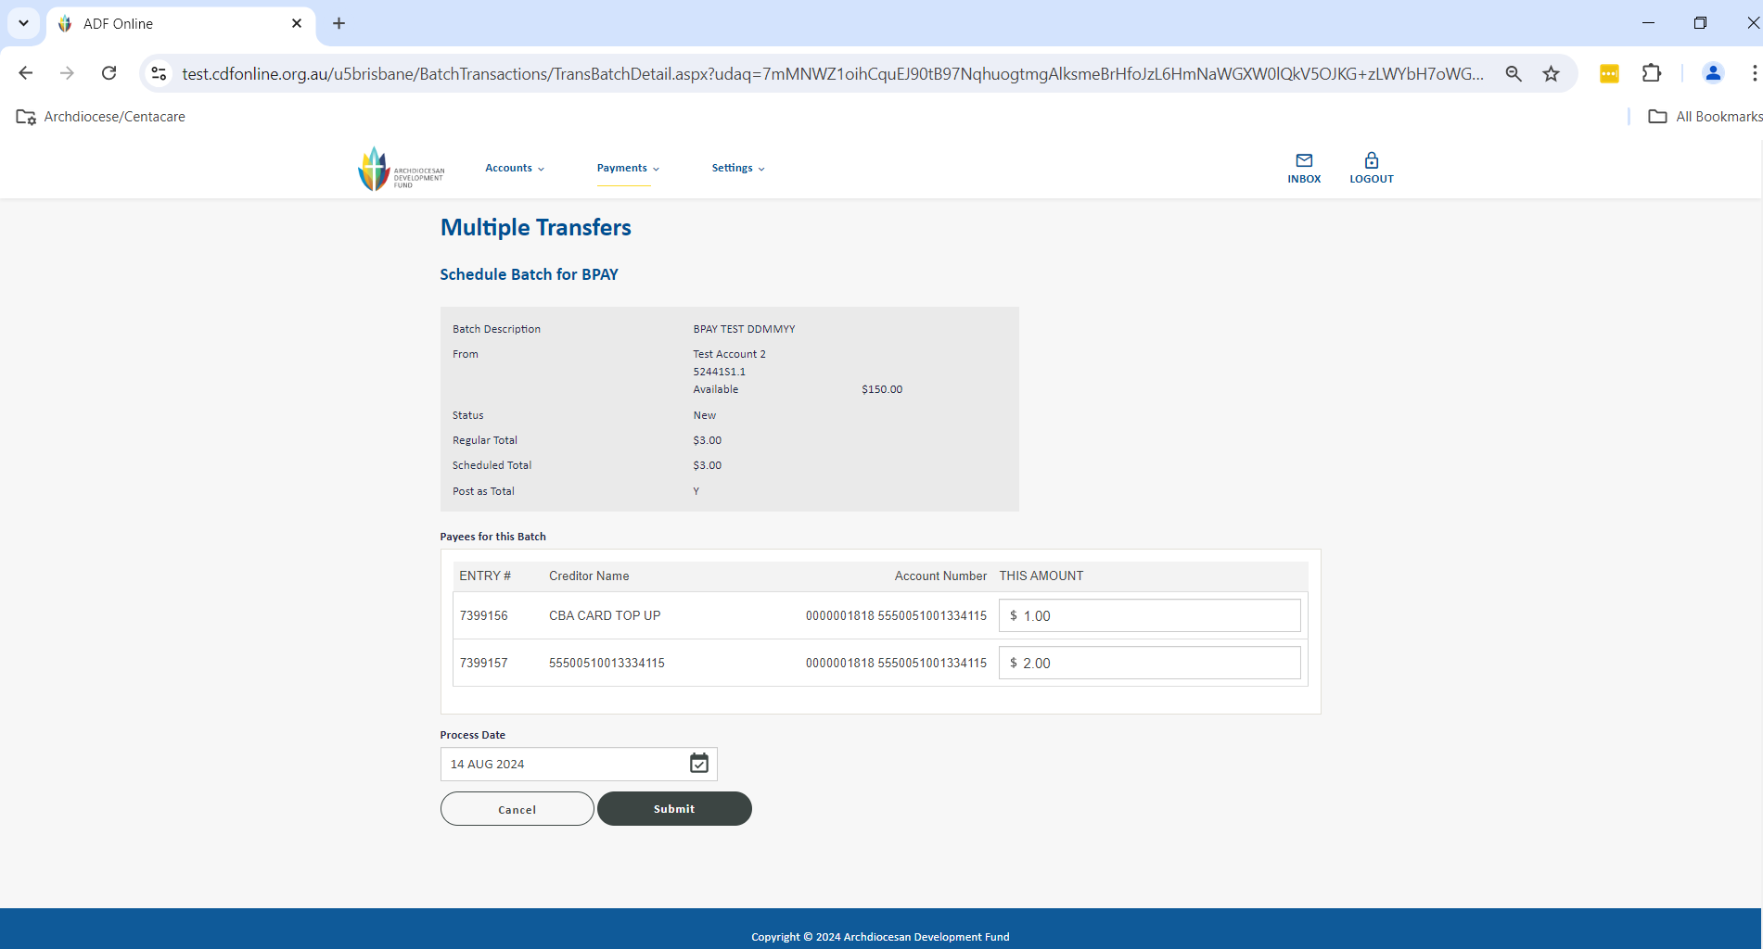

1. The screen will change slightly for you to validate that all the information is correct. If it is, you have the opportunity to notify any users via email from the system before clicking Submit. This will now store the payment as an Authorisation Request for a user with the appropriate access level to be able to approve.

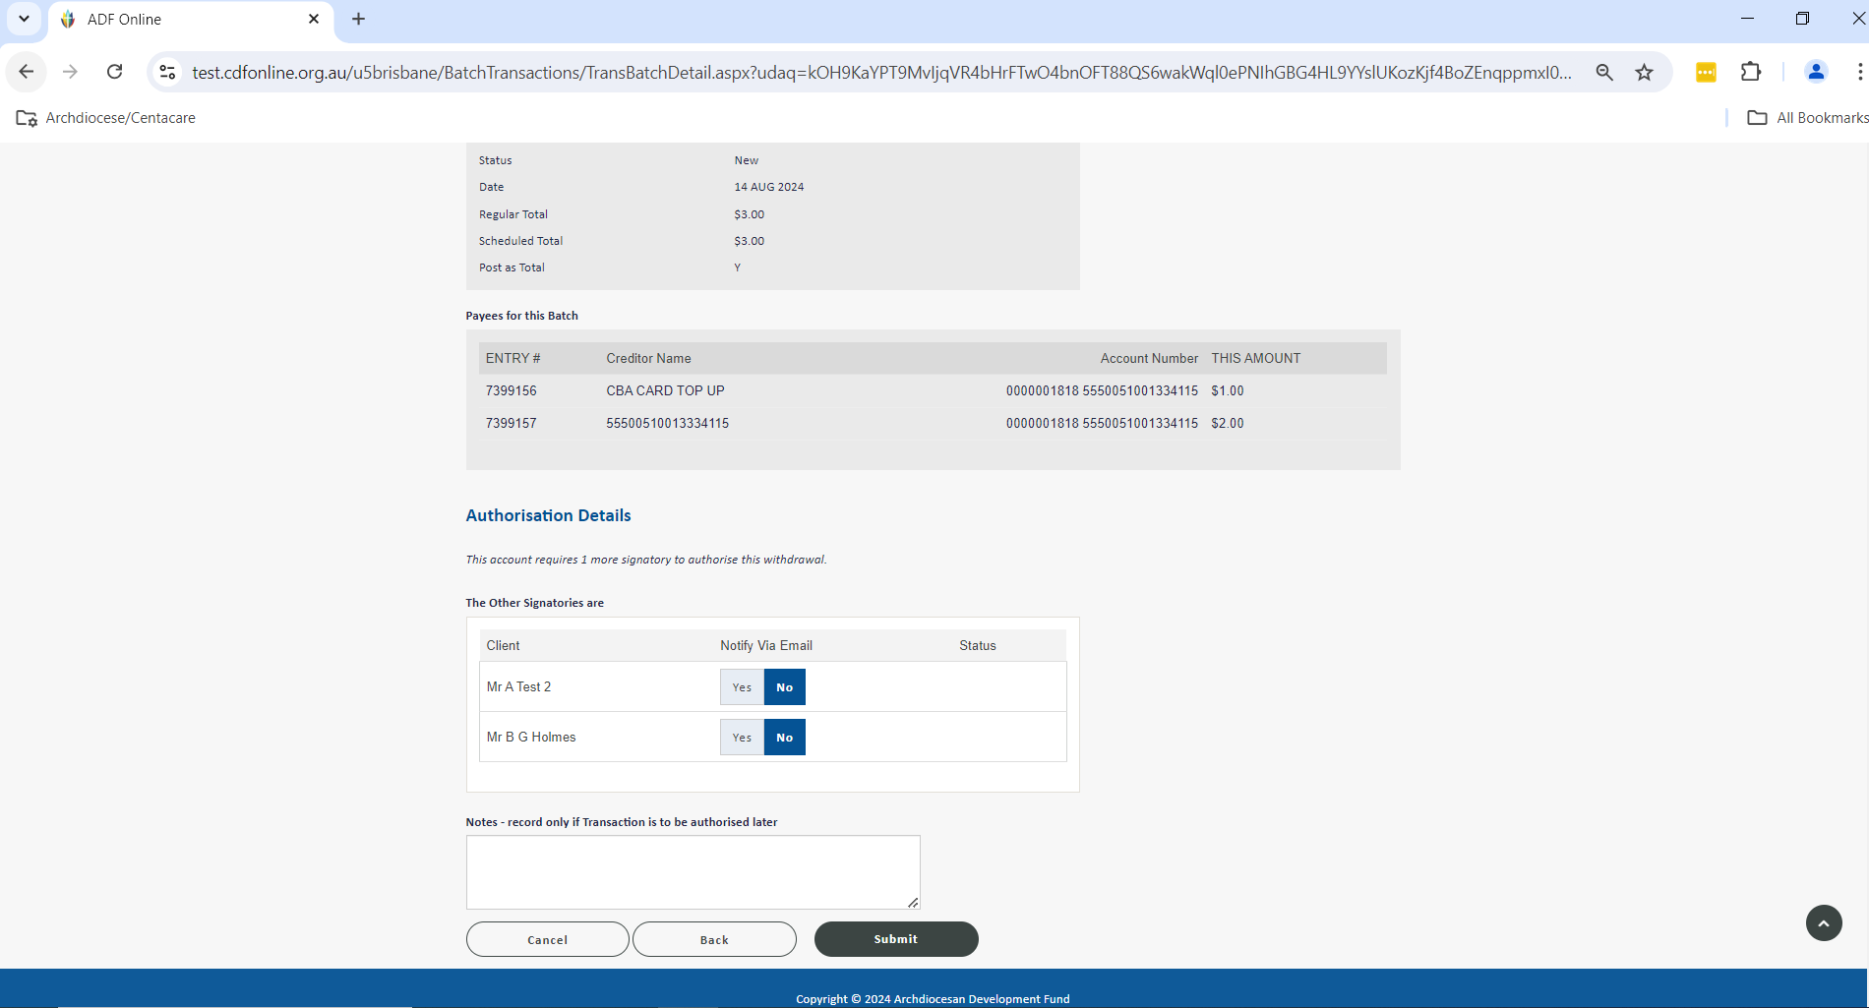

1. After selecting Submit the batch has now been set up for authorisation and you will see the confirmation screen. Once you click Submit it will take you back to your Multiple Transfers page and you can check the status is Authorisation Request which shows it is ready for your authorisers.

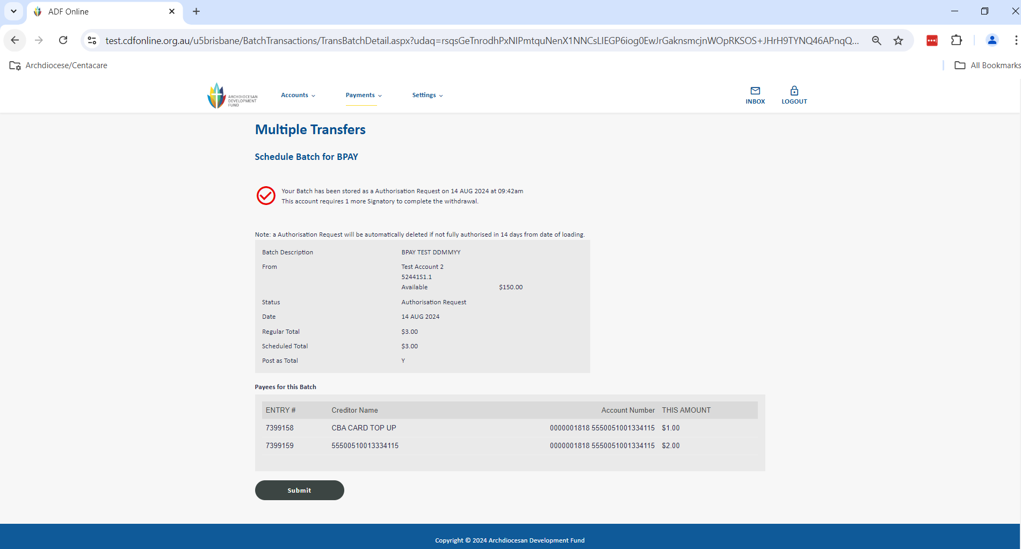

1. Authorisers can now login to CDF Online to view and approve the payments. On the home screen under click on the drop down on Authorisation Requests: For Me and click on View All.

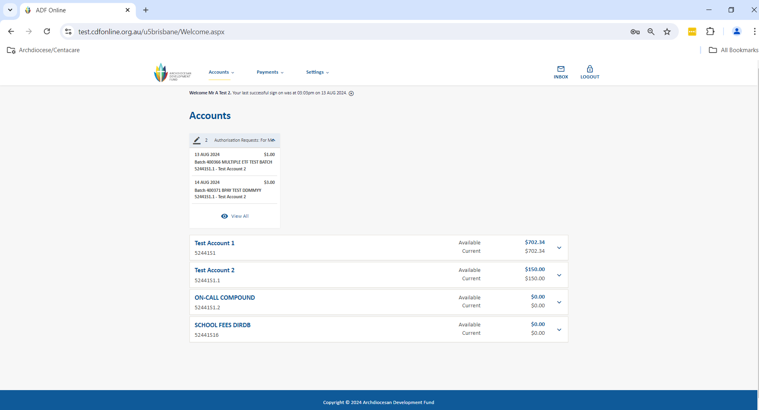

1. This will take you to view pending authorisations. You can also click into the payment and select Accept Payment after checking the details. Once fully authorised, the Multiple EFT Transfers will disappear from under Authorisation Requests and immediately debit from your account. Remember you have up until 2.00pm daily for the payment to be processed same-day, and for your recipient to receive the funds within approximately 1 business day.

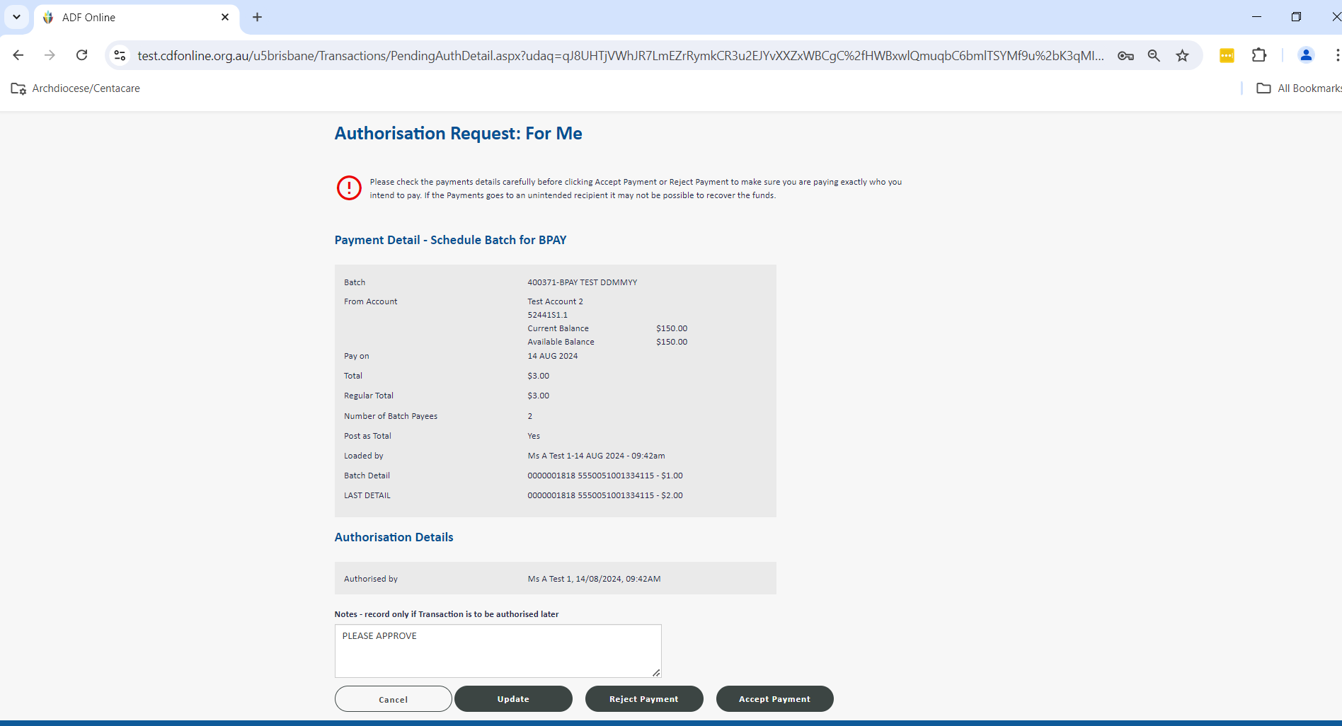

# Uploading Files for Payment

This functionality is for if you generate a batch of account details directly from your accounting package for upload and payment in CDF Online. The Multiple Transfers section allows you to upload a batch of payments. The benefits of this method are that you can efficiently process one or more payments together, this also means your authorisers are able to check and approve from one screen. Most importantly, you have more control; you can change the batch of payments at any time up until it is processed.

Go to the Payments menu up the top of the screen and select Multiple Transfers to be taken to the screen below.

1. Firstly you need to select your type of Multiple Transfer – Upload. You can then complete the Batch details. Once all the Batch information is completed, you will simply need to click Upload to go to the final step to process your batch.
   1. Leave the Document Type as Standard ABA file
   2. Click on the Choose File button to browse for the file you saved from your accounting package
   3. Enter an appropriate description for your batch of payments e.g. EFTs and the date
   4. Click in the Account Number box to select your account (any account with sufficient funds available and an external daily limit nominated). Note: if you have a sweep active on the account this will allow you to proceed with the payment without sufficient funds and will cover the overdrawn balance at the end of the day.
   5. Un-tick the Post as Total box to itemise the individual payments on your statement, or leave ticked if you prefer for only the total to be processed
   6. Enter the reference for your batch (usually same as the description) – this is what you will see on your statement if you post as a total only

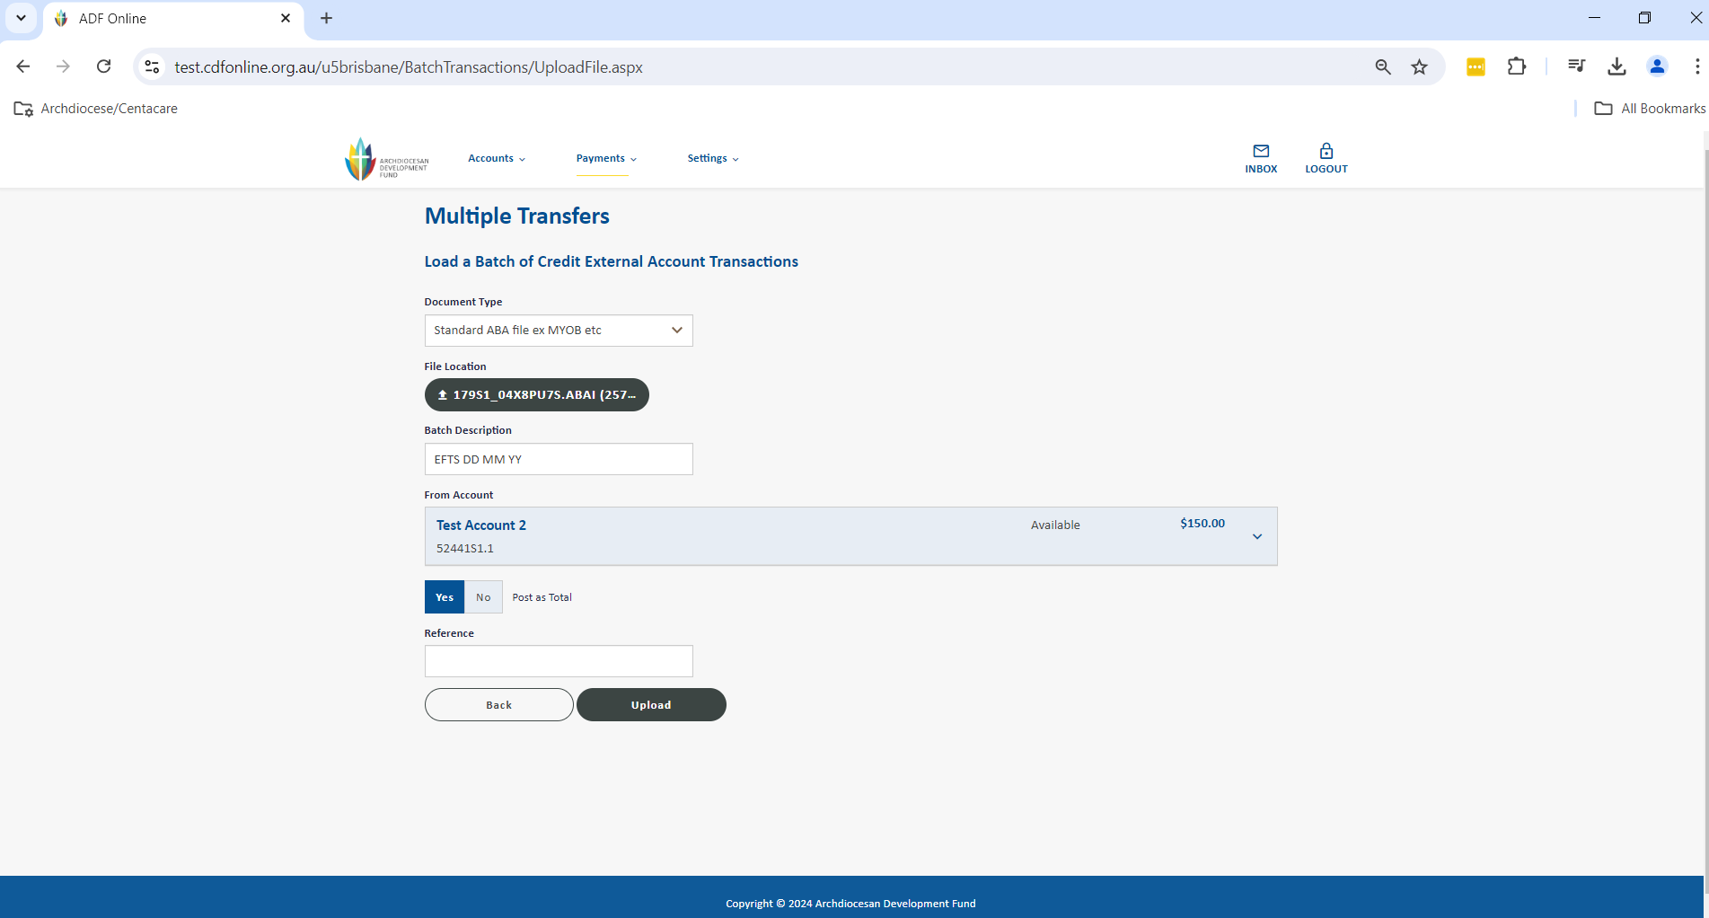

1. You are now taken back to your Multiple Transfers section that shows an overall view of all of your current or previous batches and most importantly their Status and History. From this screen you are able to change/delete/copy any of your batches as well as schedule the batch for payment. Click on Schedule to be taken to review the summary of payment details and date for the batch to process. Select Submit to proceed.

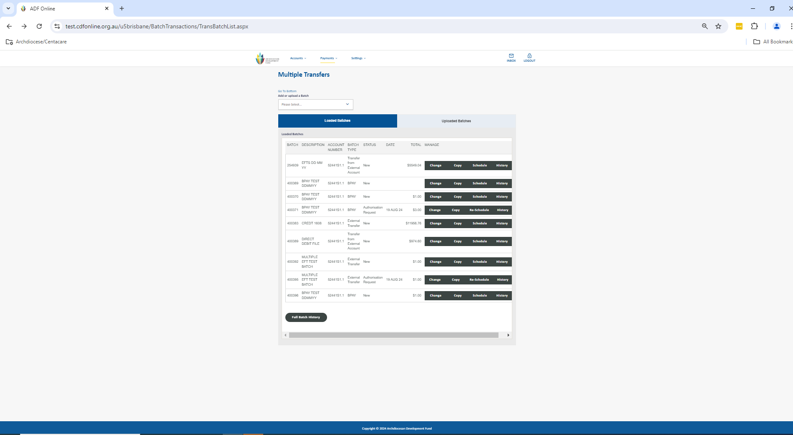

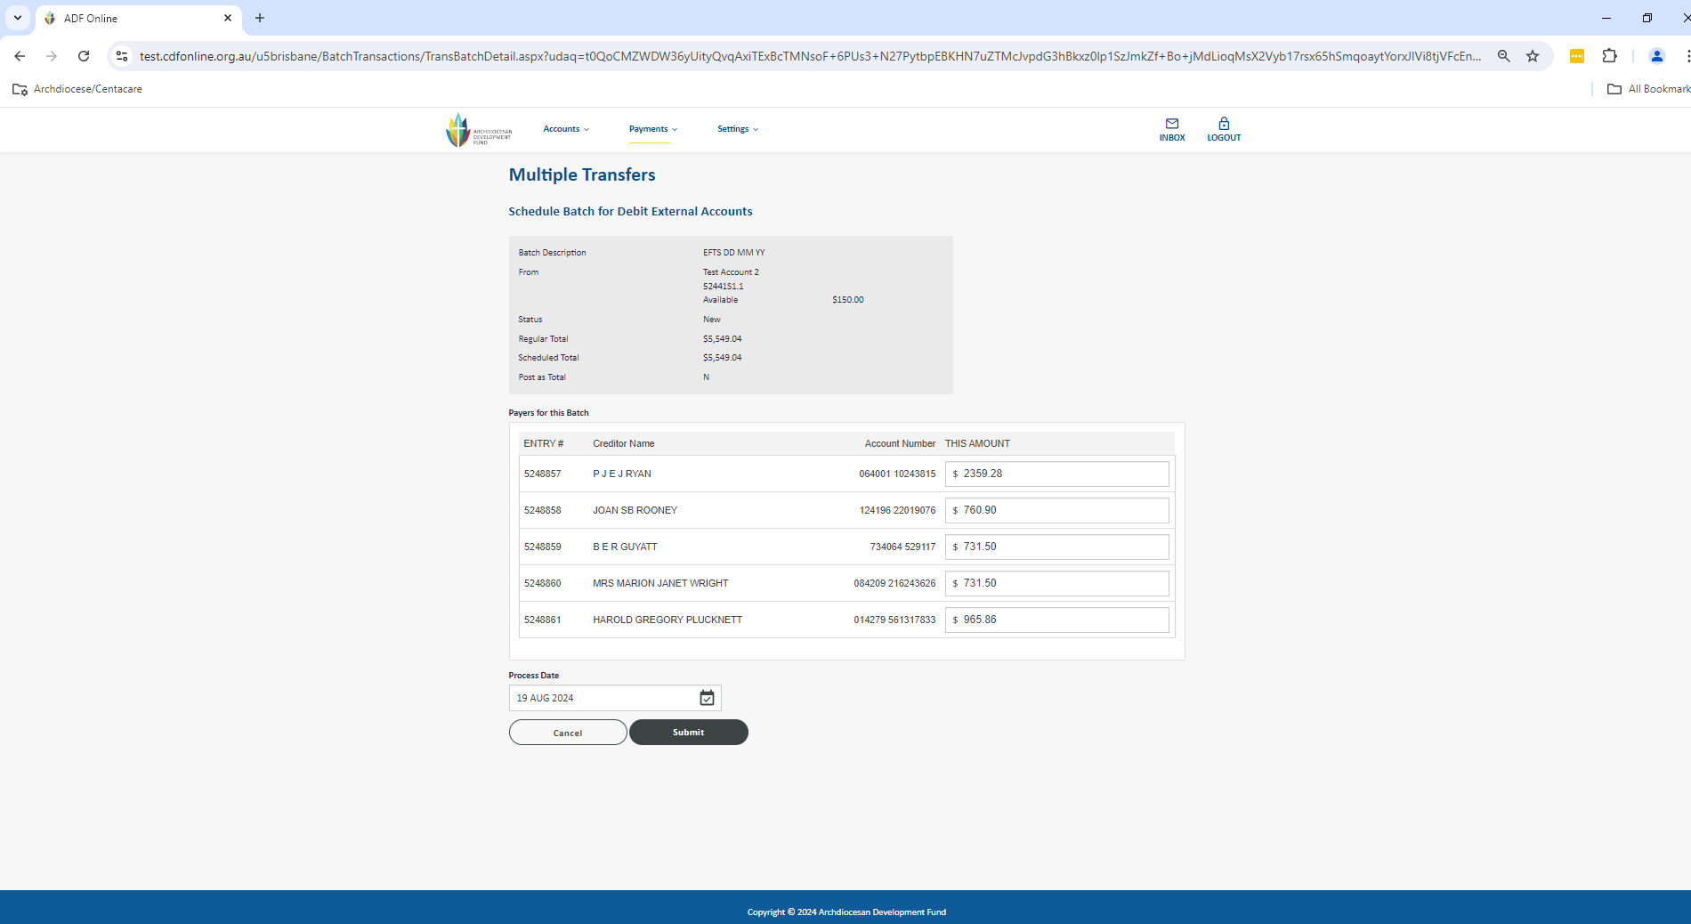

1. The screen will change slightly for you to validate that all the information is correct. If it is, you have the opportunity to notify any users via email from the system before clicking Submit. This will now store the payment as an Authorisation Request for a user with the appropriate access level to be able to approve.

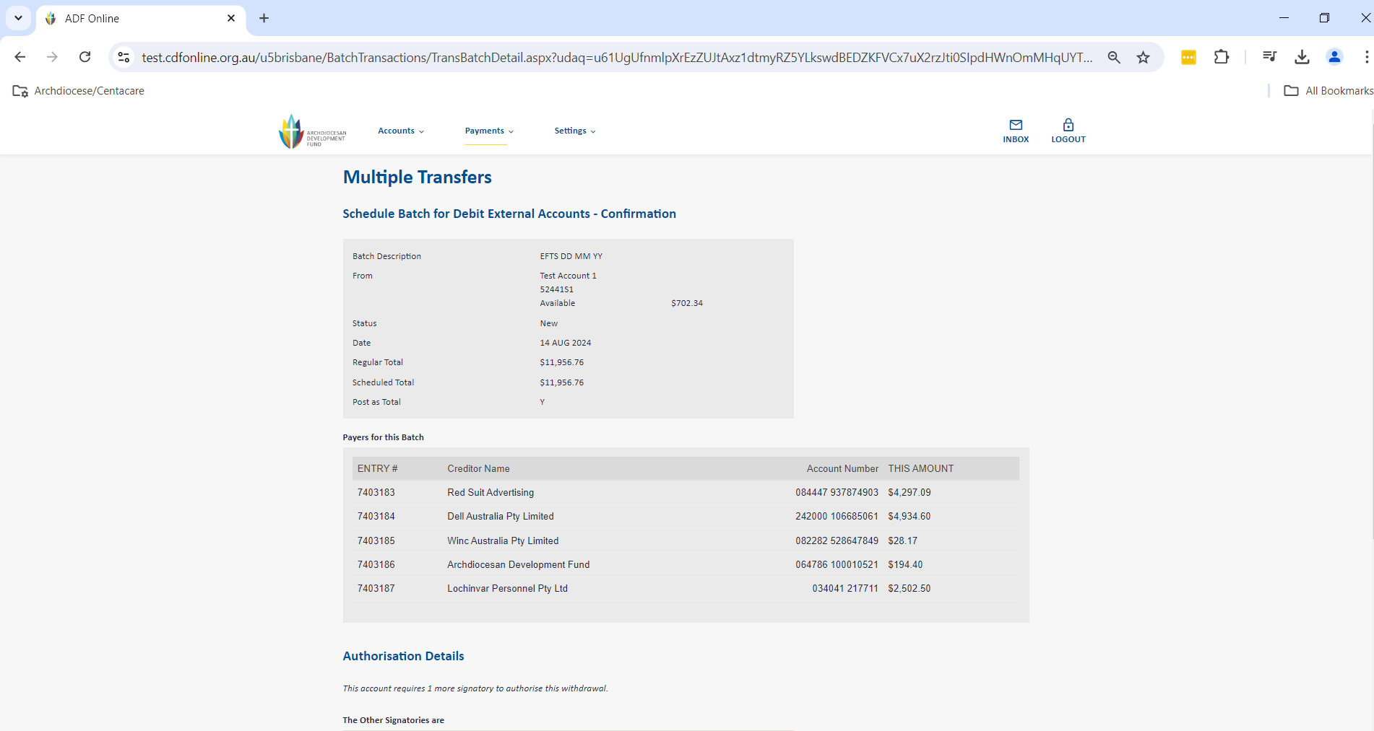

1. After selecting Submit the batch has now been set up for authorisation and you will see the confirmation screen. Once you click Submit it will take you back to your Multiple Transfers page and you can check the status is Authorisation Request which shows it is ready for your authorisers.

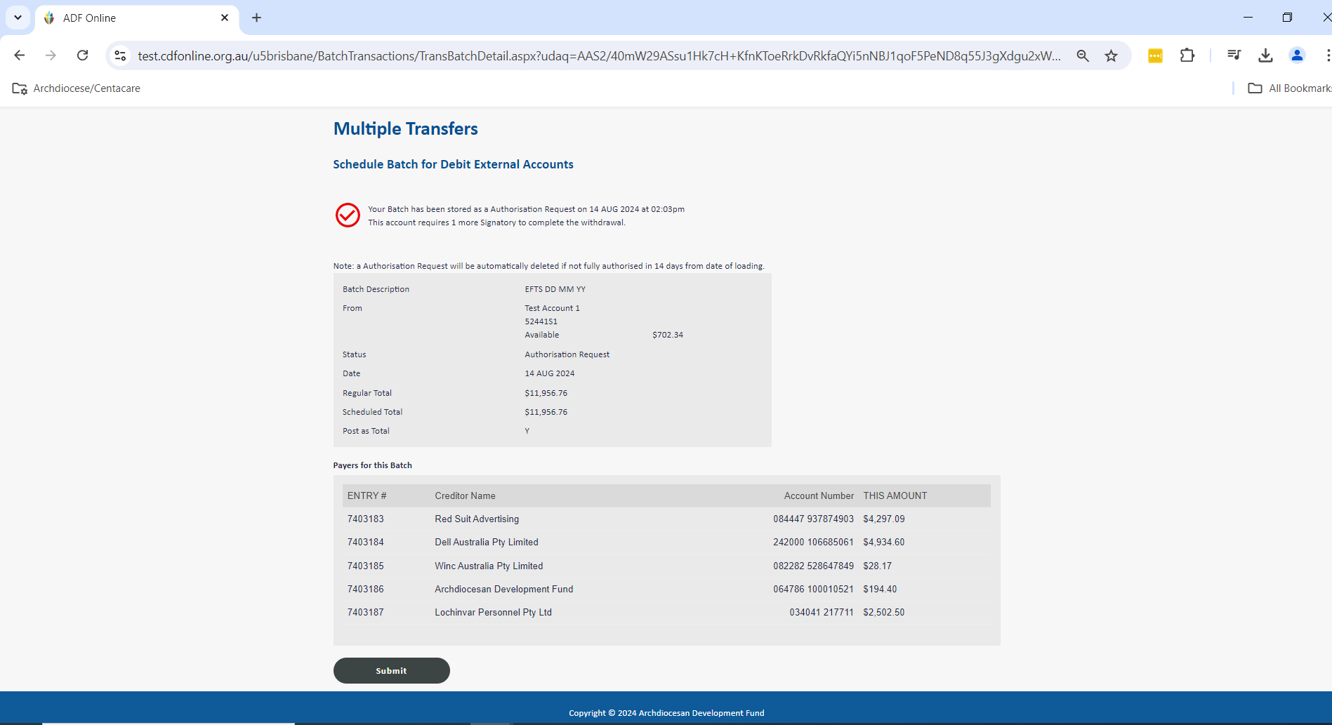

1. Authorisers can now login to CDF Online to view and approve the payments. On the home screen click the drop down menu under Authorisation Requests: For Me and View All.

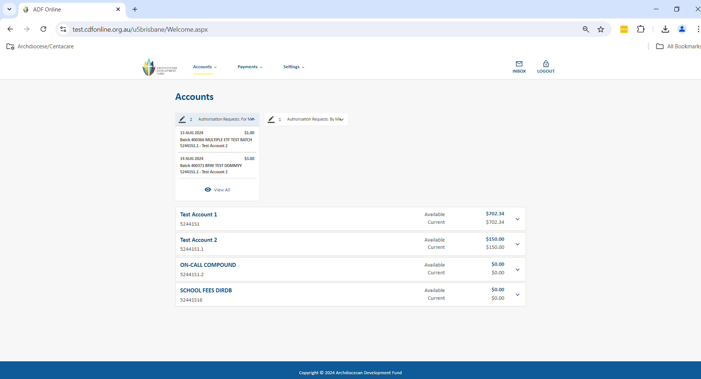

1. This will take you to view pending authorisations. You can also click into the payment and select Accept Payment after checking the details. Once fully authorised, the Multiple EFT Transfers will disappear from under Authorisation Requests and immediately debit from your account. Remember you have up until 2.00pm daily for the payment to be processed same-day, and for your recipient to receive the funds within approximately 1 business day.

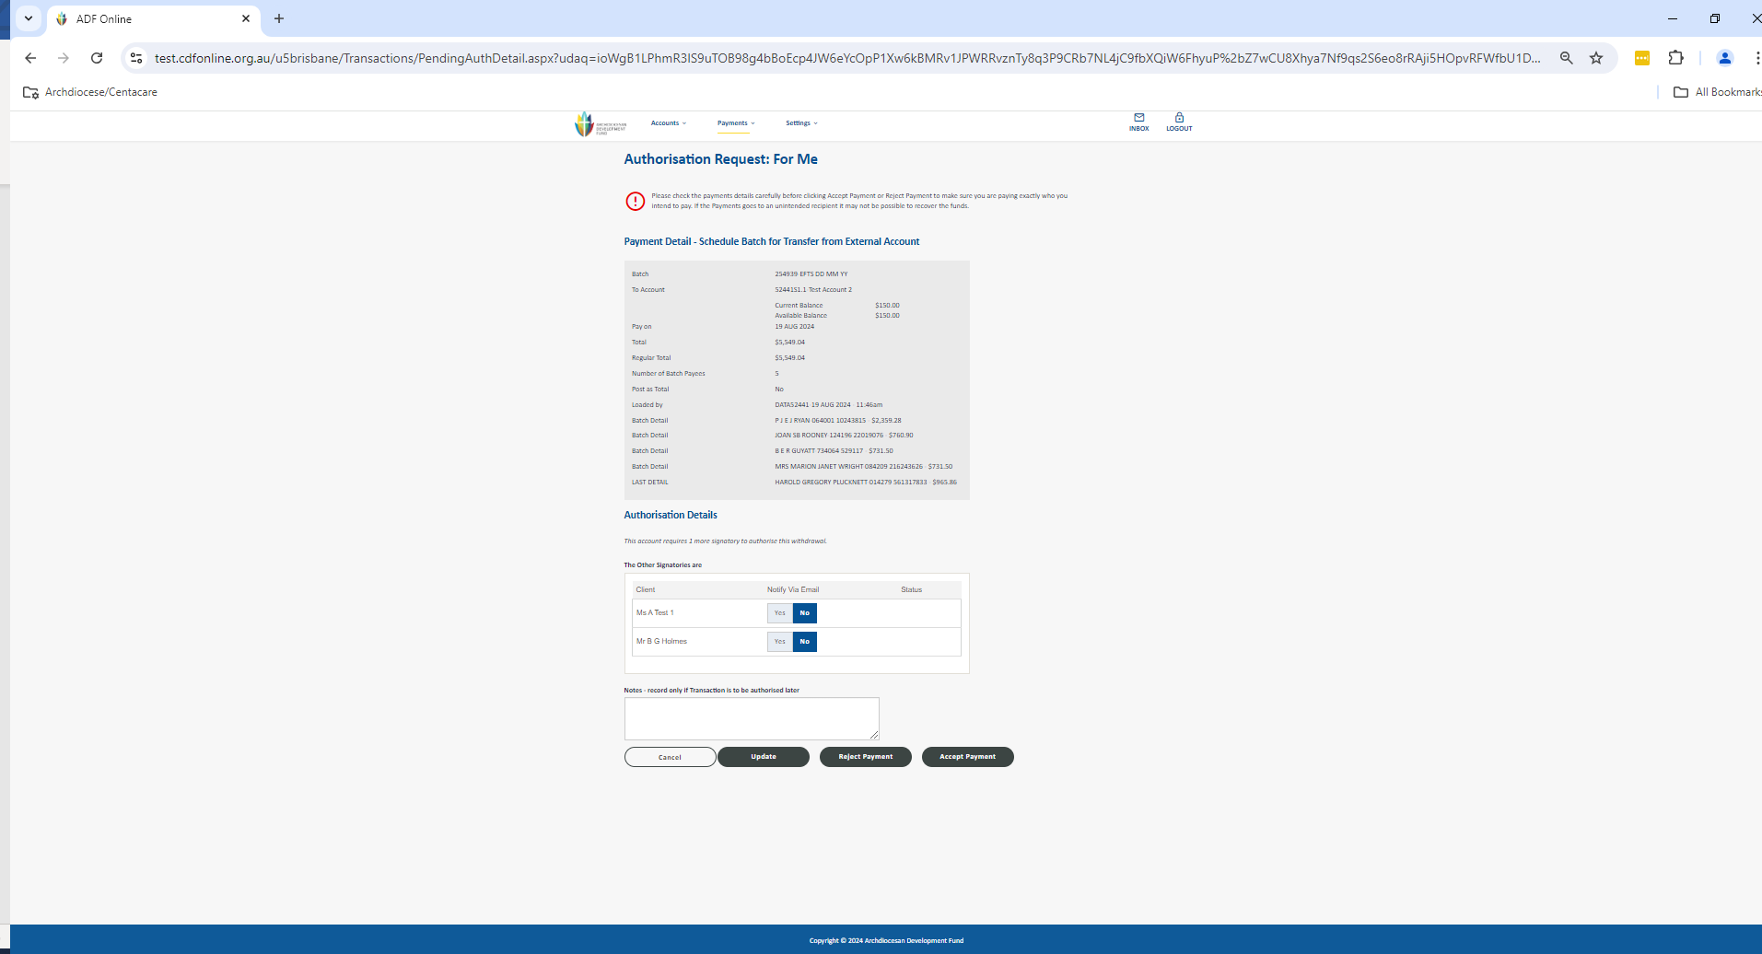

# Errors in a Batch Upload

If there is an issue within a file you have uploaded a table listing the error will appear at the bottom of the Multiple Transfers Screen. You are able to fix a minor issue without needing to re-upload the file.

If you see an error message ‘New - Contains Upload Errors’ in the Multiple Transfers screen as shown below:

1. Click on the Change action to be able to locate the payee details with the error.

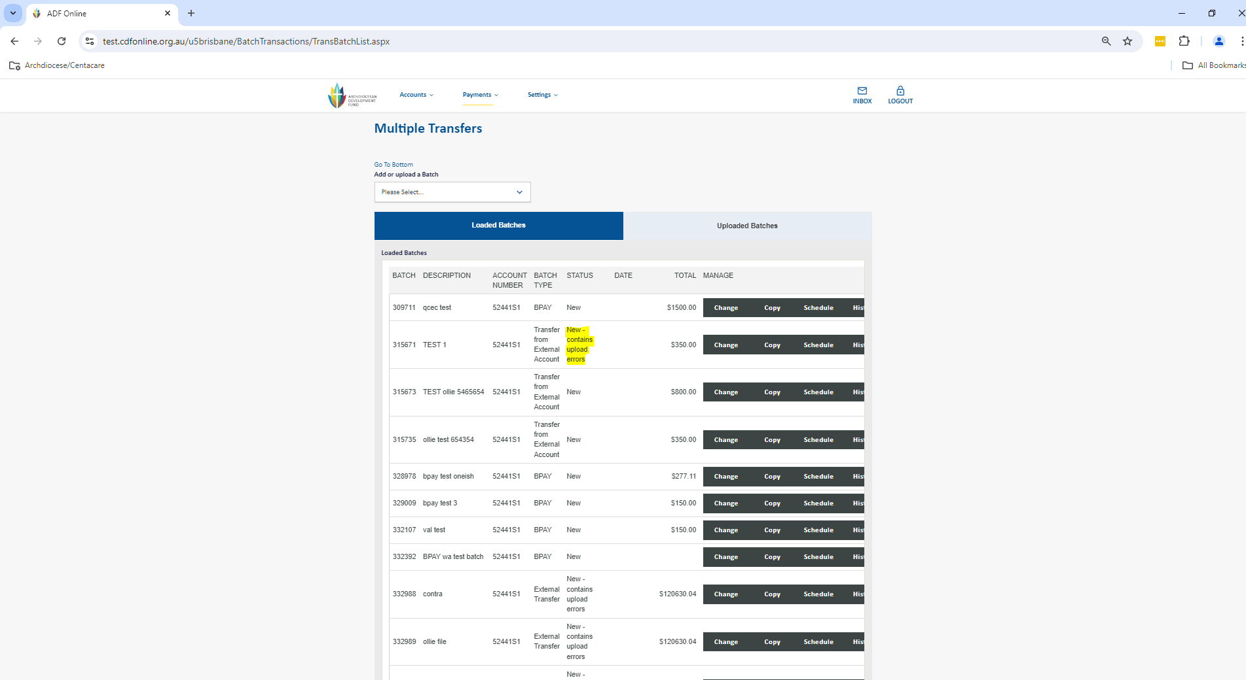

1. You can now select the Change action on this screen to see the full details of the error and fix.
2. Input the correct account details and click Save and Save again to return to your Multiple Transfers screen to be able to Schedule the batch for payment.

*Note BSB/account numbers cannot have spaces or alpha characters e.g. letter ‘S’.*

*A common error with a BSB number is either an incorrect BSB may have been provided by the payee or when being input in the accounting package it may have had a space or ‘-‘ added resulting in the file truncating the BSB to 6 characters e.g. 064 000 would be generated in the file as 064 00*

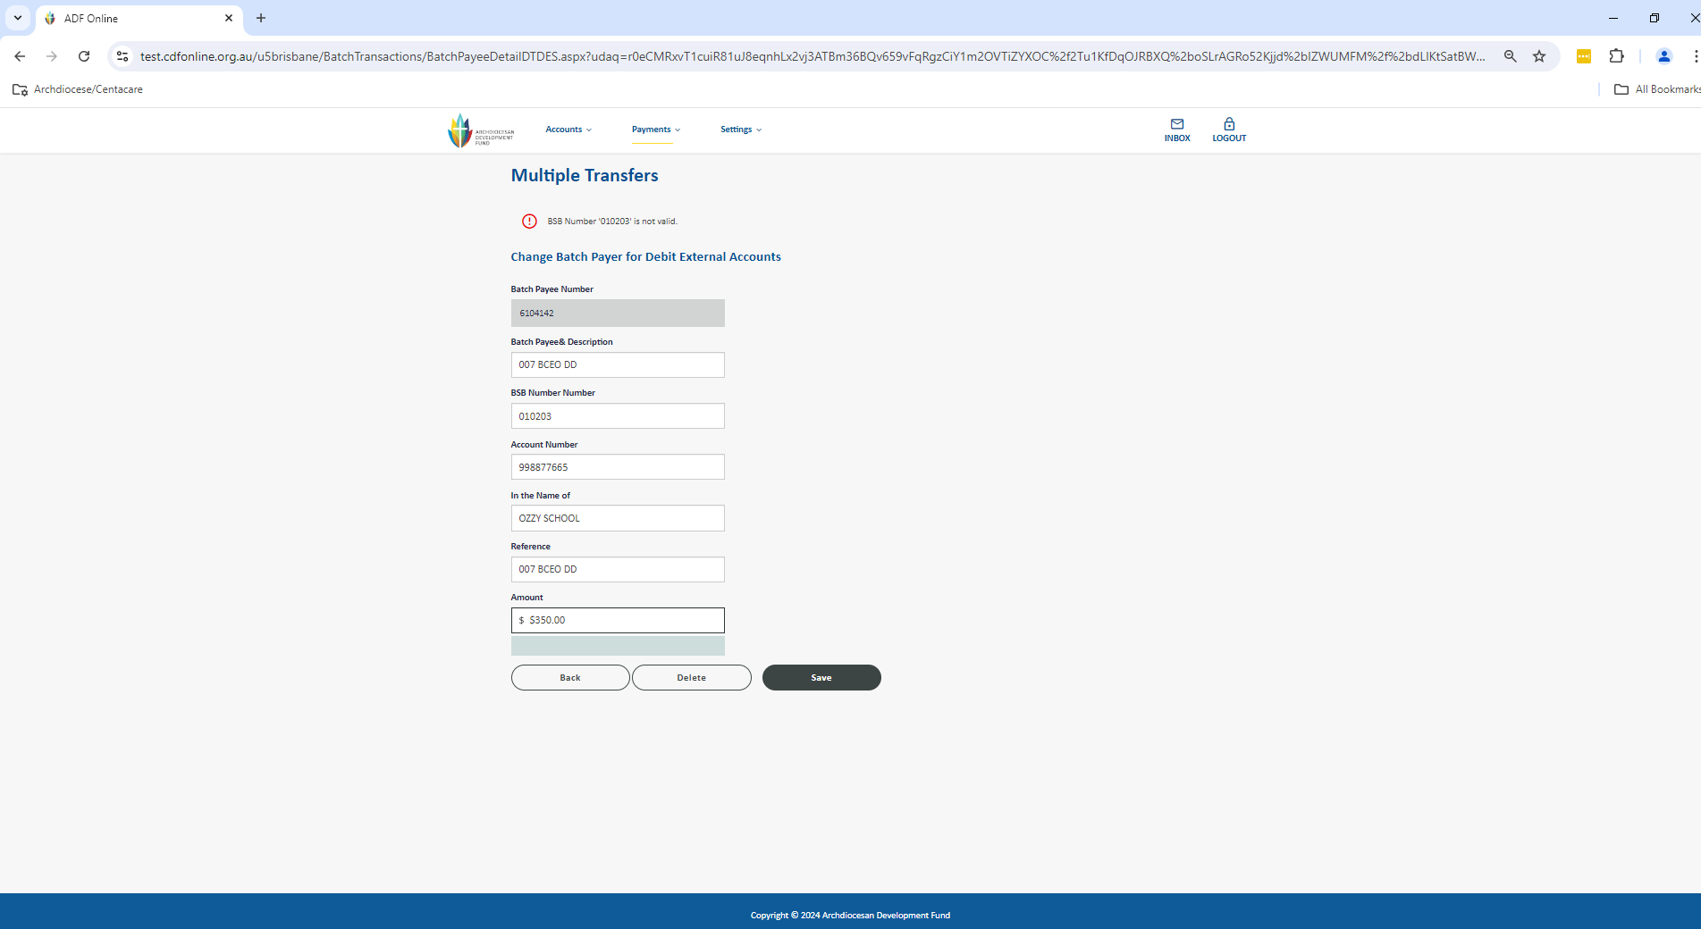

If a file has a major issue it may not be able to upload successfully into your Batch listing and instead you only see it in the tab Uploaded Batches.

1. Click on Uploaded Batches and Show Errors on this screen to see the full details of the error.

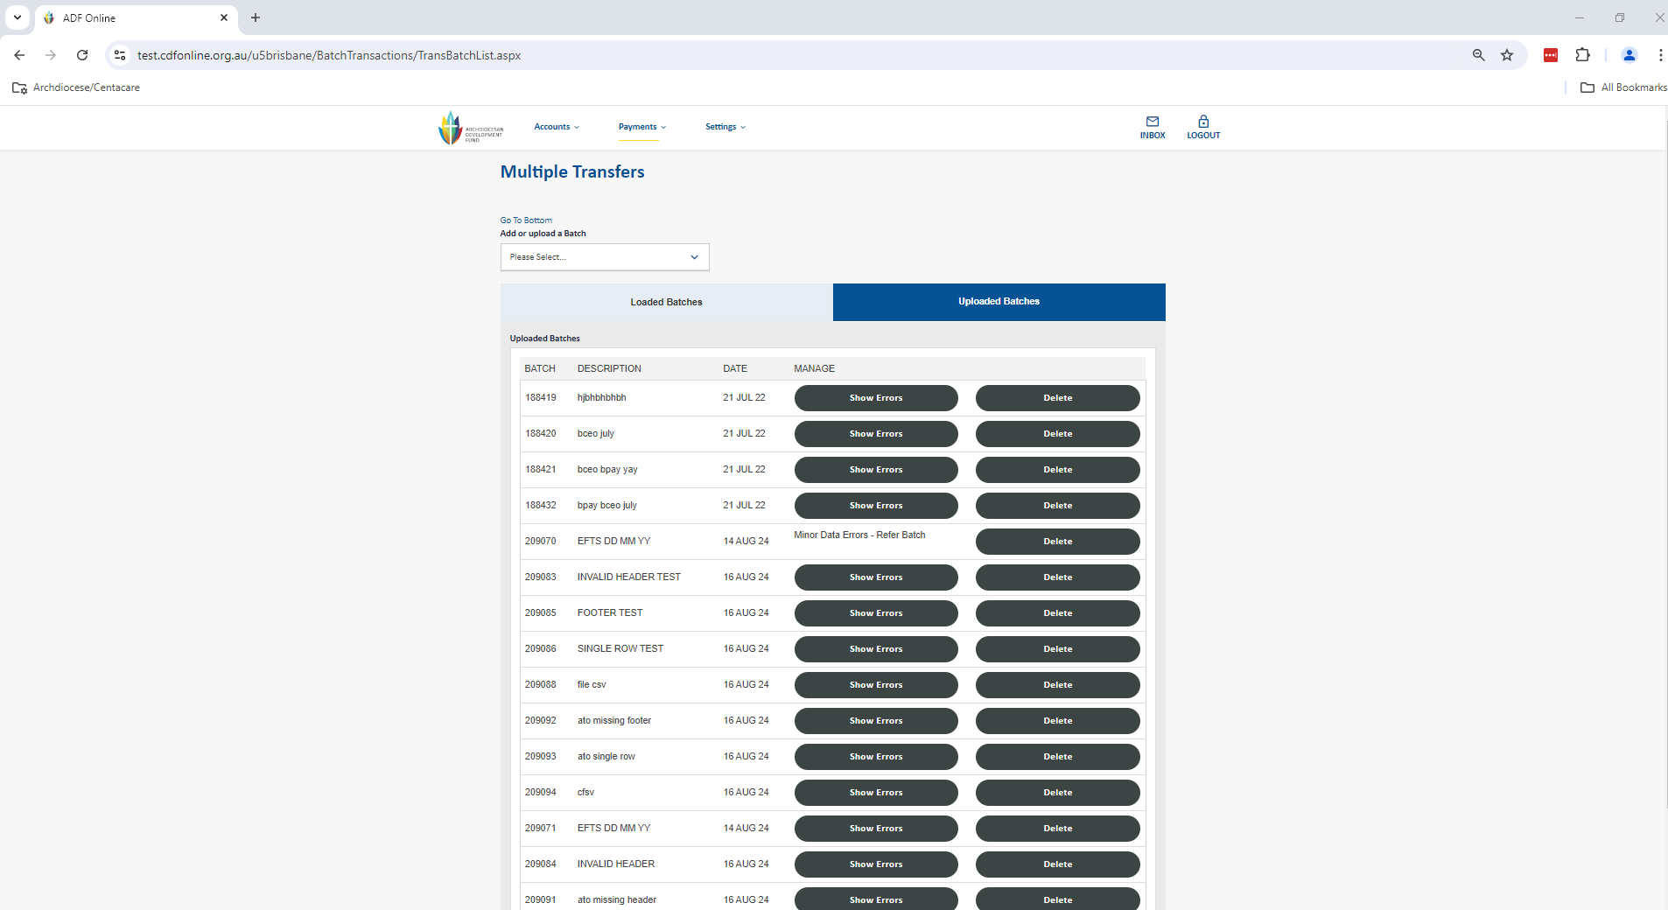

1. If you see the message below, go to where you have saved the file on your computer and open it using notepad to see what is wrong with it e.g. empty file. Most times you can carefully fix the structure of the file yourself manually or perhaps try generating the file again from your accounting package. For further assistance please don’t hesitate to contact the CDF or your support for your accounting package.

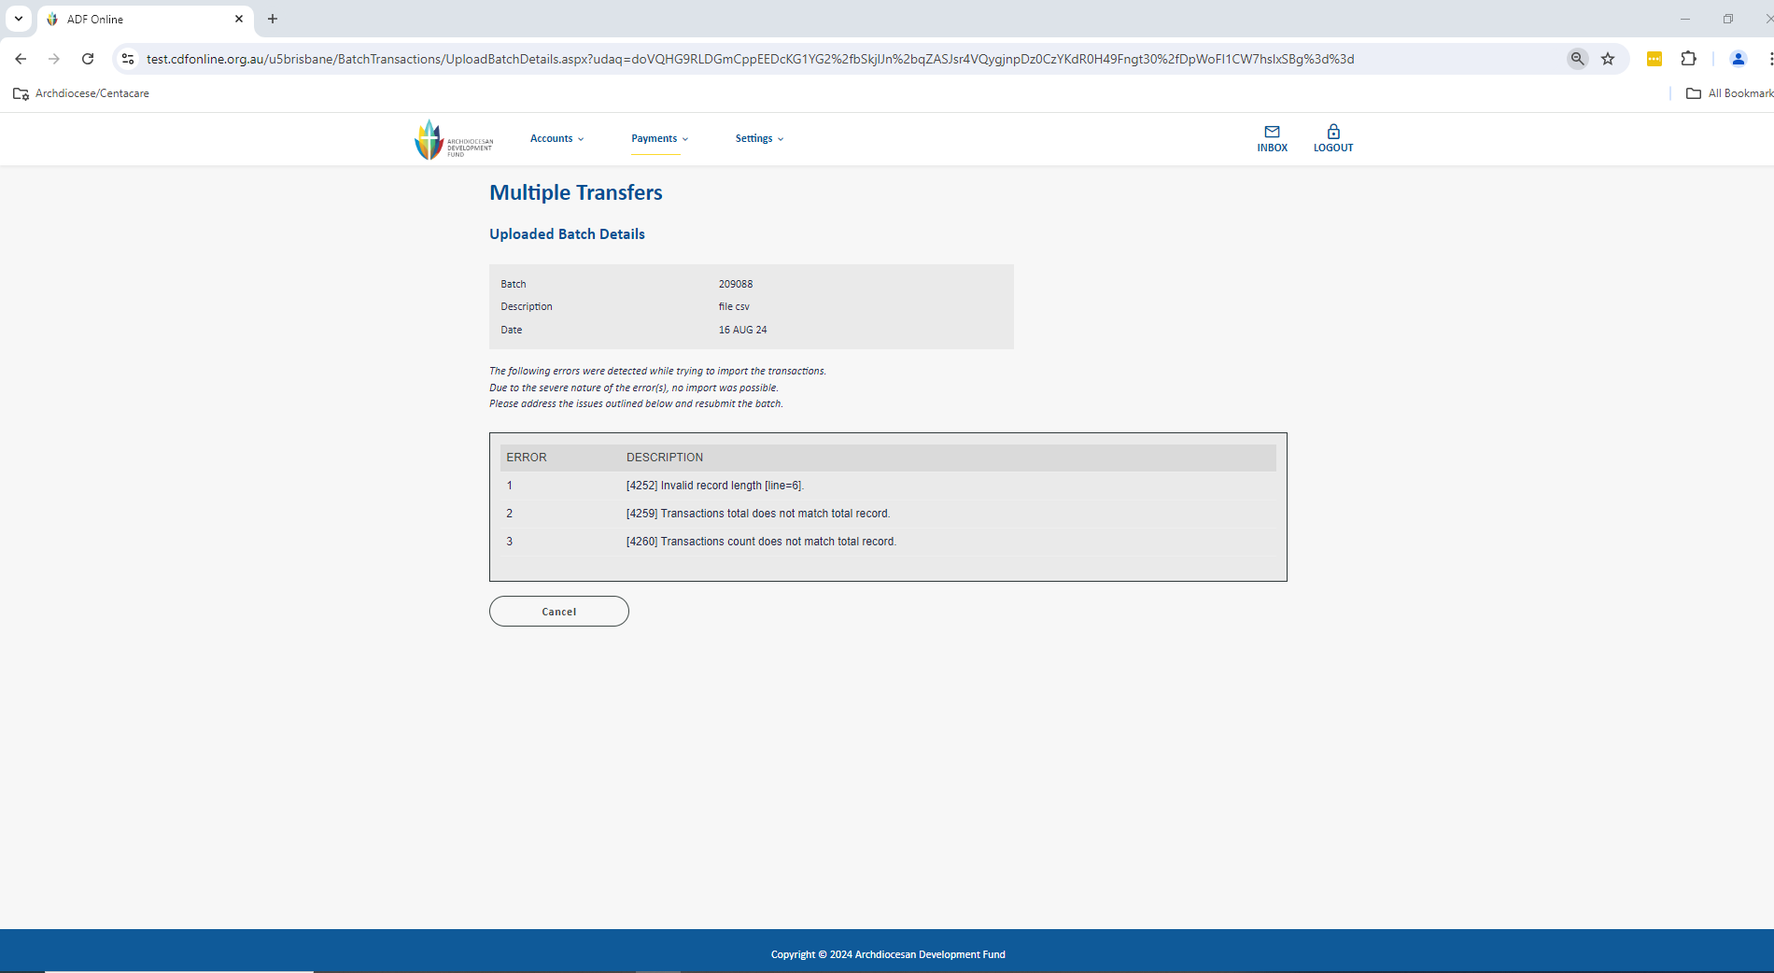

# Making Changes to a Batch

Once a batch has been scheduled for payment you are able to make changes up until the payments are processed from your account.

Go to the Payments menu up the top of the screen and select Multiple Transfers to be taken to the screen below.

1. Click on Change in the Manage area.

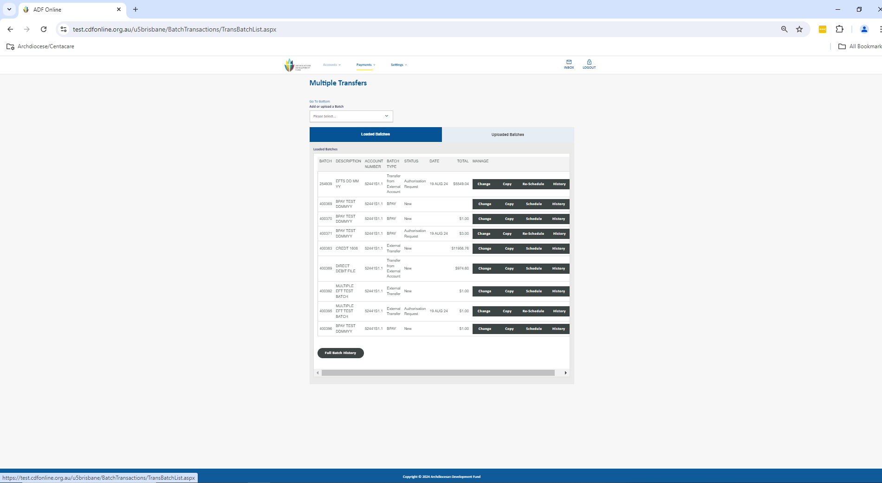

1. Locate the batch payee line that you wish to change and click on Change/Delete on the right hand side.

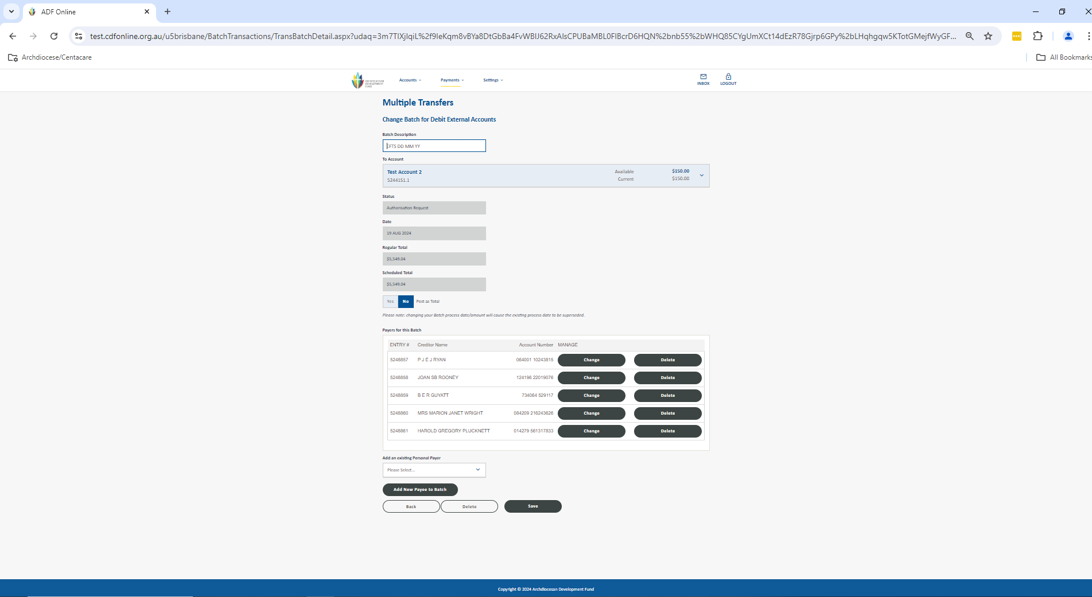

1. Change details as applicable and click Save and Save again to return to your Multiple Transfers screen. The changes have now been made and the batch is ready for scheduling.

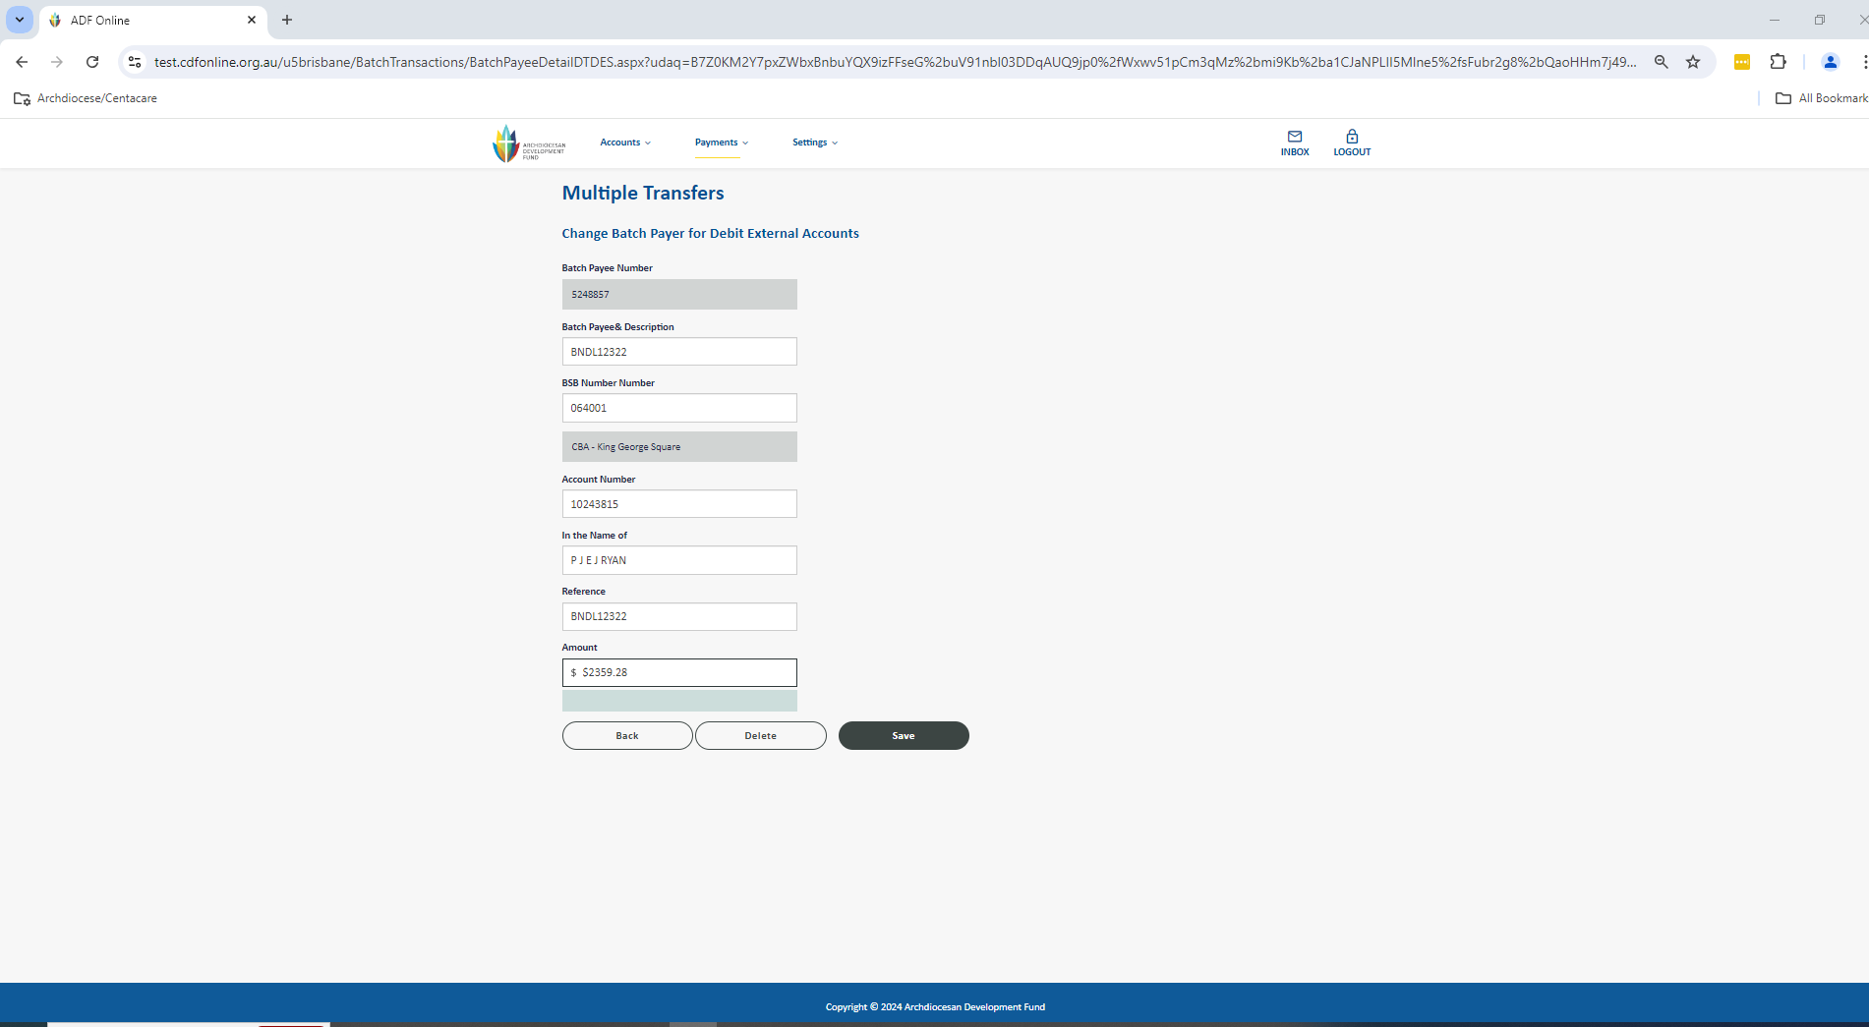

# Deleting a Batch

We recommend occasionally ‘cleaning up’ your Multiple Transfers screen by deleting old batches from your listing. You can do this at any time.

Go to the Payments menu up the top of the screen and select Multiple Transfers to be taken to the screen below.

1. Click on Change in the Manage area.

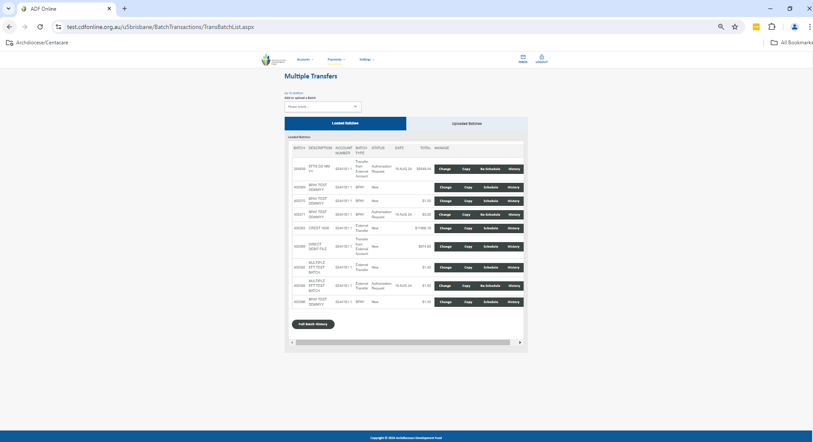

1. You can now select the Delete button at the bottom of the screen to be taken to a confirmation screen.

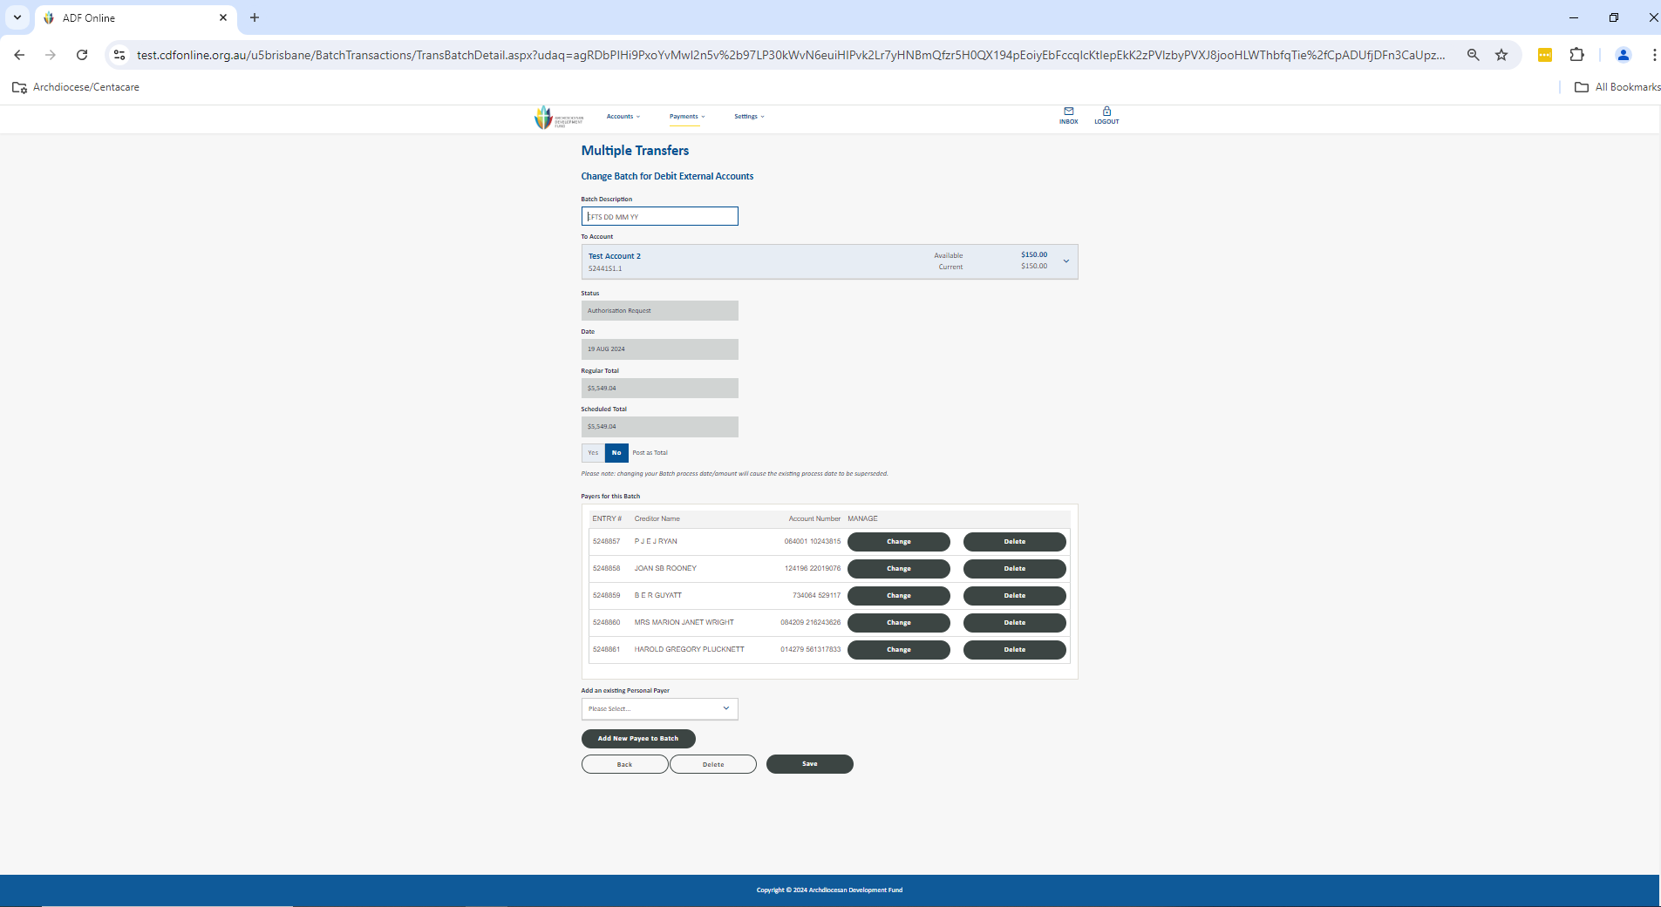

1. Click the Submit button to confirm deletion of the batch. You will be returned to the Multiple Transfers screen with the batch no longer there.

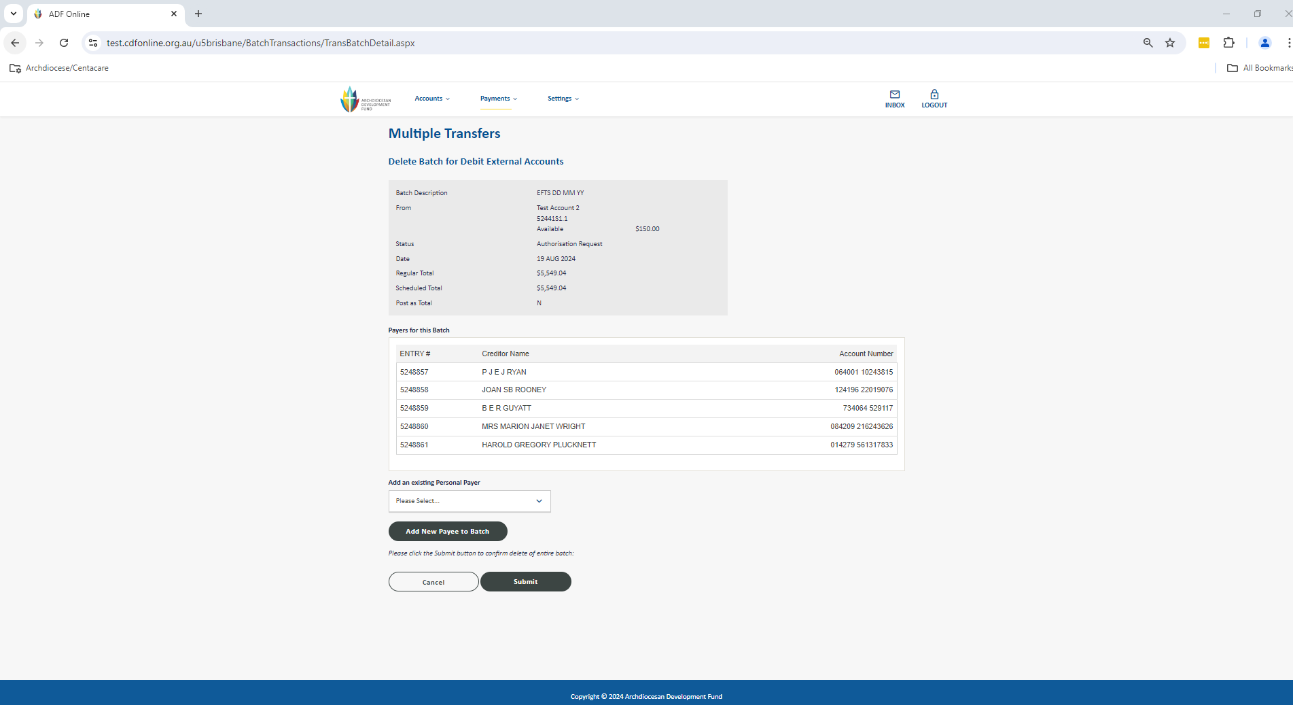

**DISCLOSURE STATEMENT**

At the Catholic Development Fund (CDF), we are committed to respecting the privacy of our clients. Personal information is collected, held, used, corrected, disposed of or transferred in accordance with the National Privacy Principles and Privacy Act 1988 as amended. If you would like to receive a copy of our privacy policy, please contact the Catholic Development Fund, GPO Box M962, Perth WA 6843 or electronically at cdf@perthcatholic.org.au.

The Roman Catholic Archbishop of Perth – Catholic Development Fund (the Fund) is not subject to the provisions of the Corporations Act 2001 nor has it been examined or approved by the Australian Securities and Investments Commission. Deposits with the Fund are guaranteed by CDPF Limited, a company established by the Australian Catholic Bishops’ Conference for this purpose.

Neither the controlling entity nor the Fund is prudentially supervised by APRA. Contributions to the Fund do not obtain the benefit of the depositor protection provisions of the Banking Act 1959. The Fund is designed for investors who wish to promote the charitable purposes of the Fund.