**User Managed Direct Debits via CDF Online**

Customer User Guide

Author – CDF Product Services

Published – 5th September 2024

**TABLE OF CONTENTS**

User Managed Direct Debits Training 3

Overview 3

Expected Learning Outcomes 3

Glossary of Terms 4

Introduction to User Managed Direct Debits 5

Overview 5

Establishing Access to User Managed Direct Debits 6

Overview 6

Things to Consider before Applying for User Managed Direct Debits 6

Applying for User Managed Direct Debits 6

Using the User Managed Direct Debit System 7

Overview 7

Receiving the Completed Direct Debit Request form 7

Creating the New Direct Debit in CDF Online 8

Altering a Direct Debit in CDF Online 13

Cancelling or Deleting a Direct Debit in CDF Online 17

# User Managed Direct Debits Handbook

**Overview**

This training manual has been designed for all CDF clients who wish to administer (view, create, alter, delete) direct debits via CDF Online. A basic level of understanding direct debits, the Bulk Electronic Clearing System (BECS) and usage of CDF Online is considered a pre-requisite for this training.

This training manual provides an overview of the direct debit functionality that has been created to allow clients to self-manage their direct debits. This training manual should be used in conjunction with the CDF’s Direct Debit Information, Terms and Conditions Booklet, if you do not have a copy of this, please contact the CDF immediately.

Contact details:

Direct Debit Support Services are available Monday to Friday between the hours of 8:30am to 4pm.

Provided below is a listing of the dedicated direct debits support team to assist in the provision of this service.

Phone: 08 6104 3600

[Email:](mailto:directdebits@bne.catholic.net.au) [cdf@perthcatholic.org.au](mailto:cdf@perthcatholic.org.au)

Website: [www.cdfperth.org.au](http://www.cdfperth.org.au)

**Expected Learning Outcomes**

At the completion of this training you should:

* Have an in-depth understanding of the CDF Online direct debit system;
* Be able to confidently navigate to and from both the Direct Debit Address Book and the Periodic Payment screens; and
* View, load, amend or delete direct debits.

**Glossary of Terms**

Below is a listing of terminology that may be used throughout this booklet in relation to the direct debit facility, functionality and transactional processing.

CDF – Catholic Development Fund

Us – The Catholic Development Fund (the CDF)

Rejection – Term for when a direct debit is returned to the CDF as unpaid.

APCA – Australian Payments Clearing Association. APCA is the self-regulatory body for the Australian Payments industry. It is their responsibility to develop regulations, procedures, policies and standards governing payments processing within Australia. They oversee five clearing systems including the direct debit network. Part of the oversight of the direct debit network focuses on who can process direct debit payments.

BECS – Bulk Electronic Clearing

A# Number – CDF system generated reference number for the direct debit request.

# Introduction to User Managed Direct Debits

**Overview**

A direct debit is a type of electronic transaction that allows an organisation or entity to debit (withdraw) funds from a person’s bank account, normally as a recurring or ongoing amount. The account holder must authorise the direct debit in writing and the account holder can revoke this authority in writing at any time.

Whilst the CDF has been able to administer direct debits on our clients behalf for a number of years, changes to CDF Online now gave some of our clients the ability to view, create, amend and delete one off or recurring direct debits. This is a service commonly utilised by our Catholic schools.

# Establishing Access to User Managed Direct Debits

**Overview**

Whilst the User Managed Direct Debit system is a great enhancement to CDF Online and has the ability to improve your internal processes, before you and your school can commence using the User Managed Direct Debits system, there are a few requirements that need to be considered to ensure that you meet your legal obligations as well as the processing requirements for your school.

**Things to Consider before Applying for User Managed Direct Debits**

There are a number of items to be considered and questions that need to be answered before you take up the User Managed Direct Debit system. These are:

* Does your school have an adequate secure storage area and procedure to store the completed forms for the required duration? Your school should already be storing the forms securely however the CDF does retain copies of forms that we process. If you move to User Managed Direct Debits, you will be solely responsible for the storage of all forms.
* Does your school utilise CDF Online?
* Does your school have someone that will be able to manage the direct debits on a daily basis?
* Does your school wish to have parents complete a new form at the start of every year or would you like to be able to use the same form as an ongoing authority?
* Will your school wish to use the direct debit form supplied by the CDF or would you like to create your own form? It should be noted that if your school opts to develop their own form, the CDF will not grant access to the User Managed Direct Debit system until we have reviewed and signed off on your form.

**Applying for user Managed Direct Debits**

Once your school has addressed the considerations for User Managed Direct Debits and has decided to proceed, you simply need to contact the CDF and advise that you would like to establish User Managed Direct Debits. The CDF will then initiate the below process:

* Email you the Customer Managed Direct Debit Authority form for review and completion. This form will request answers to consideration questions.
* Once the CDF receive the completed Authority, we will:
  + Alter your CDF Online facility to include the User Managed Direct Debits
  + Migrate all your current direct debits to CDF Online
  + We will schedule a training session, either on site, over the phone or in our office
  + Go live with the system

# Using the User Managed Direct Debit System

**Overview**

In this section we will cover how to use the User Managed Direct Debit system within CDF Online including receiving the form from the client/parent, loading the details into the Direct Debit Address Book, setting up the debits within the Periodic Payment screen, amending direct debits through the Periodic Payment screen and cancelling debits via the Periodic Payment screen.

**Receiving the Completed Direct Debit Request Form**

To ensure that you have the correct authority from the parent/account holder and that you have all the information you require to set up the debit, all DDR forms must be completed in their entirety with all mandatory details included before you can process the request. Mandatory fields are:

* Name of the person giving the direct debit authority;
* BSB, Account Number and Account name to be debited;
* Amount to be debited;
* Commencement date of the debit;
* Frequency of the debit;
* Acknowledgement that the Direct Debit Service Agreement has been read; and
* Signature of the person giving the direct debit authority.

We recommend having your Direct Debit Request forms writable PDFs. This means that they can be completed on the computer and then printed out to be signed. This assists with minimising processing errors that can occur due to poor handwriting or smudged ink.

All DDR forms must be signed by the account holder before you process the request. If it is not signed, it must be returned to the account holder for signing.

Please Note – Digital and/or typed signatures should not be accepted. Any forms received with these should not be actioned and be returned to the parent/account holder for completion.

Under no circumstances are you to change or alter any account holder or payment or account information on a completed DDR form.

**Creating the new Direct Debit in CDF Online**

Once you have received the completed form and obtained the student reference number that will be applied to this debit, you are ready to set up the direct debit. You will need to do this in two parts, the Direct Debit Address Book and then the Periodic Payment screen. Refer to the relevant section for information on how to complete each of these steps.

### Adding Account Details to the Direct Debit Address Book

When you are setting up a payment for a new parent or account holder, you first need to load their bank account details into the system (if you have previously had a debit with these details before, you can move straight to the Periodic Payment section of this manual). Below is the process to follow to add the account details into the Direct Debit Address Book.

1. Log into CDF Online.

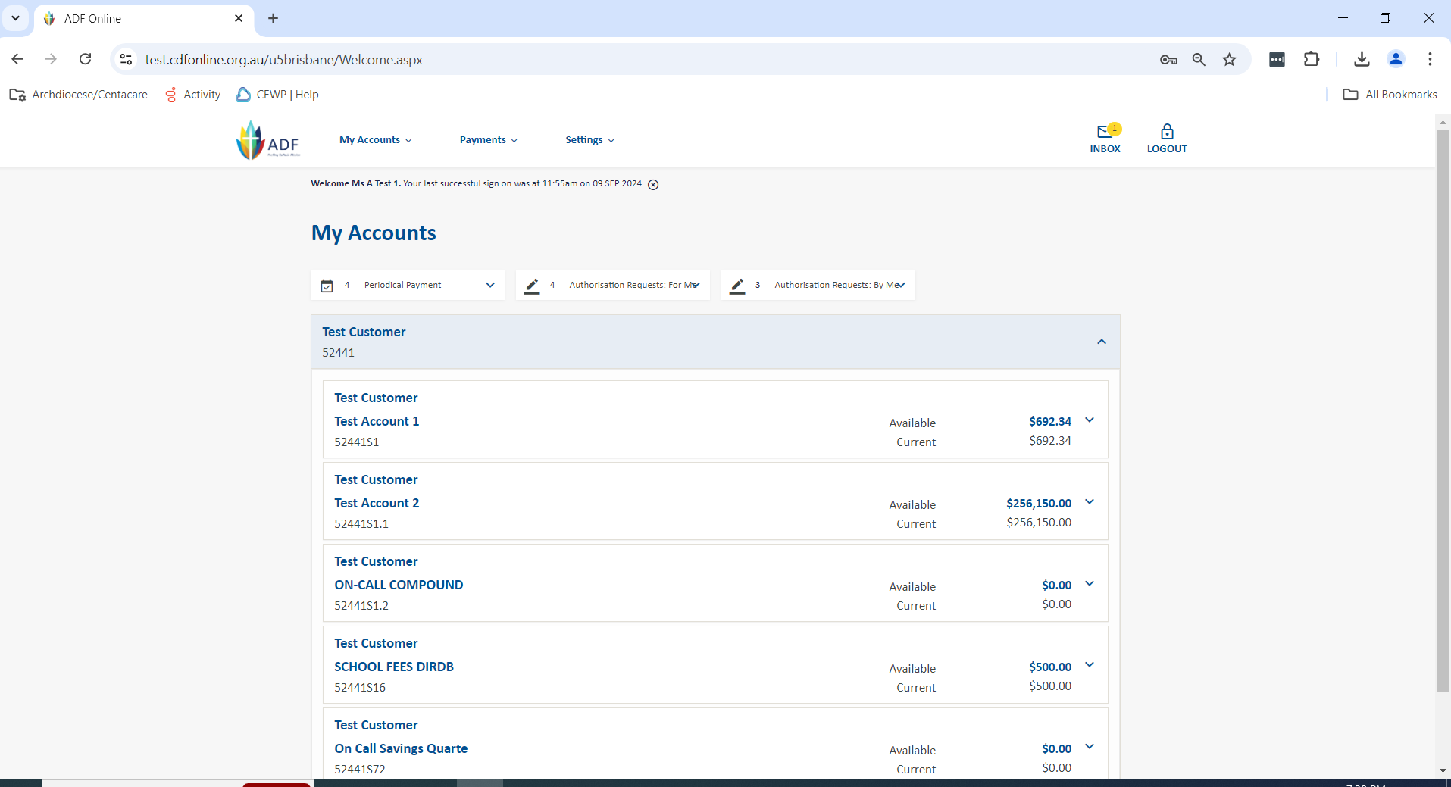

1. From the CDF Online home page you need to open the Payments Menu at the top of the page and select the option for Address Book.

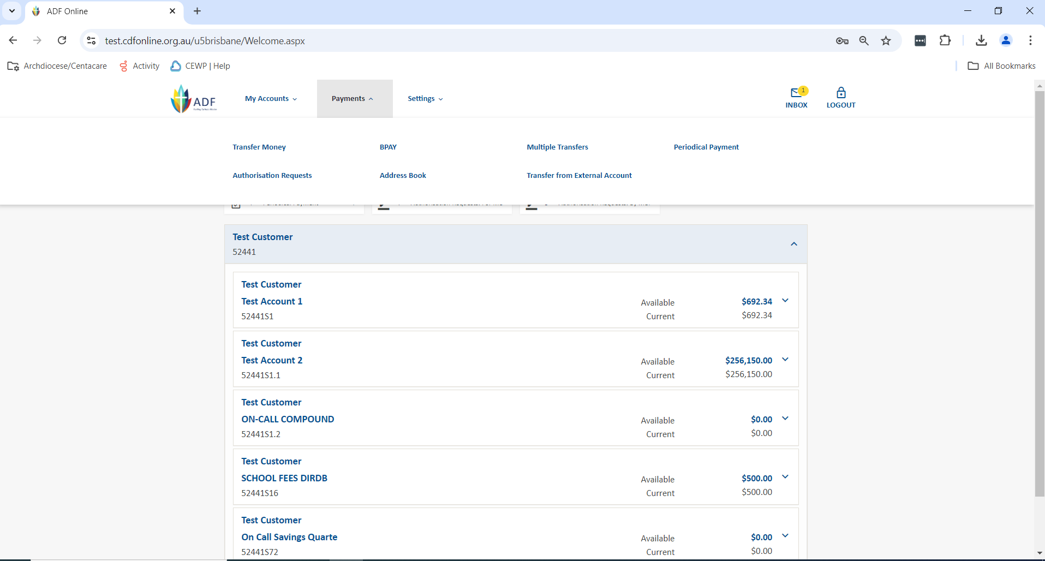

1. If this is the first account to be added into the Direct Debit Address Book, the page will be blank. If you have added account details into the Address Book previously then you will see them all listed here as shown below. Select the option for Add New Payee🡪Debit External Account Payee.

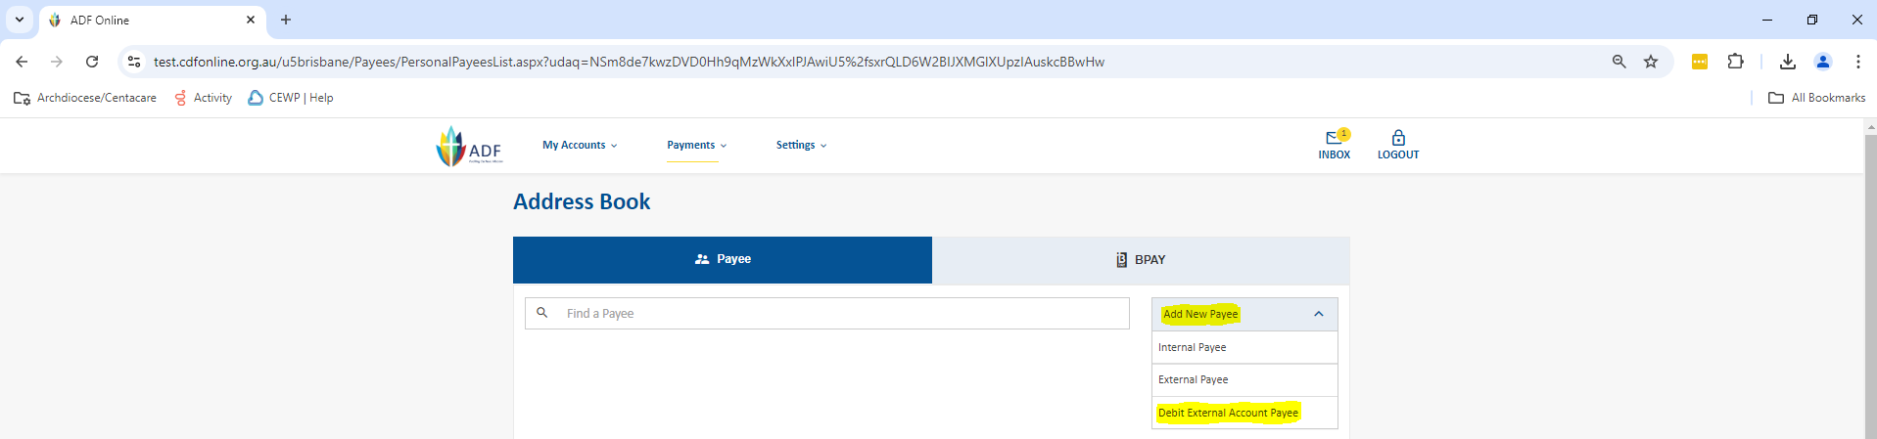

1. You will now be able to add in the account details. *When completing this section, please ensure that you do not complete the last two fields of Reference to Appear on Your Statement and Lodgement Reference.* This is because these two fields will be populated by the system and by the payment itself respectively. If you complete either of these two fields it will result in the payment not appearing on your statement correctly and if any rejections occur they won’t be processed back to the account. Once the account details are completed, if you wish to set the payment up immediately, select Update Pay (we recommend this process to ensure that setting up the payments aren’t missed) and you will be taken to the Periodic Payment screen to set up the payment. If you simply wish to add the account details into the Direct Debit Address Book, select Save.

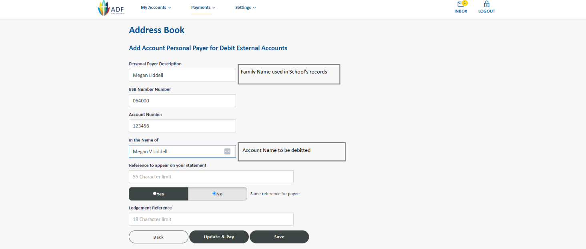

### Setting up the Direct Debit Using the Periodic Payment Screen

Once the Direct Debit account details have been loaded into the Address Book, you need to set up the direct debit payment.

1. Firstly, you need to select the account details that you wish to debit. You then can go through and complete the rest of the payment information. Once all the below information is completed, you will need to select the option for Next.
   1. The first drop down box lists all details in the Address Book, if you start typing the Family Name in this box it should bring up the account details for you to select. Please ensure that you confirm the account details are correct as per the Direct Debit form you have received.
   2. The second drop down box is where you tell it what account the funds are to be credited to. For schools the account is normally the S6 or S11.
   3. Enter the amount of the payments
   4. When – you need to complete the relevant details of the payment including the frequency, start date number of payments and/or end date.
   5. Reference to appear on the statement needs to be entered next and this is the school reference code.

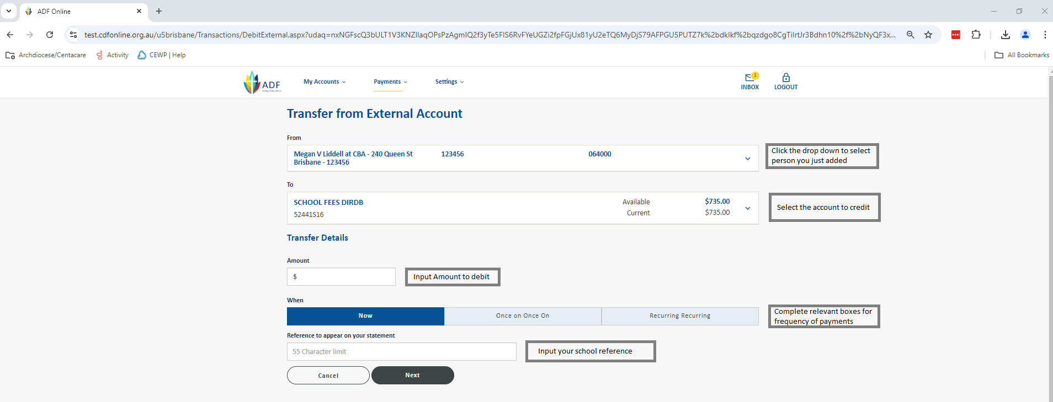

1. You will now be shown the summary screen of the payment for you to validate that all the information is correct. If it is, click on OK to set up the payment. If it is incorrect, select back to be taken back to the prior screen to fix the error.

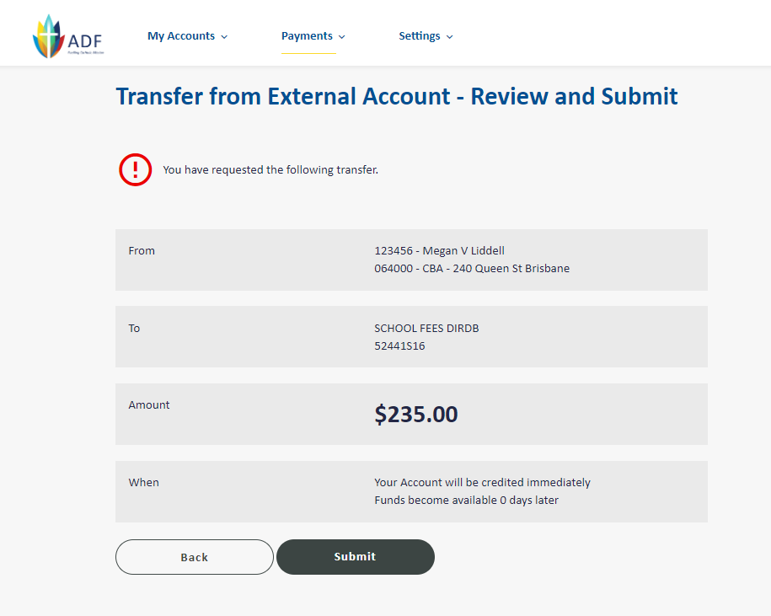

1. After selecting Submit; the payment has now been set up and you will see the confirmation screen. This screen will also provide your receipt number which you should record on your Direct Debit form as this will make it easier if you ever need to locate this payment. Once you have recorded the A# number, select Finish. (Selecting new transaction will only take you back to the Periodic Payment screen, not the Address Book). You will need to ensure that you now securely store the form in line with your schools policy (either as a hard copy or as an electronic copy).

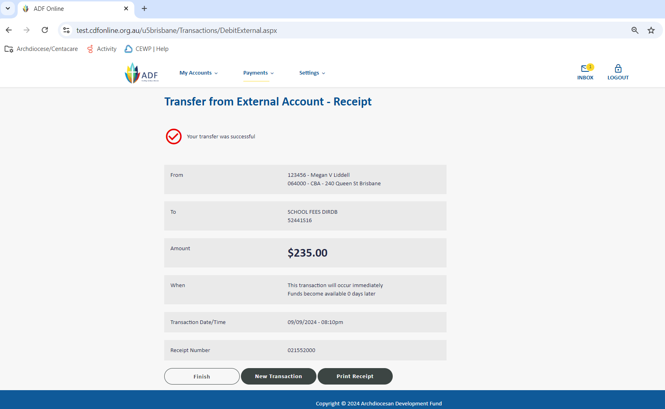

**Altering a Direct Debit in CDF Online**

From time to time you may be required to alter the details of the Direct Debit. The details that you may be required to alter are:

* Amount
* Reference
* Next Due Date
* Number of remaining payments
* Payment End Date
* Account Details

Depending on what details are needing to be altered will depend on what process you need to follow.

### Altering Account Details

If you are provided with updated bank account information, the only way for this to be actioned effectively is for the direct debit payment to be deleted, the current details removed from the Direct Debit Address Book and then it set back up as if it was a new payment. This is because once the details are loaded into the Address Book, they can’t be altered, it may appear as though the alteration has worked, however it doesn’t feed into the Payment details so the payment will still be attempted with the old details.

For details on how to delete the direct debit payment and remove the details from the Address Book, please refer to the Cancelling/Deleting a Direct Debit section.

### Altering all other Payment Details

If you are requested to alter any of the below details you can do this easily through the Periodic Payment screen (found Under the Accounts Tab and then selecting Periodic Payment List):

* Amount
* Reference
* Next Due Date
* Number of remaining payments
* Payment End Date

You will also follow this process if a parent has asked you to miss a payment/s, you will alter the next payment due date.

To alter the details of a payment, please follow the below procedure.

1. Log into CDF Online. Click on the Payments Tab then Select Periodical Payment List

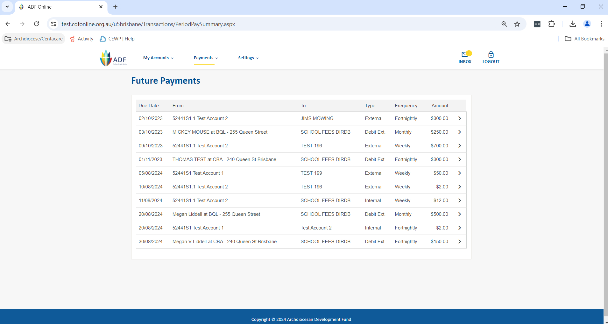

1. You now need to find the direct debit that you wish to alter. You can either scroll through the page and find the one you want manually or you can use CTRL+F to search the Family name of the payment you wish to alter. Once you have located the payment you wish to alter, click on the Change option at the right hand side of the payment. You will then be taken into this specific payment.

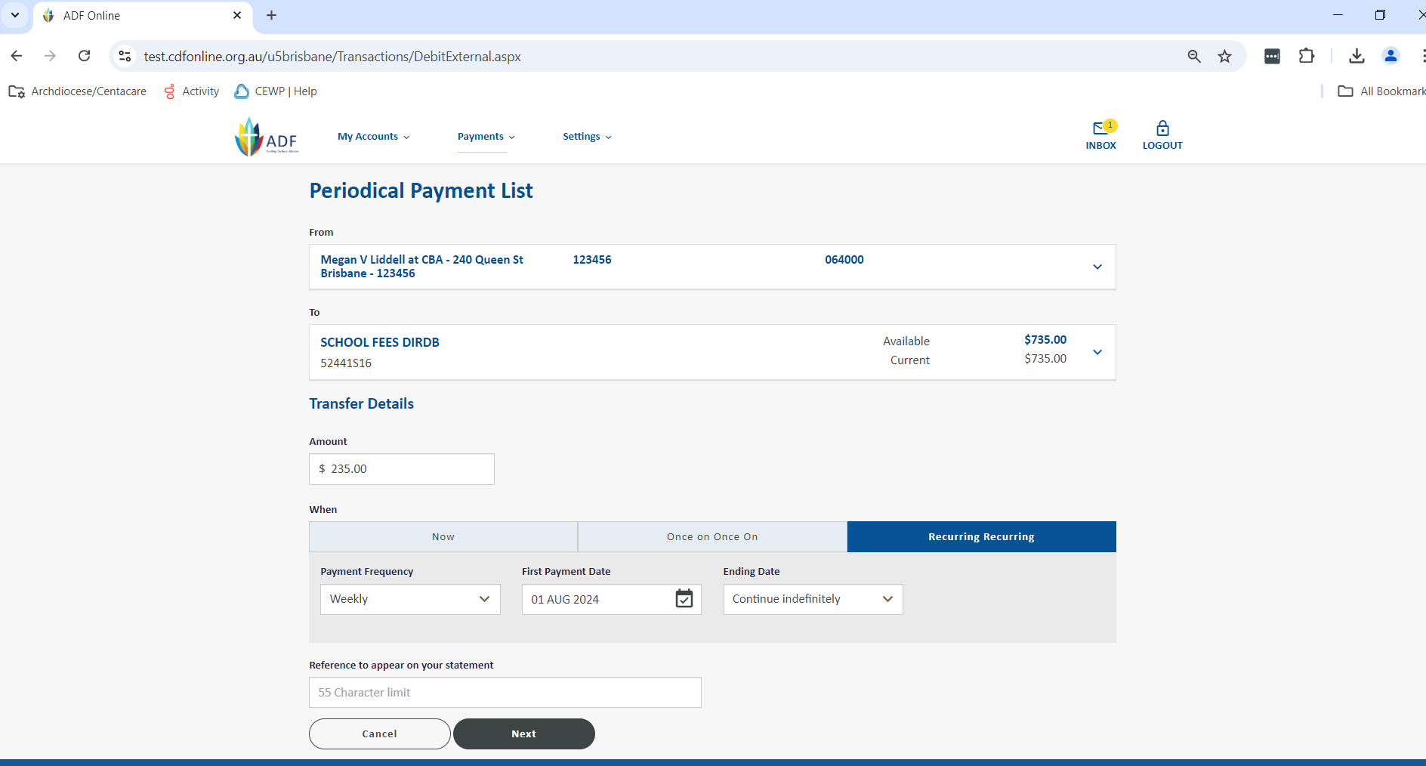

1. You can now change the required details. For this example we are changing the amount, however you can alter more than one field at once. Once the required details have been altered, click on Next.

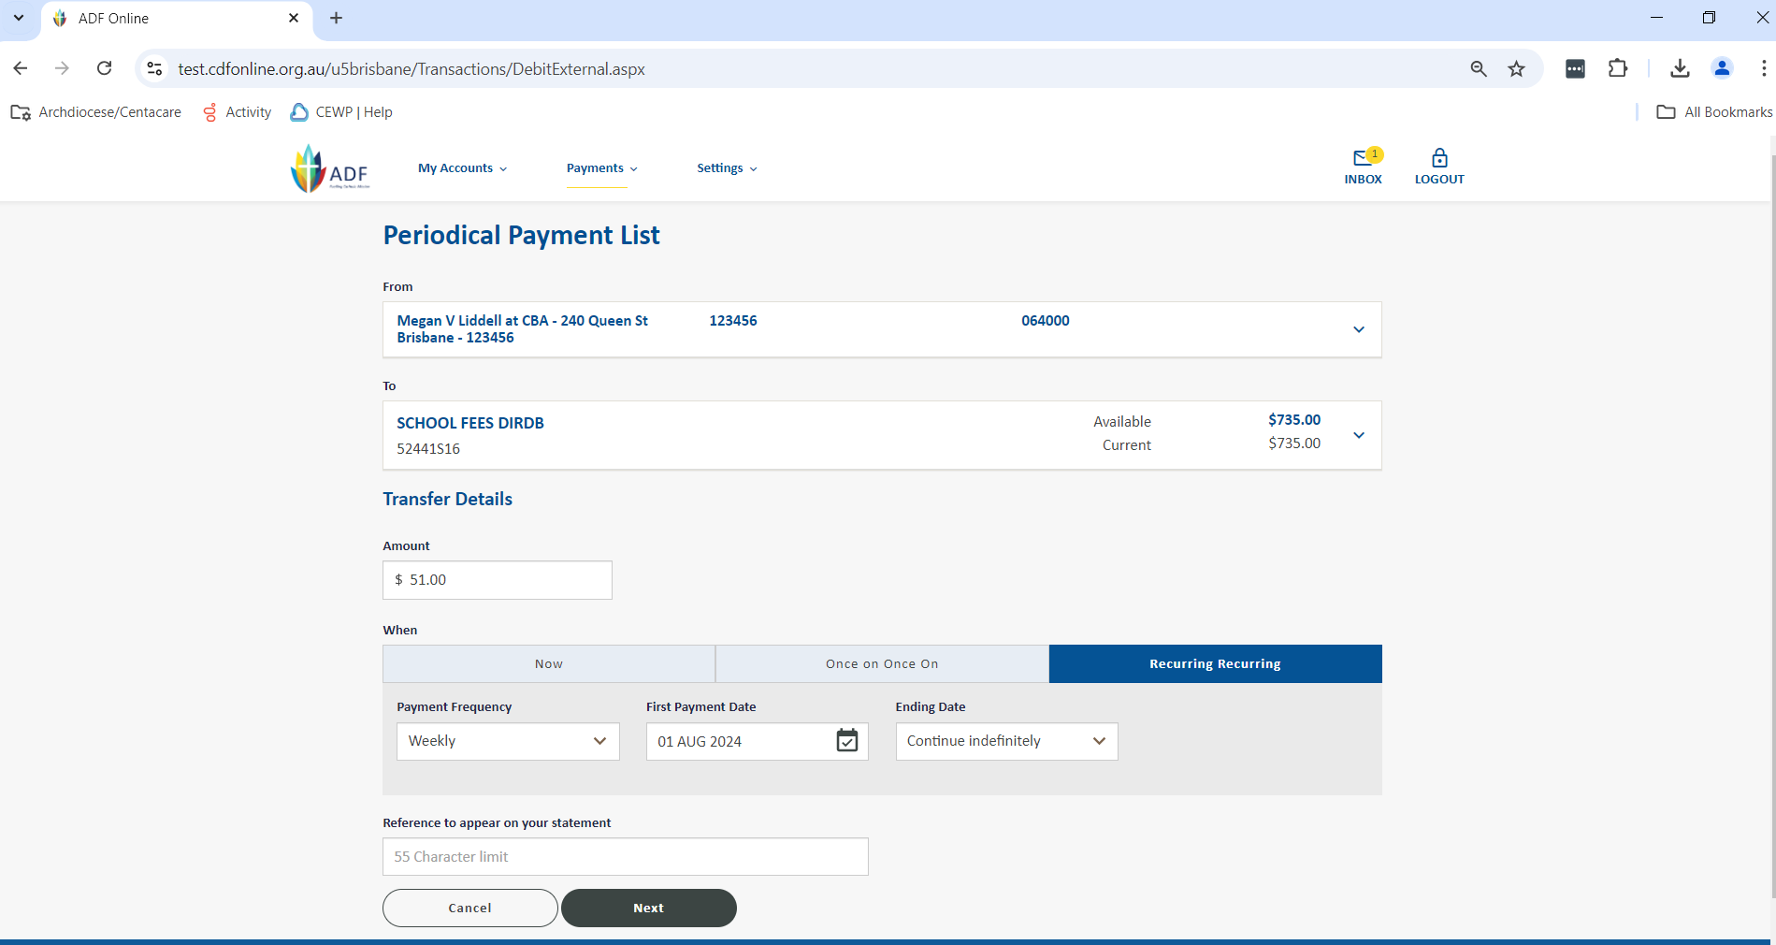

1. You will now be shown a summary screen for you to review the details of the payment to ensure that all details are correct. If they are, click on Submit. If they aren’t, click on Back and amend the details.

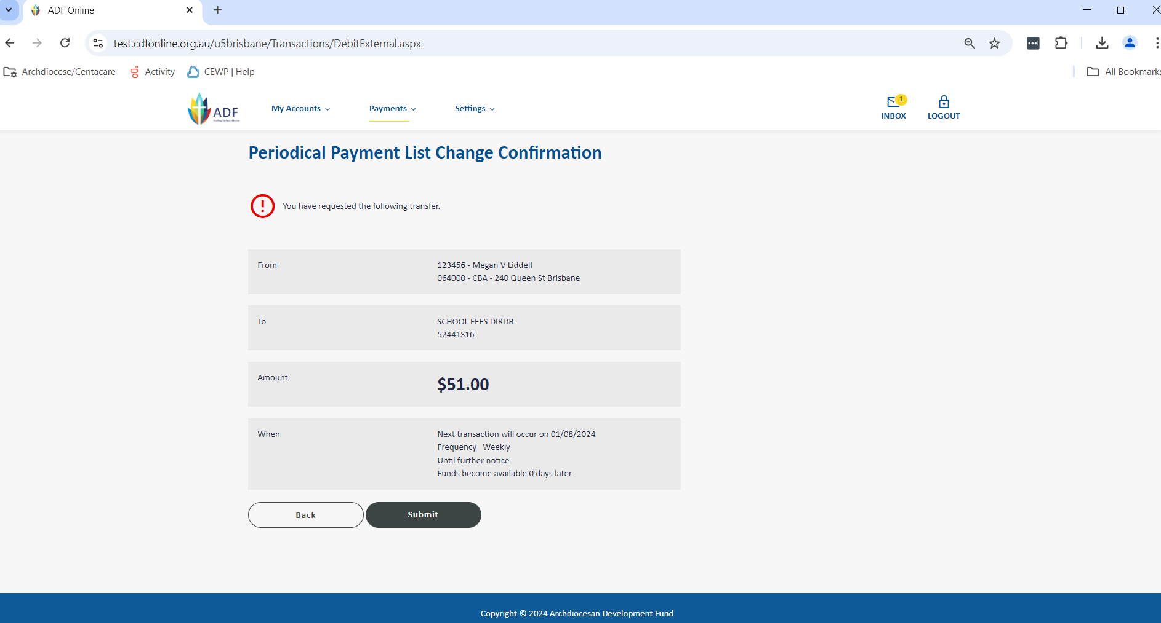

1. Once Submit has been selected the confirmation screen will appear. Click on Finish to exit the confirmation screen.

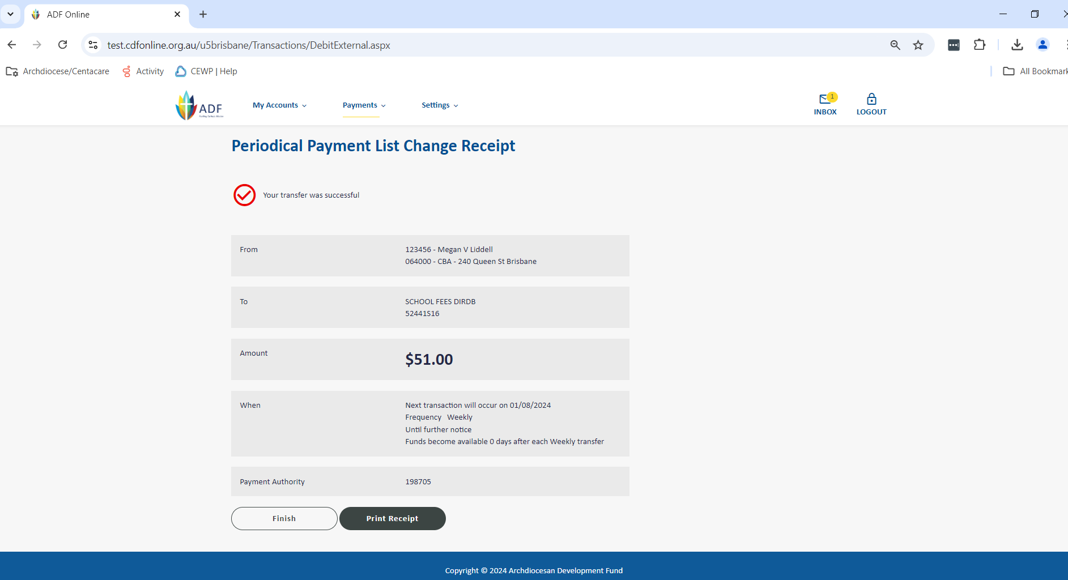

**Cancelling or Deleting a Direct Debit in CDF Online**

From time to time you will receive a request from a parent to cancel a direct debit, this can be for a couple of reasons including the child leaving the school or the parent wishing to make alternative payment arrangements.

Below is the process to follow to delete a direct debit.

1. Log into CDF Online Click on the Periodical Payment drop down which is at the top of your CDF Online Home page. This will then take you into the full Periodical Payments listing.

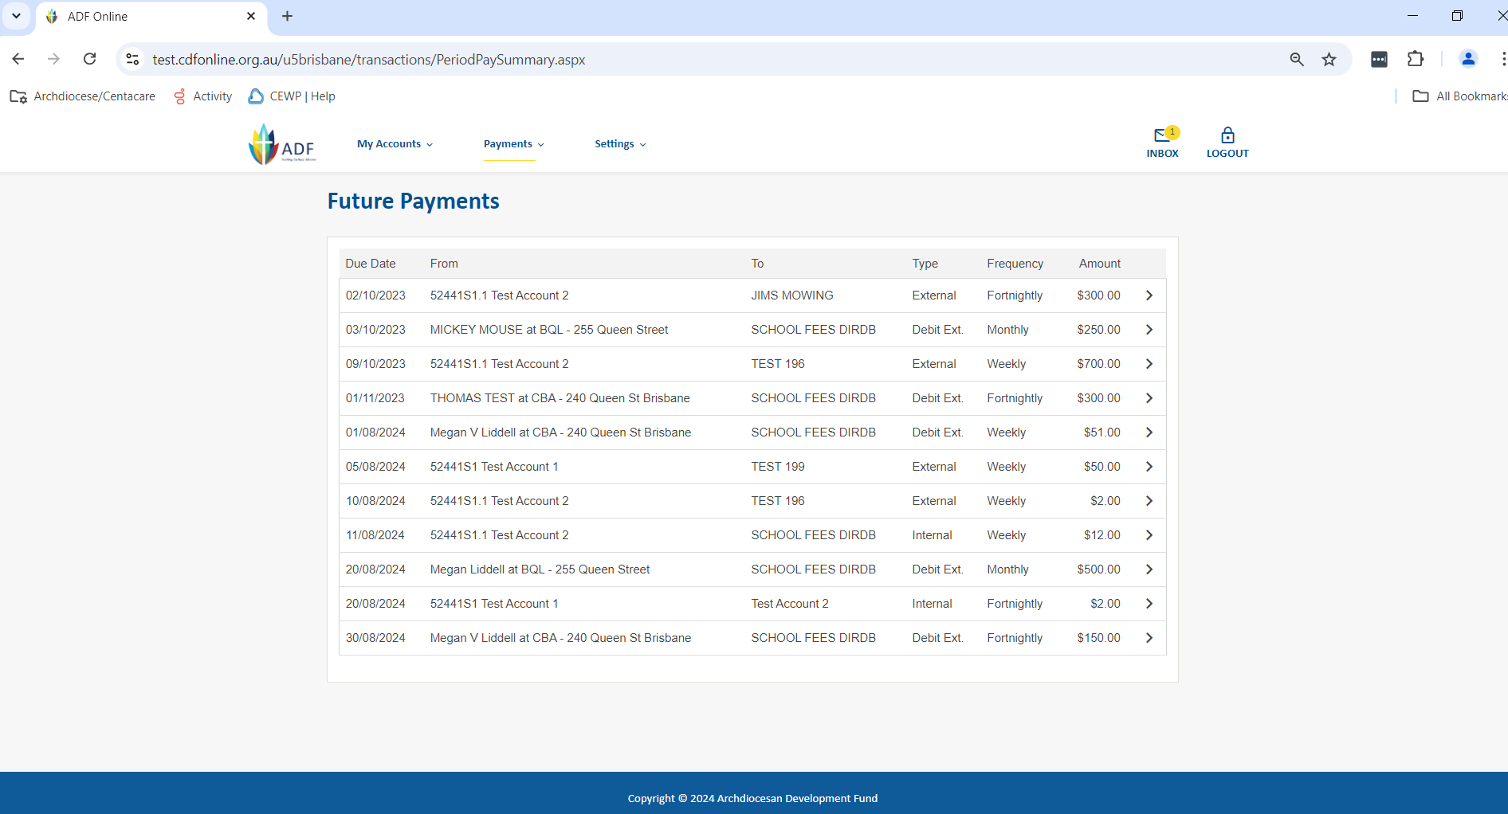

1. You now need to find the direct debit that you wish to delete. You can either scroll through the page and find the one you want manually or you can use CTRL+F to search the Family name of the payment you wish to alter. Once you have located the payment you wish to alter, click on it and then click on the Delete option at the bottom of the payment. You will now be taken into the specific below screen. Confirm if this is the payment to be deleted, if it is, click on Delete.

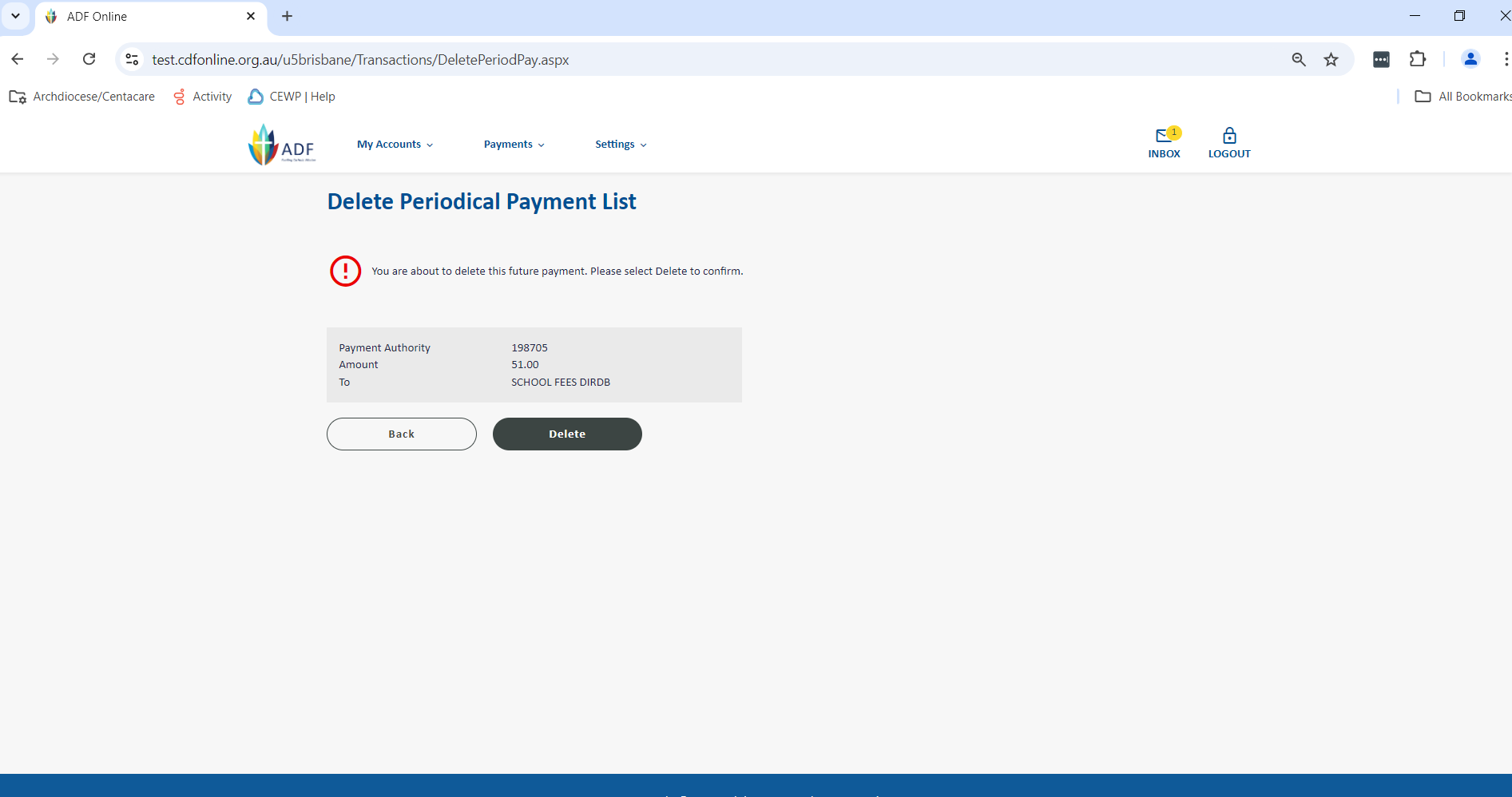

1. We now should delete the account details from the Direct Debit Address Book to ensure that only current details are recorded here. To do this you need to select the Payments menu and click on the option for the Address Book.

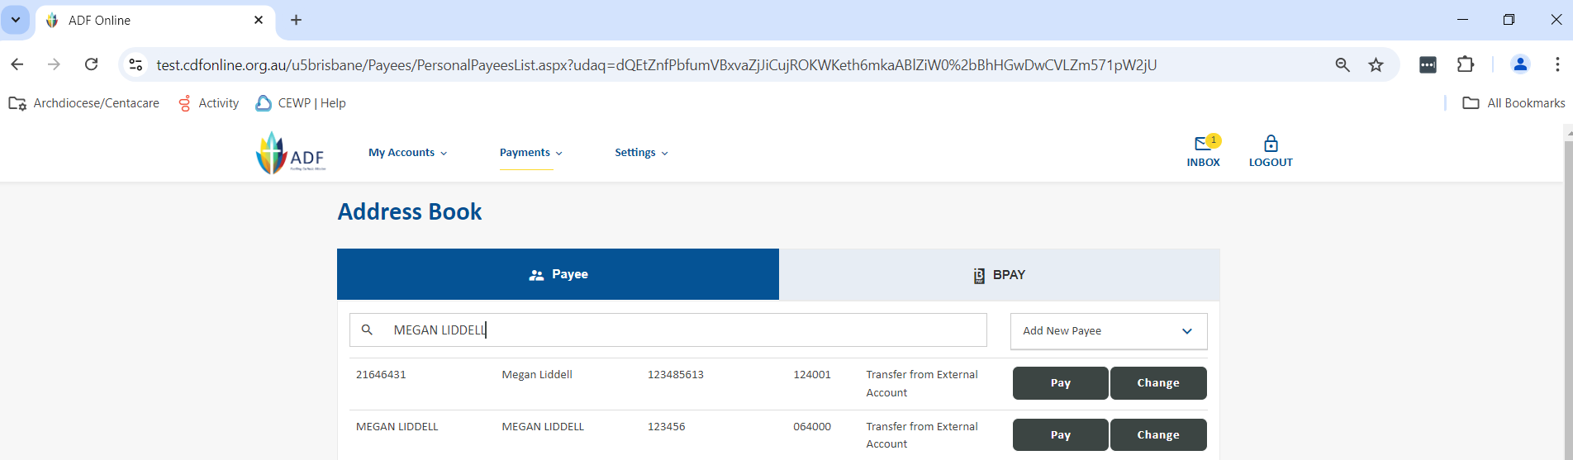

1. Once you have located the details that you wish to remove, click on the Change option. You will now be shown the full details, if these are the ones you wish to delete, click on the option Delete.

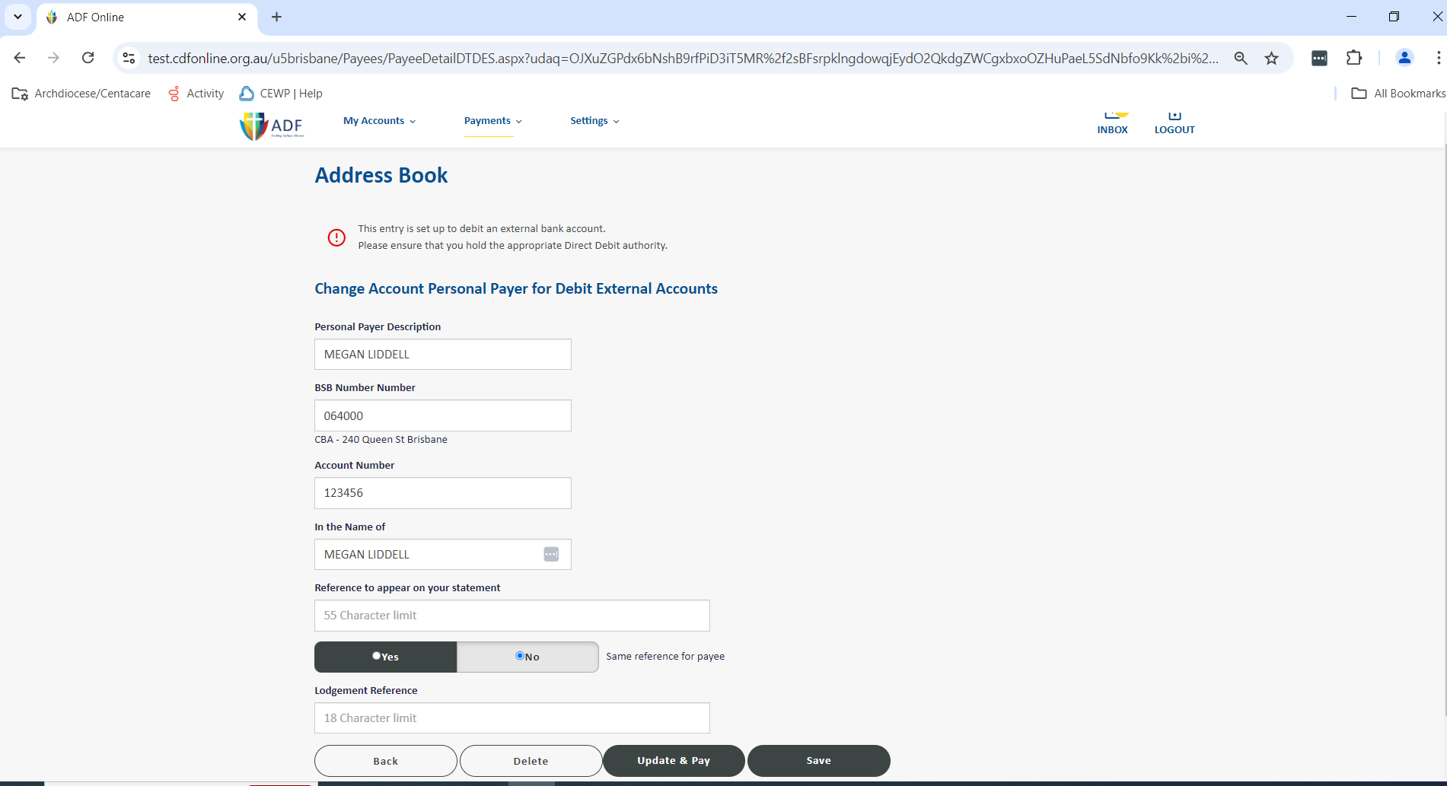

1. The details have now been deleted from the Direct Debit Address Book.